  Year 1  Ongoing throughout the year:  Seasonal Change. |  |  | 
Vocabulary

season | In the UK, there are four seasons each year. They are Spring, Summer, Autumn, and Winter, | Need to know knowledge:  - That in the UK we have 4 seasons.  - That the seasons are called Spring, Summer, Autumn and Winter.  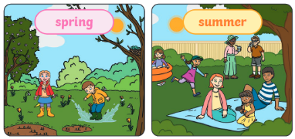  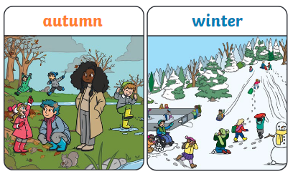  - To understand that with each season come weather changes and begin to describe this in simple terms. (Plants begin to grow in Spring, it is warmer in Summer, the leaves fall off the trees in Autumn and it is cold in Winter.)  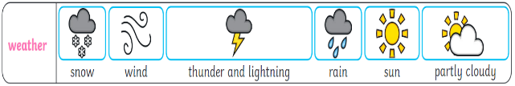  - To begin to understand that days are longer in the Summer months and shorter in Winter. | Nice to know knowledge:  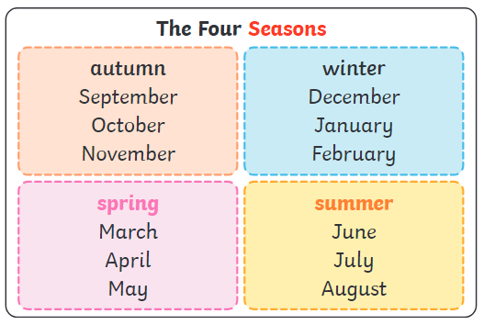  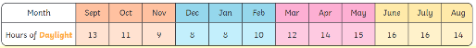  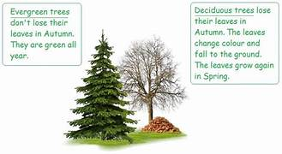  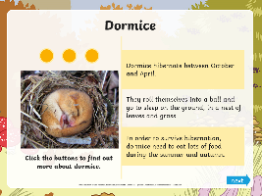  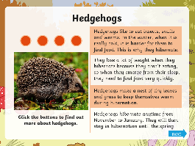  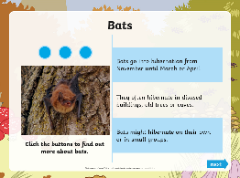  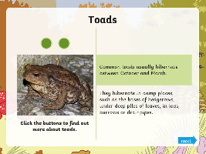
Spring | In Spring, the weather starts to get warmer.  Leaves begin to grow and some trees may  blossom (have flowers). Days start to have  more daylight hours.
Summer | In Summer, the weather gets hotter. Days in  summer have the most daylight hours. Trees  are full of leaves and there are lots of flowers, bees, butterflies and other insects.
Autumn | In Autumn, the temperature begins to get lower and it can be quite chilly and windy. It starts to get darker earlier in the day. Some animals get ready to hibernate and some trees lose their leaves.
Winter | Winter is the coldest season of the year. It can be very rainy and windy and it might even snow. Not many flowers are in bloom during winter and lots of trees have lost all their leaves. Some animals hibernate during winter and many are less active than in the warmer months.
day | Day is usually described as when it is light outside and night is when it is dark.
month | Each season has 3 months in it. There are 12 months in a whole year.
year | A year contains all 4 seasons. Each year contains 12 months.
weather | The weather includes the temperature  outside, how windy it is and rainfall (how  much it rains). We can also describe cloud,  snow and sun.
temperature | How hot or cold something is.
daylight | Daylight is when it is light outside. The  amount of daylight changes with each season.

