  Year 1  Autumn 1: Animals including humans part 1:  Ourselves! |  |  | 
Vocabulary

body | The whole physical structure that forms a person or animal. | Need to know knowledge:  - To name and identify parts of the human body.  - To identify the five senses. (Sight, smell, touch, taste and hearing/sound)  - To link the five senses to the corresponding body parts.  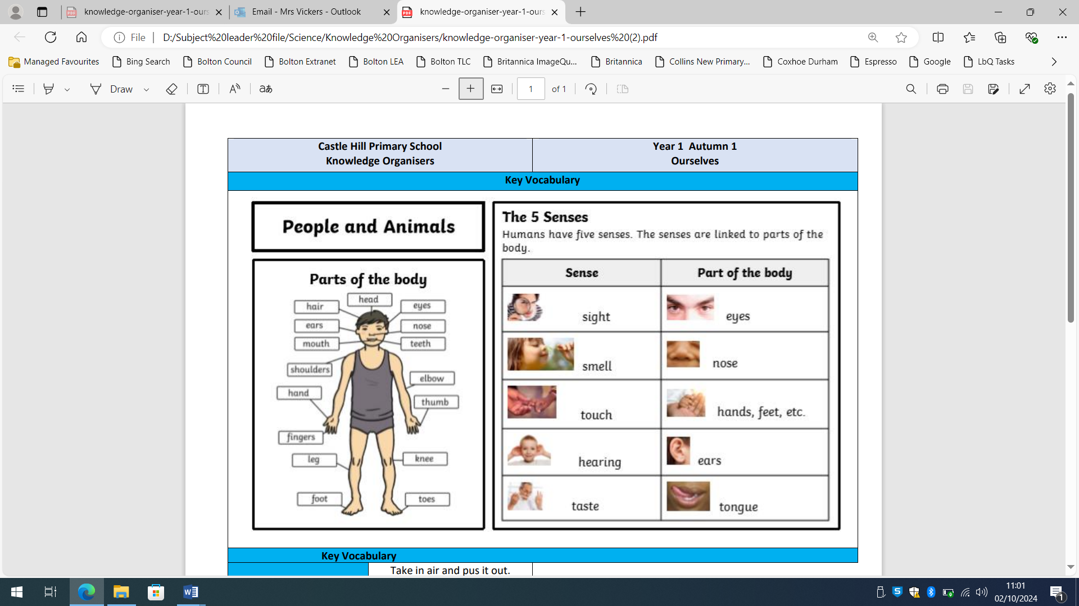  - To give examples of what we can see/ hear/ smell/ taste and touch. | Nice to know knowledge:  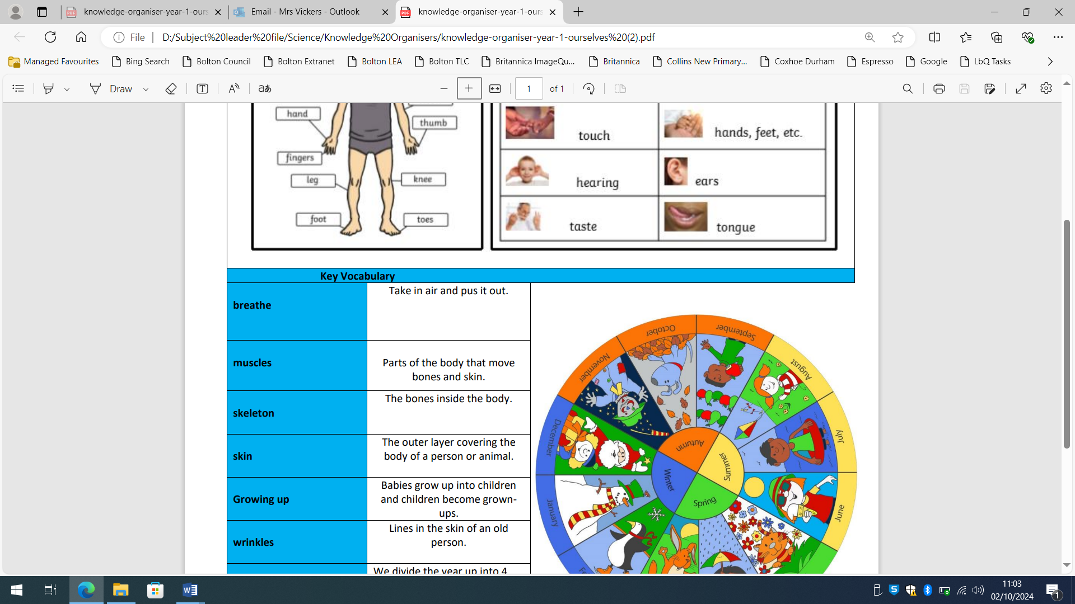
body part | A single part of the body such as an arm or a leg.
sense | Humans have 5 senses that we use to explore and interact with the world around us.
sight | One of our five senses. We use our eyes to see.
smell | One of our five senses. We use our nose to smell.
hearing | One of our five senses. We use our ears to hear.
touch | One of our five senses. We use our hands to touch.
taste | One of our five senses. We use our tongue to taste.
function | The action for which a thing is used: the function of our eyes is to see.
human | We are humans. Humans are mammals.
growing up | The process of changing from a baby, to a toddler, to a child, to a teenager and finally to an adult.
change | To become different.

