  Year 1  Autumn 2: Everyday Materials! |  |  | 
Vocabulary

object | A thing that can be used. For example, a door, a chair, car, and a table are all objects. | Need to know knowledge:  - To identify and name a variety of materials. (wood, metal, plastic, glass, fabric, paper)  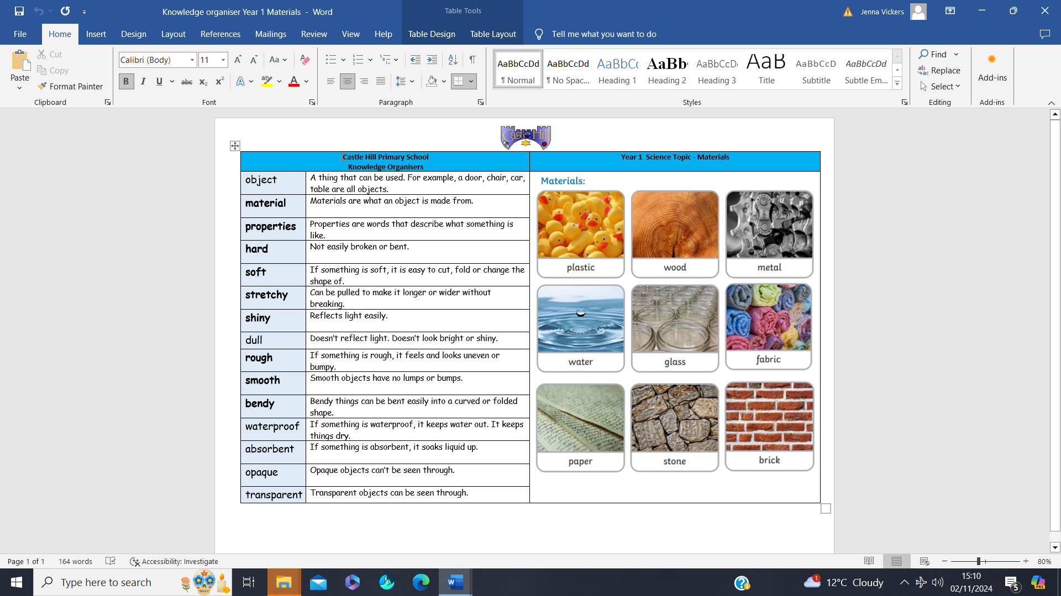  - To sort materials by considering their properties. (hard, soft, bendy etc)  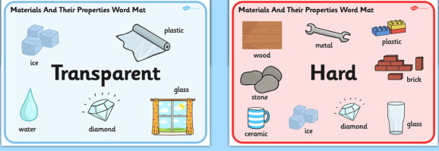  - To distinguish between objects and the material they are made from.  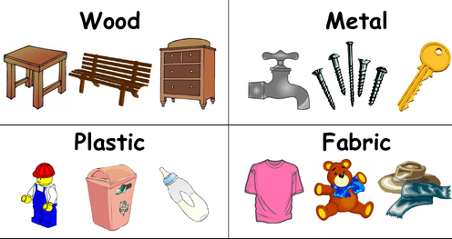  - To link their knowledge of properties to choose a suitable purpose for materials. | Nice to know knowledge:  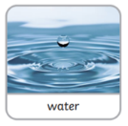  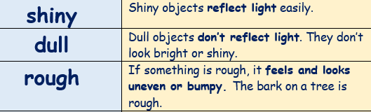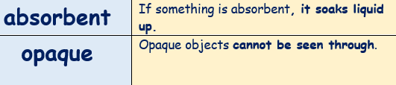  Some objects are made from more than one material. For example: these shoes are made from leather, but they have a rubber sole and fabric laces.  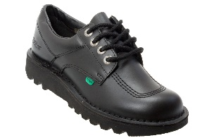
material | Materials are what an object is made from: keys are made out of the material ‘metal’.
properties | Properties are words that describe what something is like: glass is ‘hard’ and ‘transparent’.
hard | If something is hard, it is not easily broken or bent. It is hard to change the shape of a hard object.
soft | If something is soft, it is easy to cut, fold or change the shape of.
stretchy | Stretchy objects can be pulled to be made longer or wider.
bendy | Bendy things can be bent easily into a curved or folded shape.
smooth | Smooth objects have no lumps or bumps. Glass is smooth.
waterproof | If something is waterproof, it keeps water out. We wear waterproof wellies or coats to keep us dry.
transparent | Transparent objects can be seen through.

