  Year 1  Summer 1: Animals and Humans |  |  | 
Vocabulary

Animal | An animal is a living creature such as a dog, lion or rabbit. | Need to know knowledge:  - To name the 5 main animal groups. (Mammal, fish, reptile, amphibian, bird)  - To understand that within each group of animals they have shared features.  - To use this knowledge of features to identify and sort animals into their animal groups.  - To understand that animals have different dietary needs.  - To know that:  - A carnivore only eats meat  - A herbivore only eats plants and  - An omnivore eats both.  To sort animals into categories according to their diet, identifying one or two carnivores, herbivores and omnivores. | Nice to know knowledge:  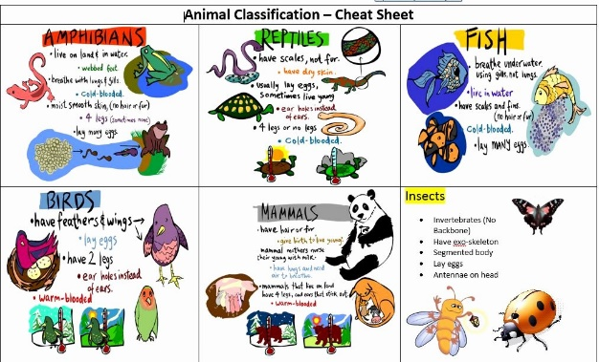  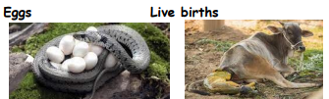  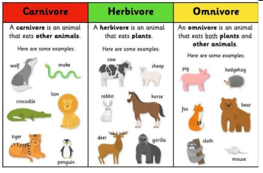
Live young | A baby born naturally out of the mother’s body. Most mammals give birth to live young.
Eggs | A shell which contains an embryo. The babies hatch from the eggs when they are ready.
Fish | An animal which lives in water and has gills. They are cold blooded.
Amphibians | Amphibians live on the land and in water. They are cold-blooded animals.
Reptiles | Reptiles are cold-blooded with scales. They lay eggs.
Birds | An animal covered in feathers. They lay eggs. Most birds can fly.
Mammals | Mammals are warm-blooded with fur and hair. They give birth to live young.
Insects | Insects have an exoskeleton. They have 6 legs. Some have wings.
Features | What an animal has.
Diet | The type of food that an animal eats.
Carnivore | An animal that eats the flesh of other animals.
Herbivore | An animal that only eats plants.
Omnivore | An animal that eats meat and plants.

