  Year 1  Summer 1: Plants! |  |  | 
Vocabulary

Alive | Things that are alive such as humans, animals and plants breathe and grow. They need food and energy to survive. | Need to know knowledge:  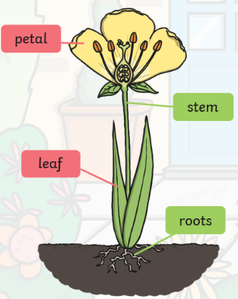  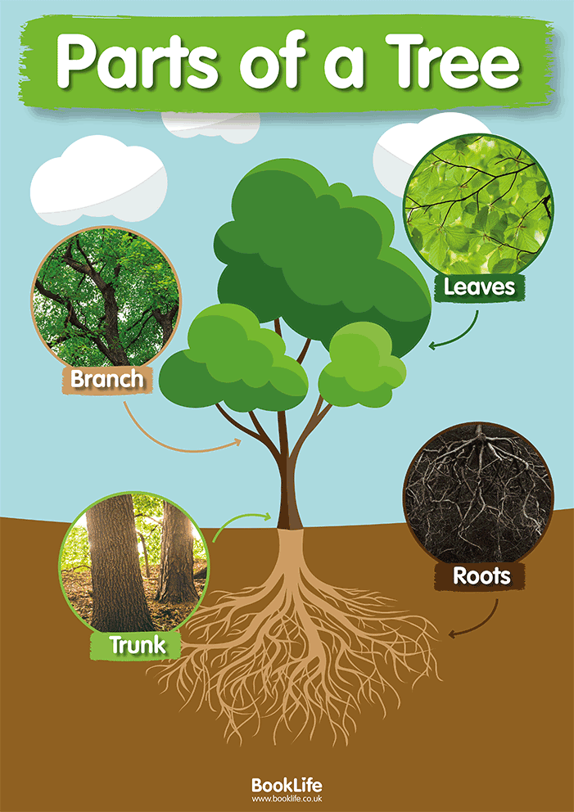  - To label the 4 main parts of a plant. (roots, stem, leaves, petals)  - To label the 4 main parts of a tree. (roots, trunk, branch, leaves)  - To know that some plants are wild and some we have to carefully grow in gardens and begin to name them (dandelion, daisy, buttercup, rose, tulip, sunflower)  - To know that some trees stay green all year and some trees change with the seasons. | Nice to know knowledge:  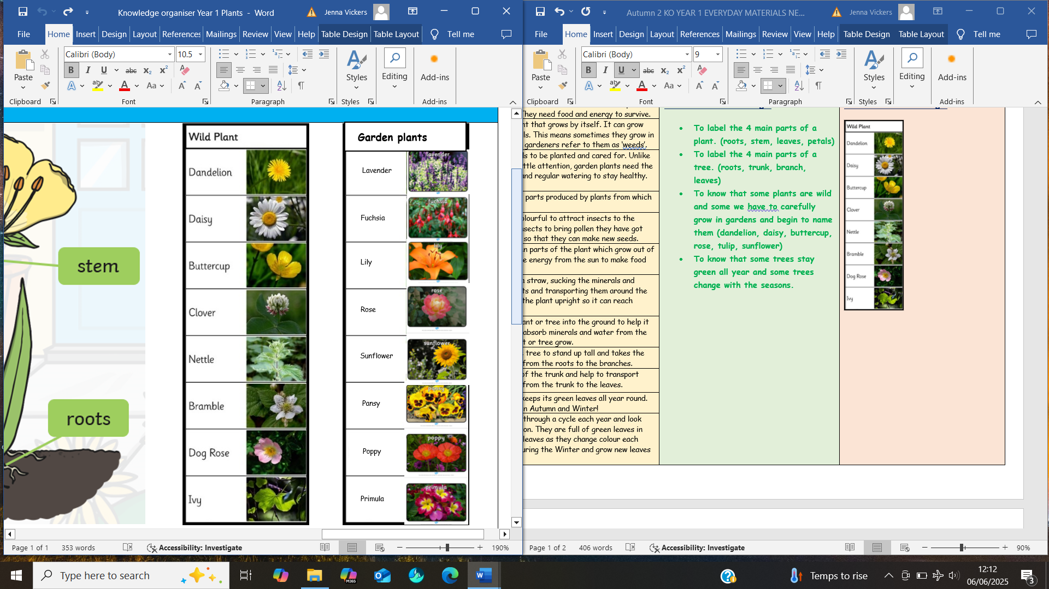  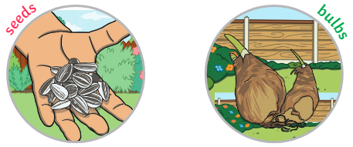  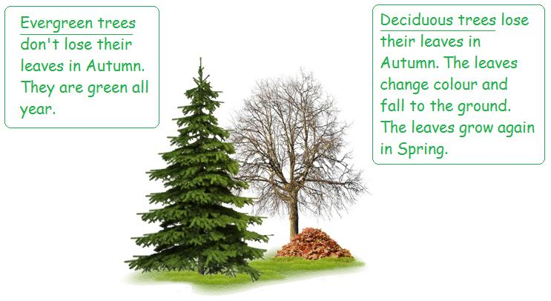
Wild plants | A wild plant is a plant that grows by itself. It can grow wherever a seed falls. This means sometimes they grow in unwanted areas and gardeners refer to them as ‘weeds’.
Garden plants | A garden plant needs to be planted and cared for. Unlike weeds which need little attention, garden plants need the correct conditions and regular watering to stay healthy.
Seeds | Seeds are the small parts produced by plants from which new plants grow.
Petals | Petals are usually colourful to attract insects to the plant. Petals need insects to bring pollen they have got from other flowers so that they can make new seeds.
Leaves | Leaves are the green parts of the plant which grow out of the stem. Leaves use energy from the sun to make food for the plant.
Stem | The stem acts like a straw, sucking the minerals and water from the roots and transporting them around the plant. It also holds the plant upright so it can reach towards the sun!
Roots | Roots anchor the plant or tree into the ground to help it to stay upright and absorb minerals and water from the soil to help the plant or tree grow.
Trunk | The trunk helps the tree to stand up tall and takes the water and minerals from the roots to the branches.
Branches | Branches grow out of the trunk and help to transport minerals and water from the trunk to the leaves.
Evergreen | An evergreen tree keeps its green leaves all year round. They remain green in Autumn and Winter!
Deciduous | Deciduous trees go through a cycle each year and look different each season. They are full of green leaves in Summer, lose their leaves as they change colour each Autumn, are bare during the Winter and grow new leaves each Spring!

