  Year 2  Spring 1: Uses for everyday materials. |  |  | 
Vocabulary

materials | Materials are what objects are made from. Materials can include wood, plastic, glass, and metal. | Need to know knowledge:  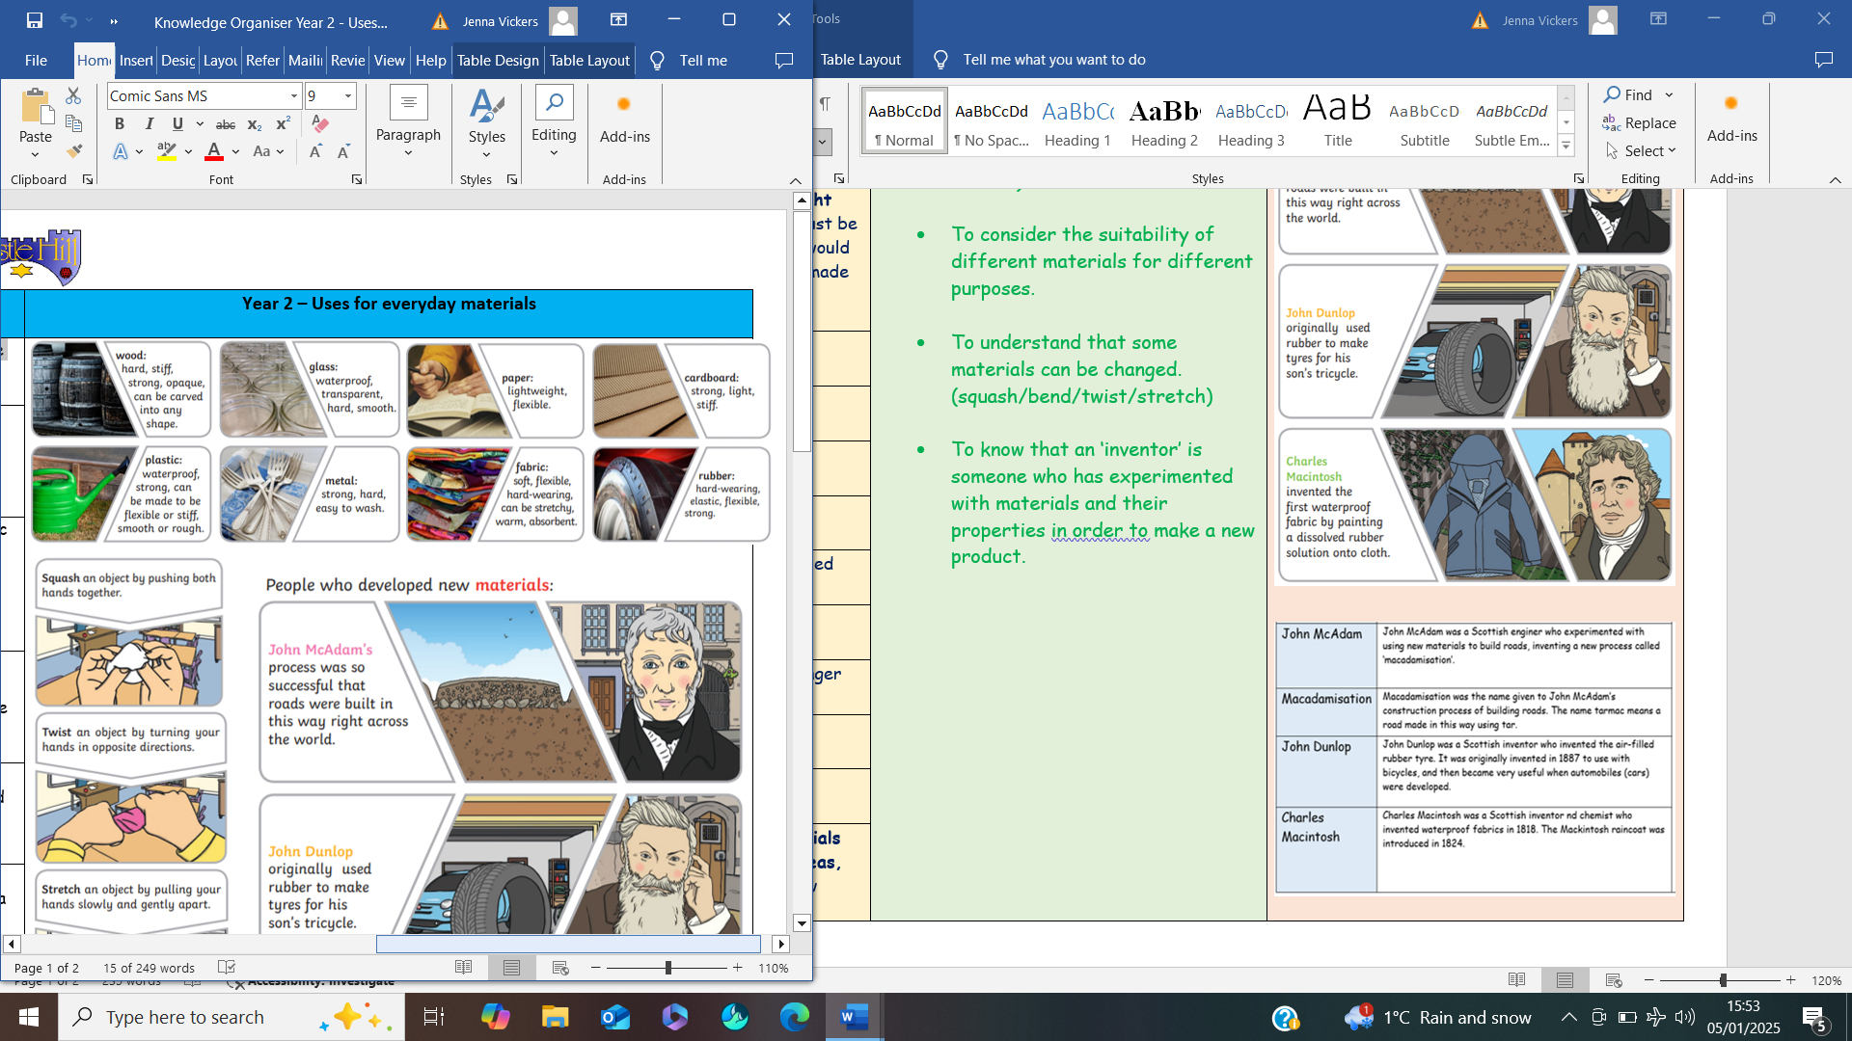  - To describe different materials according to their properties. (glass is…...hard, transparent, smooth)  - To consider the suitability of different materials for different purposes.  - To understand that some materials can be changed. (squash/bend/twist/stretch)  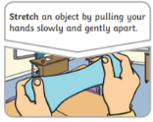  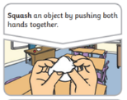  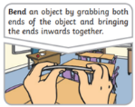  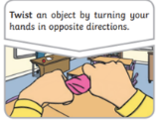  - To know that an ‘inventor’ is someone who has experimented with materials and their properties in order to make a new product. | Nice to know knowledge:  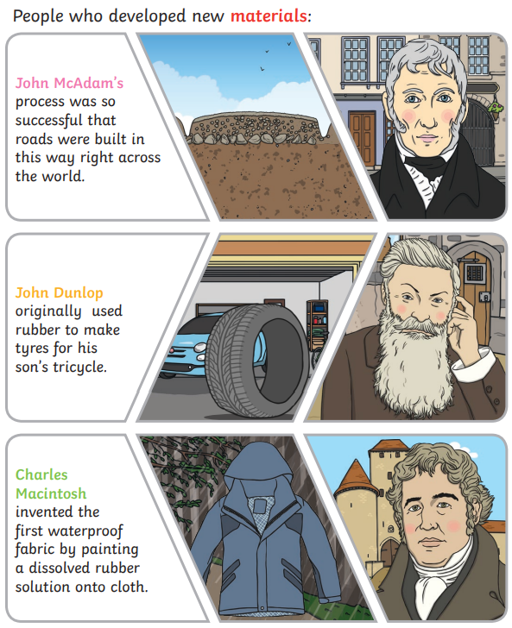  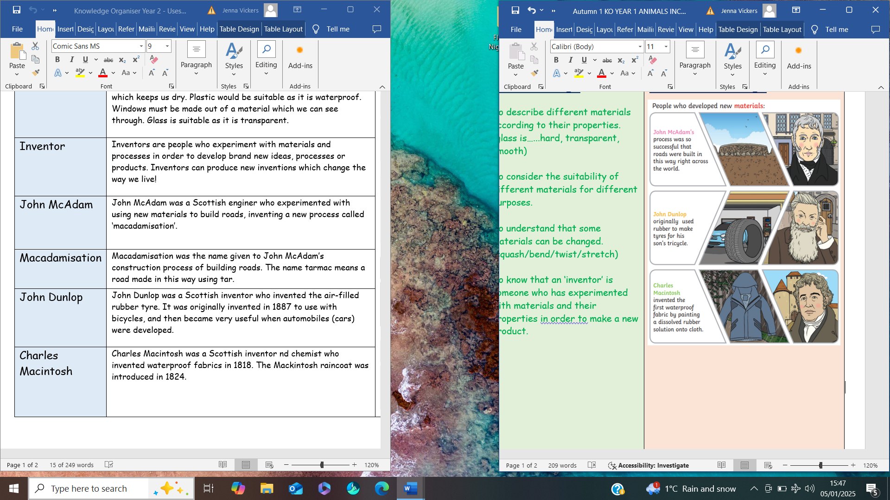
properties | Each material has different properties to distinguish one from another. Properties describe what a material is like and how it behaves. Examples of properties are soft, smooth, bendy or waterproof.
suitability | Suitability means having properties which are right for a specific purpose. For example; umbrellas must be made from a material which keeps us dry. Plastic would be suitable as it is waterproof. Windows must be made from a material which we can see through. Glass is suitable as it is transparent.
compare | To look closely at two or more objects to find similarities and/or differences.
flexible | Objects are known to be flexible when their shape can be changed by bending, stretching or twisting without breaking.
change | An act or process through which something becomes different.
squash | To crush or squeeze an object with force, by pushing both hands together, so that it becomes flat or out of shape.
bend | The act of bending an object into a curved or folded shape by grabbing both ends and bringing them inwards together.
twist | The act of turning an object in different directions to form a bent, curling, or distorted shape.
stretch | The act of pulling an object in order to make it longer or wider.
recycle | The act of turning rubbish or waste into reusable materials.
investigate | A scientific investigation is a process of finding the answer to a question using various research methods.
inventor | Inventors are people who experiment with materials and processes in order to develop brand new ideas, processes or products. Inventors can produce new inventions which change the way we live!

