  Year 2  Spring 2: Living things and their habitats! |  |  | 
Vocabulary

living | Things that are living have all of the life processes such as moving, breathing, sensing, growing, making babies, getting rid of waste and getting energy from food. | Need to know knowledge:  - To understand that some things are living, some things are dead and some things have never been alive.  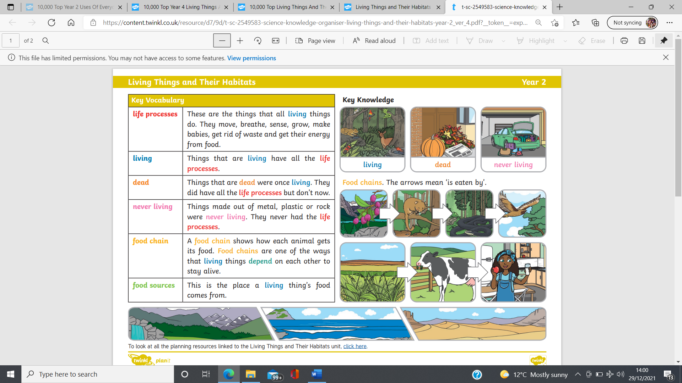  - To know that each living thing has 7 life processes such as all living things ‘breathe’ and ‘move’.  - To know that a habitat is an animal’s home.  - To know that each animal has its own habitat with certain conditions to help it to survive.  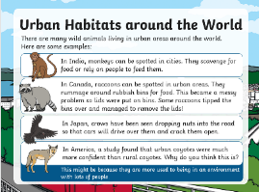  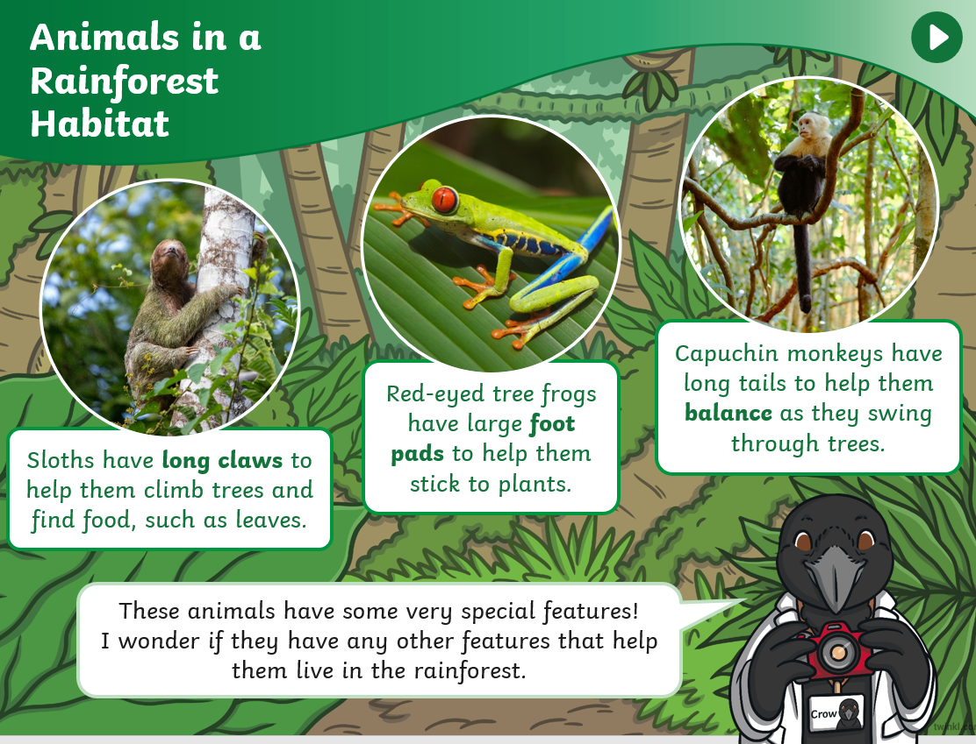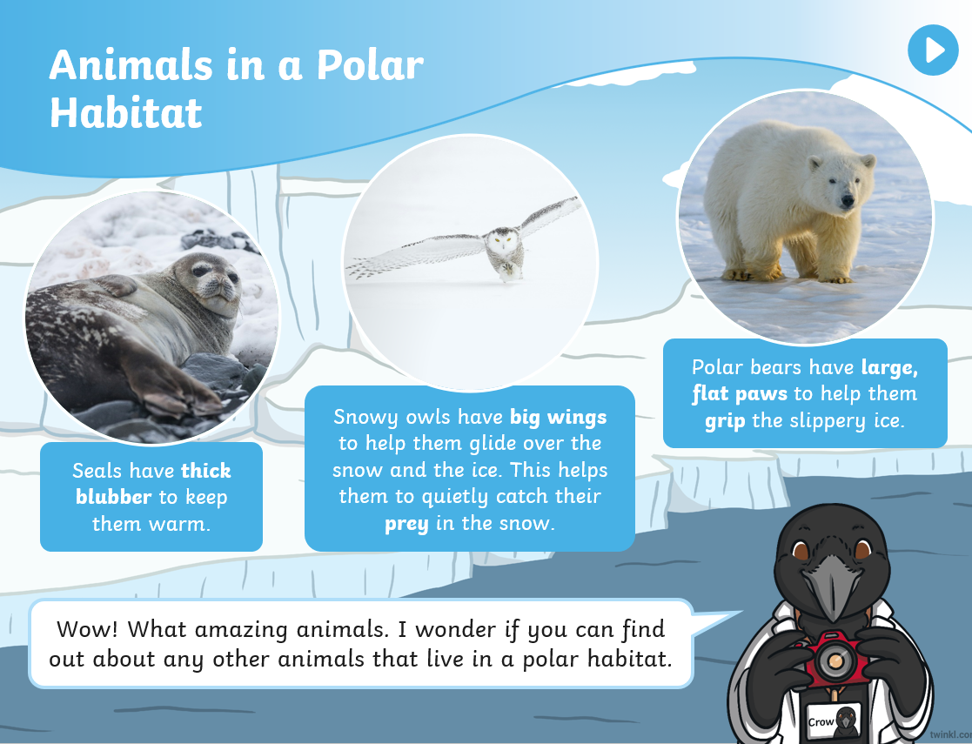  - To know that animals depend on each other to survive and this is called a food chain.  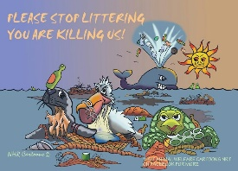  - To begin to identify simple food chains such as ‘grass – cow – human’  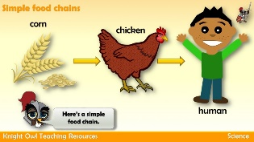  - To know that our environment can pose dangers to living things through change. (litter/ climate change) | Nice to know knowledge:  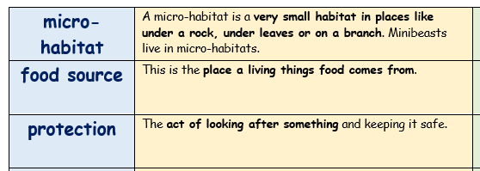  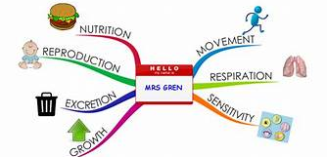  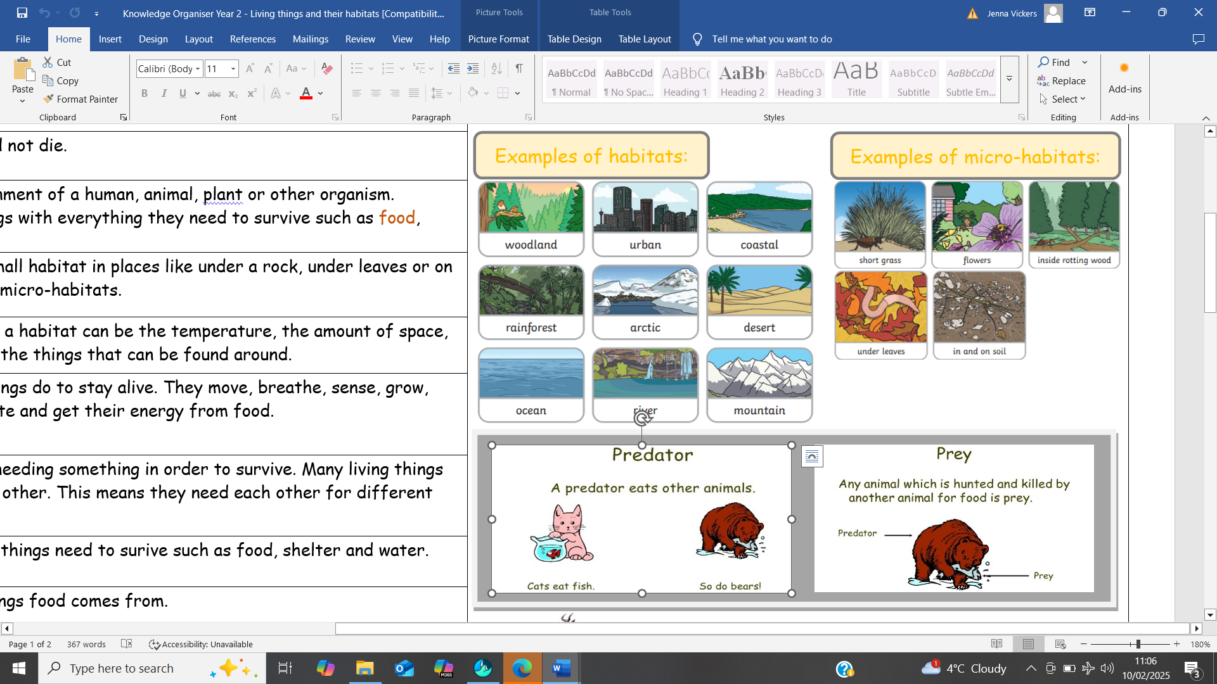  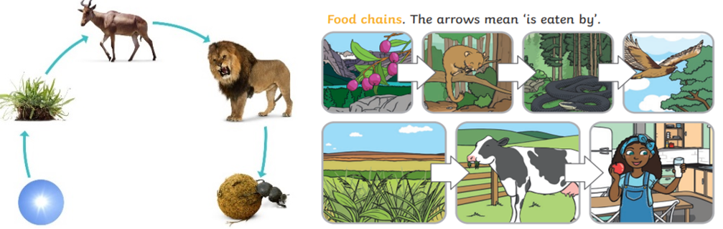
dead | Things that are dead, used to be alive but no longer have all of the life processes to keep them alive and healthy. They can no longer move, breathe, sense, grow, make babies. get rid of waste or get energy from food.
never living | Things made out of materials such as metal, plastic, glass or rock were never living. They never had the life processes.
survive | This means to stay alive and not die.
life processes | The things that all living things do to stay alive. They move, breathe, sense, grow, make babies, get rid of waste and get their energy from food.
basic needs | The basic things that living things need to surive such as food, shelter and water.
habitat | The natural home or environment of a human, animal, plant or other organism. Habitats provide living things with everything they need to survive such as food, shelter and water.
conditions | The different conditions of a habitat can be the temperature, the amount of space, food or water available and the things that can be found around.
depend | Depending on something is needing something in order to survive. Many living things in a habitat depend on each other. This means they need each other for different things.
food chain | A food chain shows how each animal gets its food. Food chains are one of the ways that living things depend on each other to stay alive.
predator | An animal that is hunting for its food, eating other animals.
prey | An animal that is hunted, killed and then eaten by other animals.
danger | The possibility of suffering from harm, injury or even death.

