  Year 2  Summer 1: Plants |  |  | 
Vocabulary
Seeds | The seed is the embryonic stage of the plant life cycle. It is enclosed in a protective outer covering. | Need to know knowledge:  - To know that plants grow from seeds/ beans or bulbs.  - To know that in order to grow healthily, plants need 4 main conditions (sunlight/ water/ soil and the right temperature).  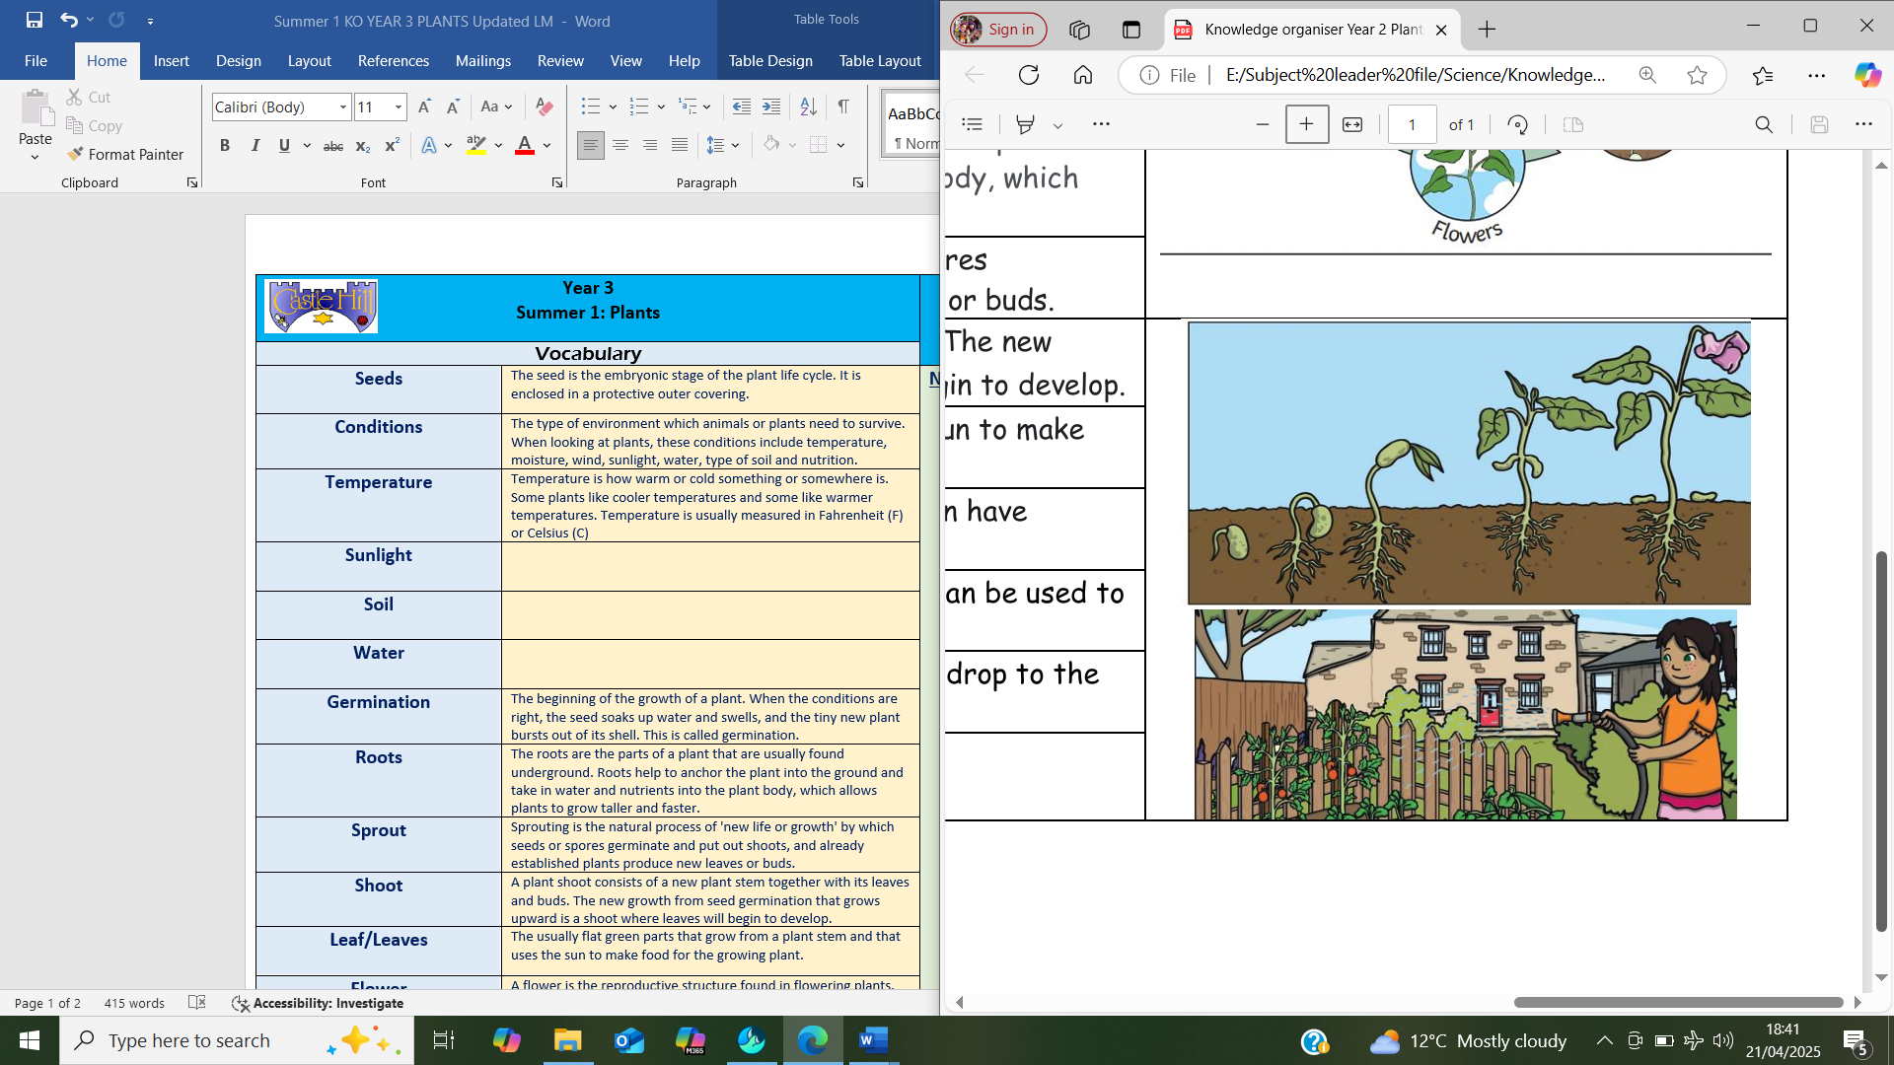  - To understand that if plants are missing any of the above things, they will not grow healthy and will die.  - To begin to discuss, in very simple terms, the lifecycle of a plant. | Nice to know knowledge:  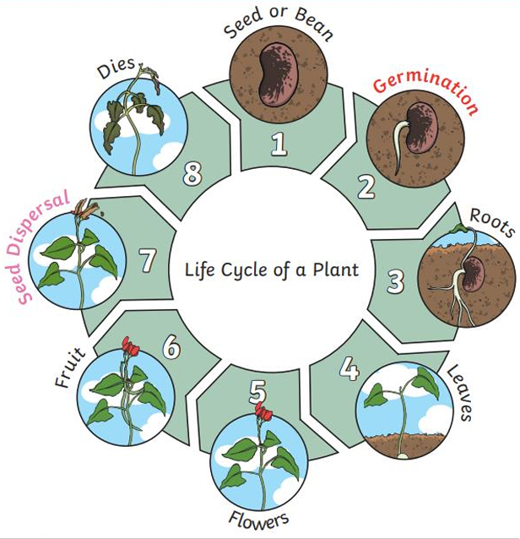  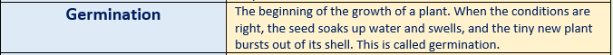  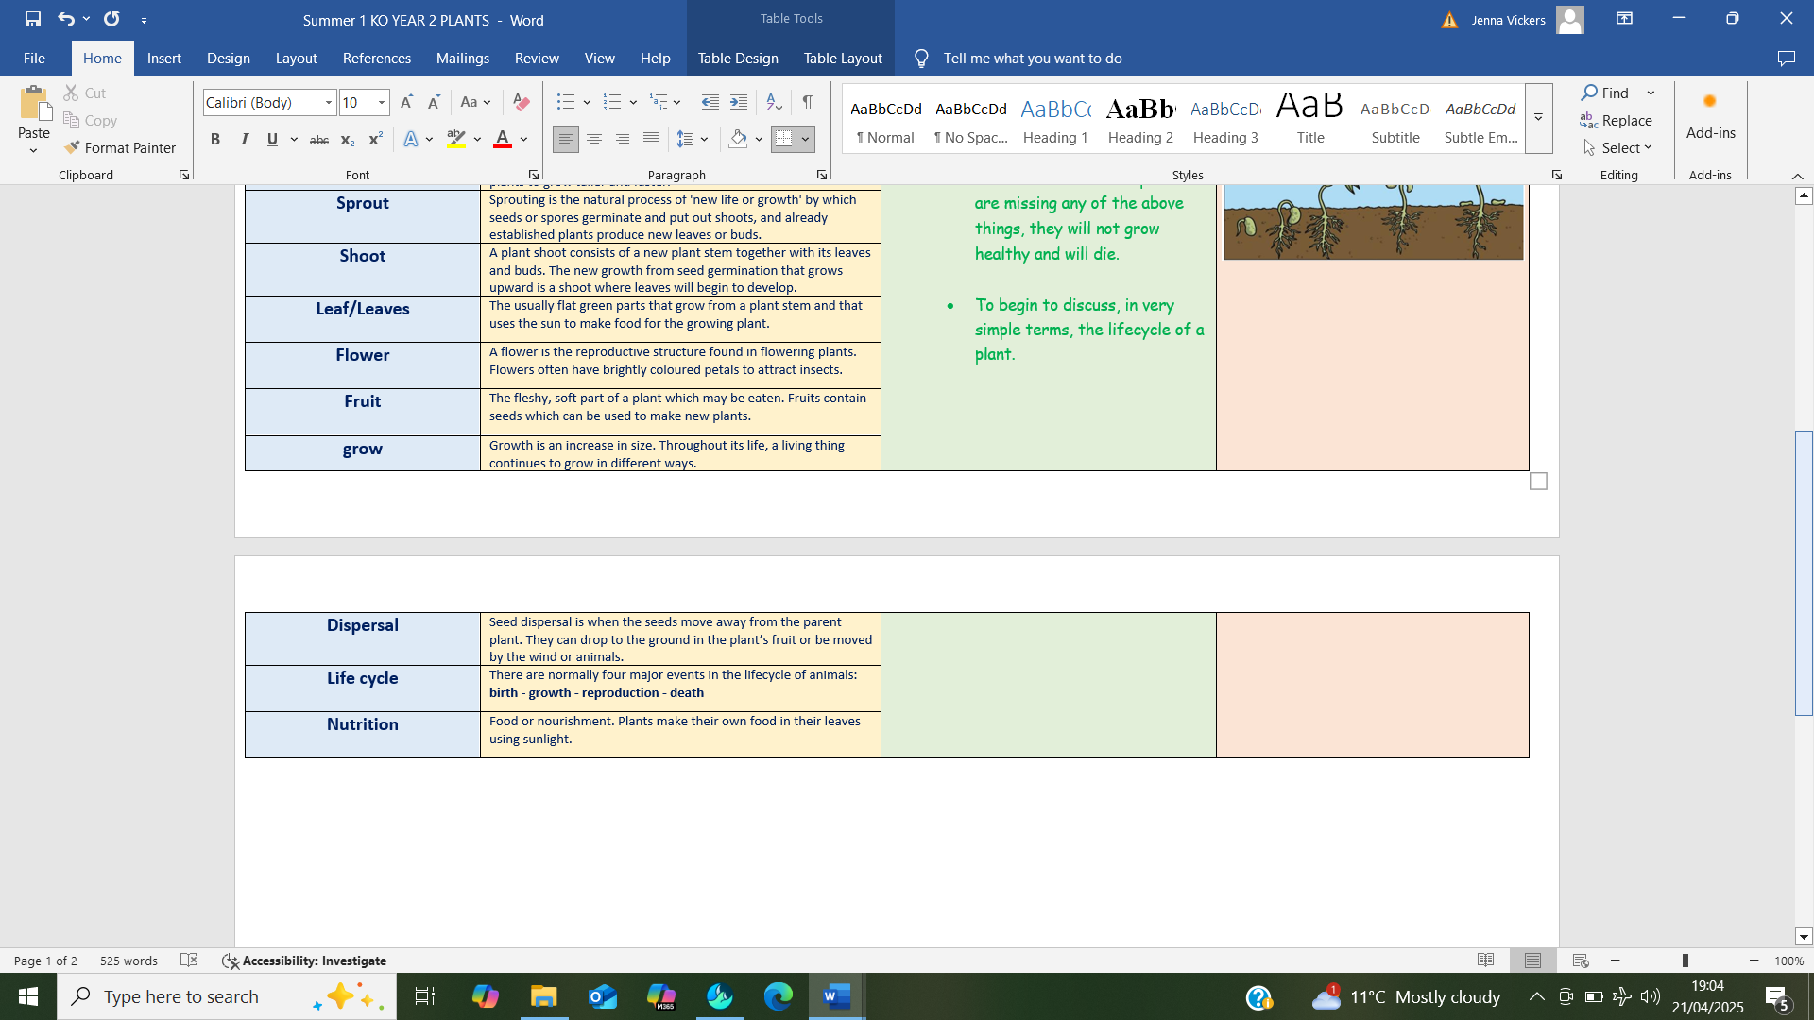
Conditions | The type of environment which animals or plants need to survive. When looking at plants, these conditions include temperature, moisture, wind, sunlight, water, type of soil and nutrition.
Temperature | Temperature is how warm or cold something or somewhere is. Some plants like cooler temperatures and some like warmer temperatures. Temperature is usually measured in Fahrenheit (F) or Celsius (C)
Sunlight | Sunlight is the light and energy that comes from the Sun.
Soil | Soil is a mixture of mineral and organic matter that contains air, water, and micro-organisms. It provides a medium in which plants grow, a habitat for animals, and storage for water.
Water | Water is the most important liquid on Earth. It covers almost 75 percent of Earth’s surface in the form of oceans, rivers, and lakes. All plants and animals need water to live.
Roots | The roots are the parts of a plant that are usually found underground. Roots help to anchor the plant into the ground and take in water and nutrients into the plant body, which allows plants to grow taller and faster.
Sprout | Sprouting is the natural process of 'new life or growth' by which seeds or spores germinate and put out shoots, and already established plants produce new leaves or buds.
Shoot | A plant shoot consists of a new plant stem together with its leaves and buds. The new growth from seed germination that grows upward is a shoot where leaves will begin to develop.
Leaf/Leaves | The usually flat green parts that grow from a plant stem and that uses the sun to make food for the growing plant.
Flower | A flower is the reproductive structure found in flowering plants. Flowers often have brightly coloured petals to attract insects.
Fruit | The fleshy, soft part of a plant which may be eaten. Fruits contain seeds which can be used to make new plants.
grow | Growth is an increase in size. Throughout its life, a living thing continues to grow in different ways.
Life cycle | There are normally four major events in the lifecycle of animals: birth - growth - reproduction - death

