  Year 2  Summer 2: Animals Including Humans! |  |  | 
Vocabulary

Life cycle | The changes living things go through to become an adult. All young animals change as they go through the different stages of their lifecycle and grow into adults. | Need to know knowledge:  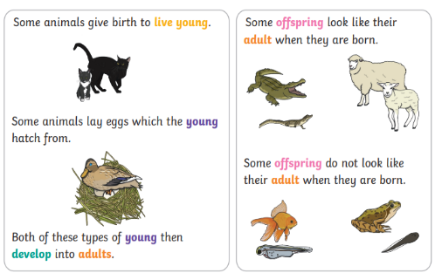  - To know that adult animals have babies and they then grow up and the cycle continues. This is called a lifecycle.  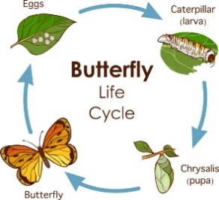  - To name and draw/ order one simple life cycle. E.g. Eggs, caterpillar, chrysalis, butterfly etc.)  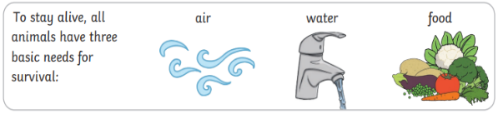  - To know that all living things have basic needs in order to survive. E.g. air, food, water.  - To understand the importance of healthy eating, hygiene and exercise for humans to keep their bodies and minds strong! | Nice to know knowledge:  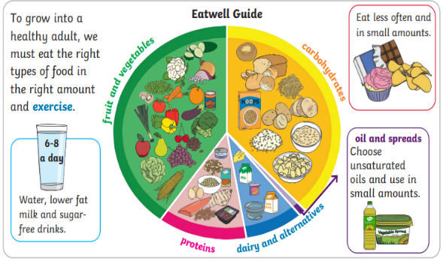  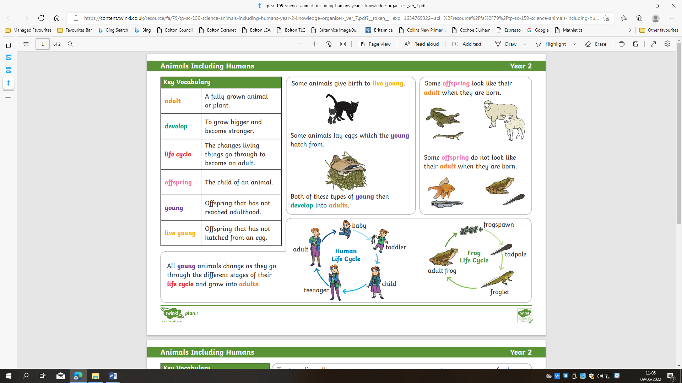  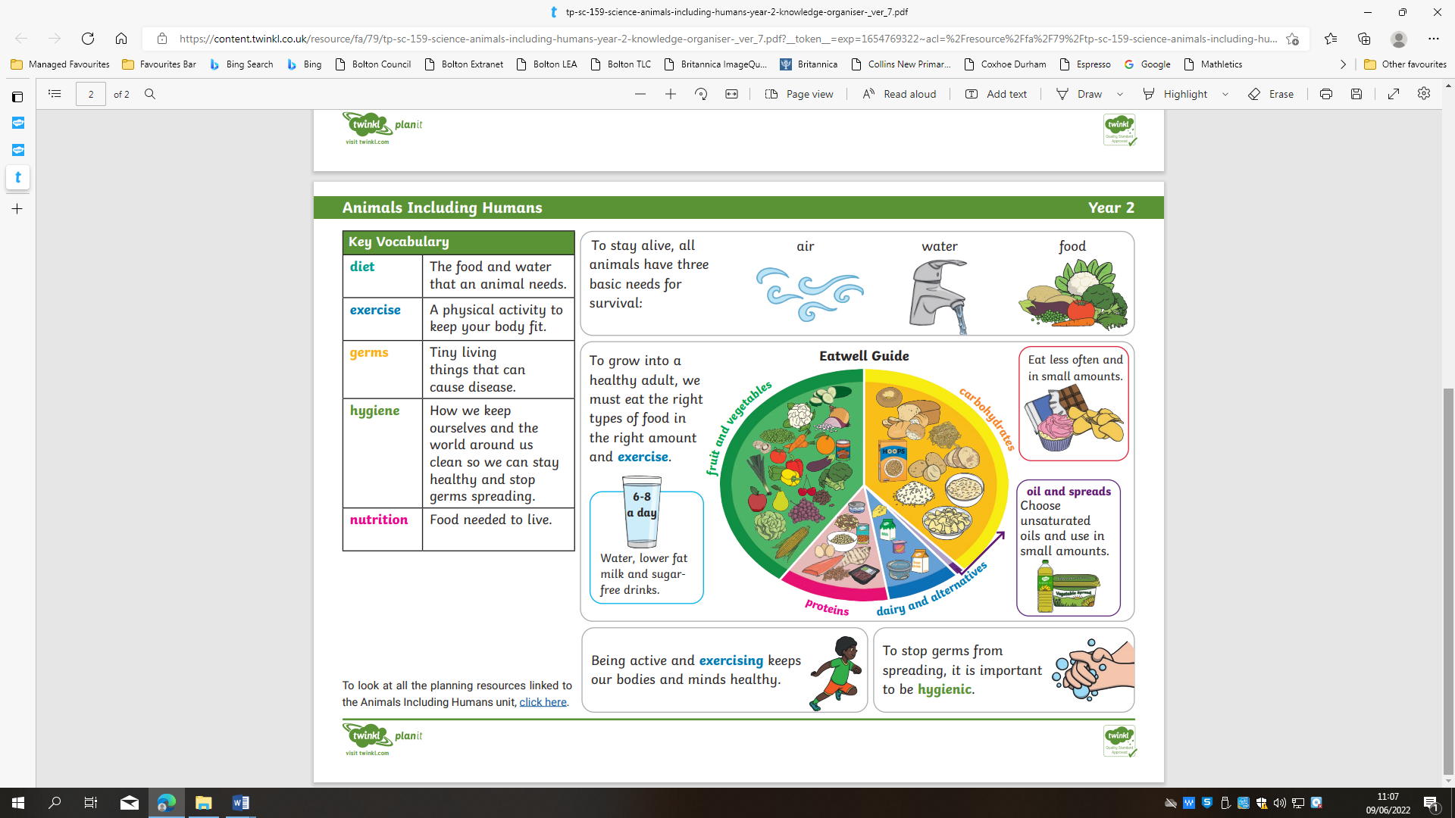
Grow | To grow in size and get bigger.
Change | For something new to happen.
Develop | To grow bigger and become stronger.
Reproduce | To produce new animals or plants.
Adult | A fully grown adult or plant
Offspring | The child of an animal.
Young | Offspring that has not reached adulthood.
Live Young | Offspring that has not hatched from an egg.
Basic Needs | The things that plants or animals need in order to survive.
Energy | The power needed to enable something to do work.
Survival | The ability to live on.
Exercise | A physical activity to keep your body fit.
Hygiene | How we keep ourselves and the world around us clean so we can stay healthy and stop germs spreading.
Nutrition | The food materials that enable them to grow, maintain themselves, and reproduce.
Diet | The food and water that an animal needs.

