  Year 3  Spring 1: Light! |  |  | 
Vocabulary

light | A form of energy that travels in a wave from a source. | Need to know knowledge:  - To understand that a ‘light source’ is an object that makes its own light.  - To know that light travels in a wave from a source.  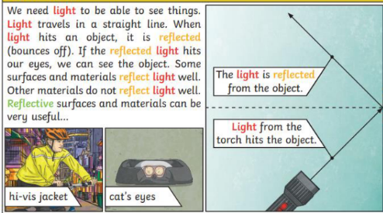  - To understand that ‘reflection’ is where light hits the surface of an object and bounces back into our eyes.  - To know that dark is the absence of light.  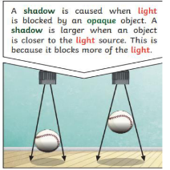  - Two know that shadows are formed when an opaque object blocks the light from travelling further.  - To know that:  - Transparent objects let light travel through them easily like a window. We can ‘see through’ them.  - Opaque objects block light and we cannot see through them. | Nice to know knowledge:  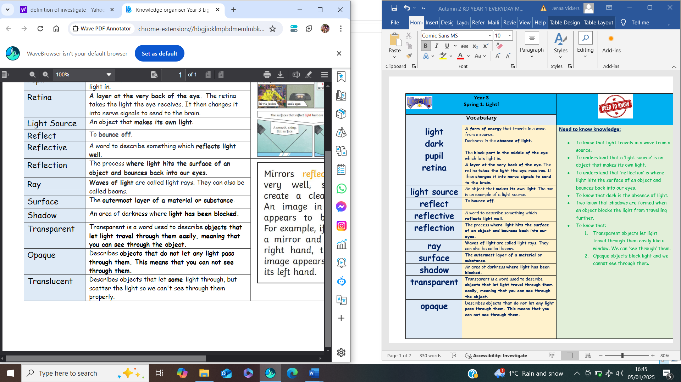  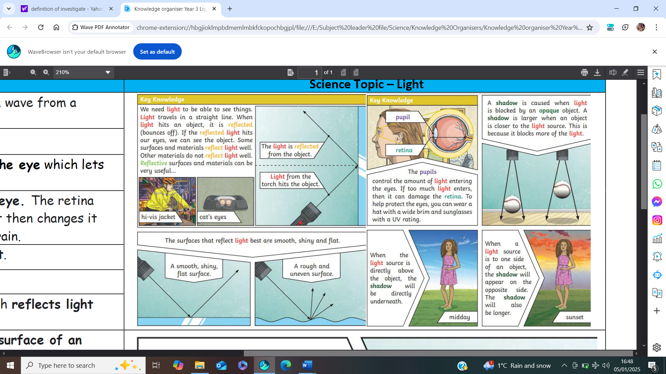  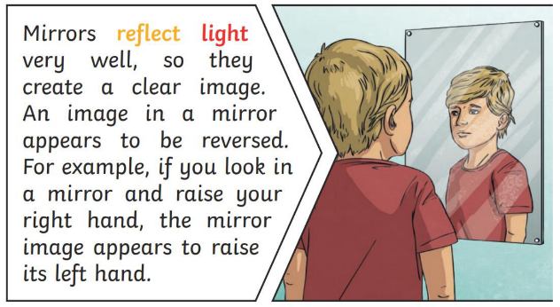
dark | Darkness is the absence of light.
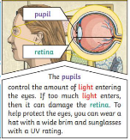  pupil | The black part in the middle of the eye which lets light in.
retina | A layer at the very back of the eye. The retina takes the light the eye receives. It then changes it into nerve signals to send to the brain.
light source | An object that makes its own light. The sun is an example of a light source.
reflect | To bounce off.
reflective | A word to describe something which reflects light well.
reflection | The process where light hits the surface of an object and bounces back into our eyes.
ray | Waves of light are called light rays. They can also be called beams.
surface | The outermost layer of a material or substance.
shadow | An area of darkness where light has been blocked.
transparent | Transparent is a word used to describe objects that let light travel through them easily, meaning that you can see through the object.
opaque | Describes objects that do not let any light pass through them. This means that you can not see through them.

