  Year 3  Summer 1: Plants |  |  | 
Vocabulary
Nutrients | They help the plant to grow and be healthy. | Need to know knowledge:  - Know that plants and flowers have lifecycles and describe their lifecycle using these words:  - Pollination  - Fertilisation  - Germination  - Growing  - Seed dispersal  - Know that germination is when seeds start to grow.  - Know that pollination is when pollen is moved from the male part of the flower to the female part of the flower.  - Know that fertilisation is when the pollen (male) and egg (female) have fused together to make a new seed.  - Know that seed dispersal is when the seeds are moved away from the parent plant to its own space. | Nice to know knowledge:  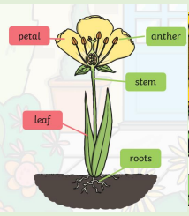  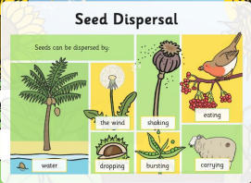
Transportation | The moving of nutrients and water through the plant.
Dispersal | The spreading of seeds.
Pollination | Pollen is rubbed onto another flower and fertilises it.
Flower | The part of the plant that has petals. This is where seeds are made.
Roots | The roots suck up nutrients in the soil and hold the plant in place so that it stays still.
Petal | The outer part of the flower which contains bright colours to attract insects.
Stem | The structure which holds the plant up and carries nutrients to the leaves.
Anther | This is the male part of the plant which contains pollen.
Carbon dioxide | A gas plants use to make food.
Absorb | Plants suck up and take in water and nutrients to help them grow.
Soil | A brown mixture of rocks, water and nutrients. This is where plants grow.

