  Year 3  Summer 2: Animals including humans! |  |  | 
Vocabulary

Human | A type of animal. We are humans. | Need to know knowledge:  - To know that we are humans. Humans are part of the animal kingdom and we come under the category of mammals.  - To know that nutrition is the diet that living things need to stay alive and healthy.  - To understand that a skeleton is a system of bones that serves as the framework of the body of an animal.  - To know that skeletons have important jobs such as protecting our organs, allowing movement and supporting our bodies so that we don’t flop to the floor.  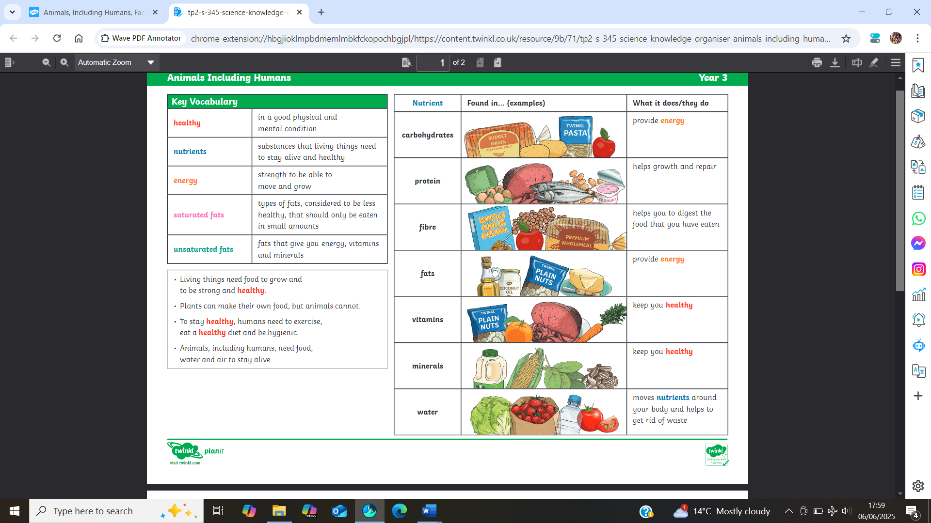  - To know that muscles are soft tissues in the body that help us to move. | Nice to know knowledge:  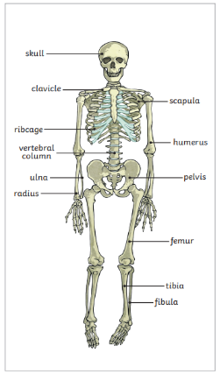  Skeletons do three important jobs:  • protect organs inside the body  • allow movement  • support the body and stop it from falling on the floor.  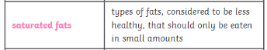  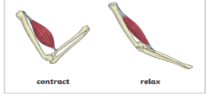  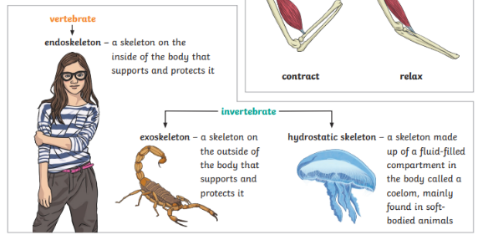  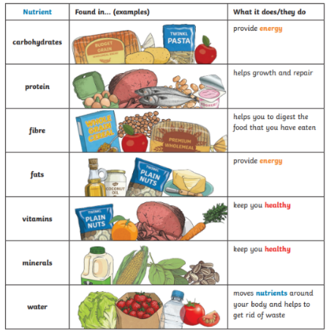
Healthy | To be in in a good physical and mental condition.
Nutrition/ nutrients | The substances that living things need to stay alive and healthy.
Energy | The strength needed to survive, move and grow.
Balanced diet | A diet that contains the correct proportions of carbohydrates, fats, proteins, vitamins, minerals, fats and water to maintain good health.
Sugar | A sweet tasting substance.
Fruit and vegetables | Healthy foods which grow naturally from the ground.
Skeleton | A system that serves as the framework of the body of an animal.
Bones | The hard calcified tissues that make up the skeleton.
Joints | The areas where two or more bones are fitted together.
Vertibrates | Animals with backbones.
Invertibrates | Animals without backbones.
Support | To provide help.
Protection | To keep something safe.
Skull | The part of the skeleton inside the head.
Muscles | The soft tissues in the body that contract and relax to cause movement.
Contract and relax | Skeletal muscles work in pairs to move the bones they are attached to by taking turns to contract (get shorter) and relax (get longer).

