  Year 3  Autumn 2: Forces and Magnets! |  |  | 
Vocabulary

force | Pushes and pulls are forces. They are actions that cause other objects to move, speed up, slow down or stop. | Need to know knowledge:  - To know that forces are actions that make other objects move, change speed or stop.  - To understand that pushes and pulls are examples of forces and demonstrate using these forces to move objects.  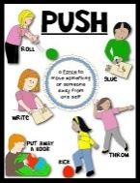  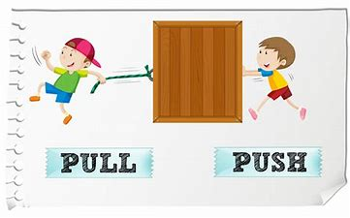  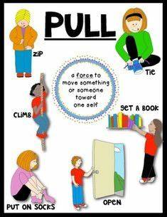  - To know that a magnet is an object which produces a magnetic force around it.  - To understand that this magnetic force can push or pull objects around it.  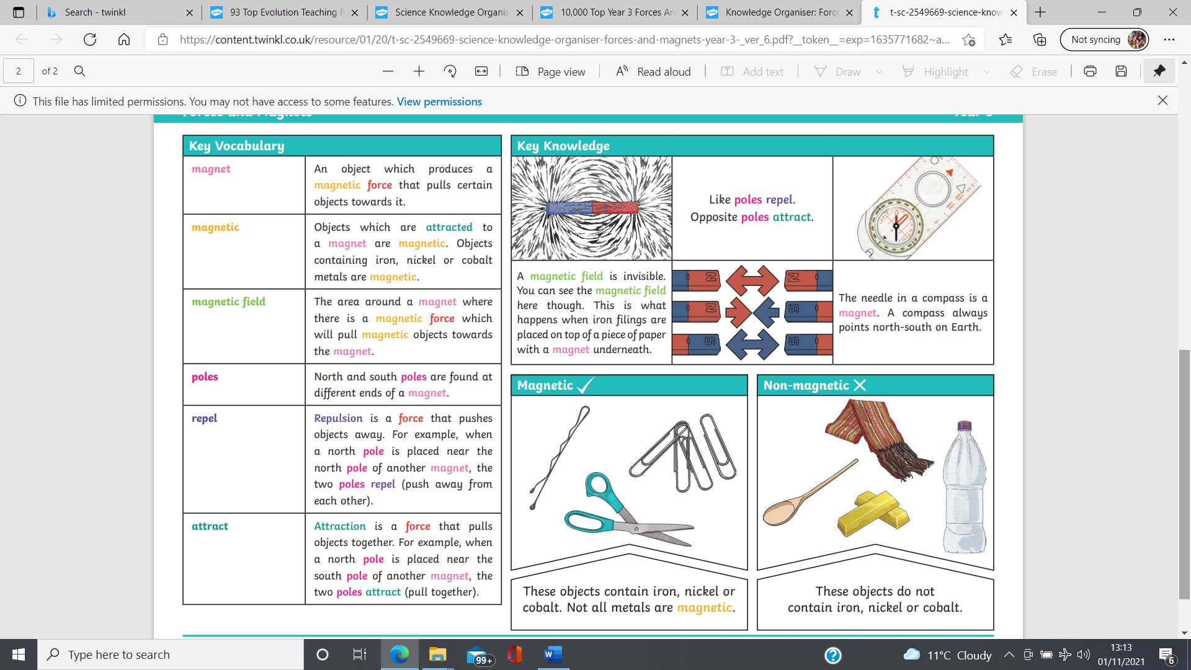  - To begin to explain how magnets can attract objects by pulling them closer or repel objects by pushing them away. | Nice to know knowledge:  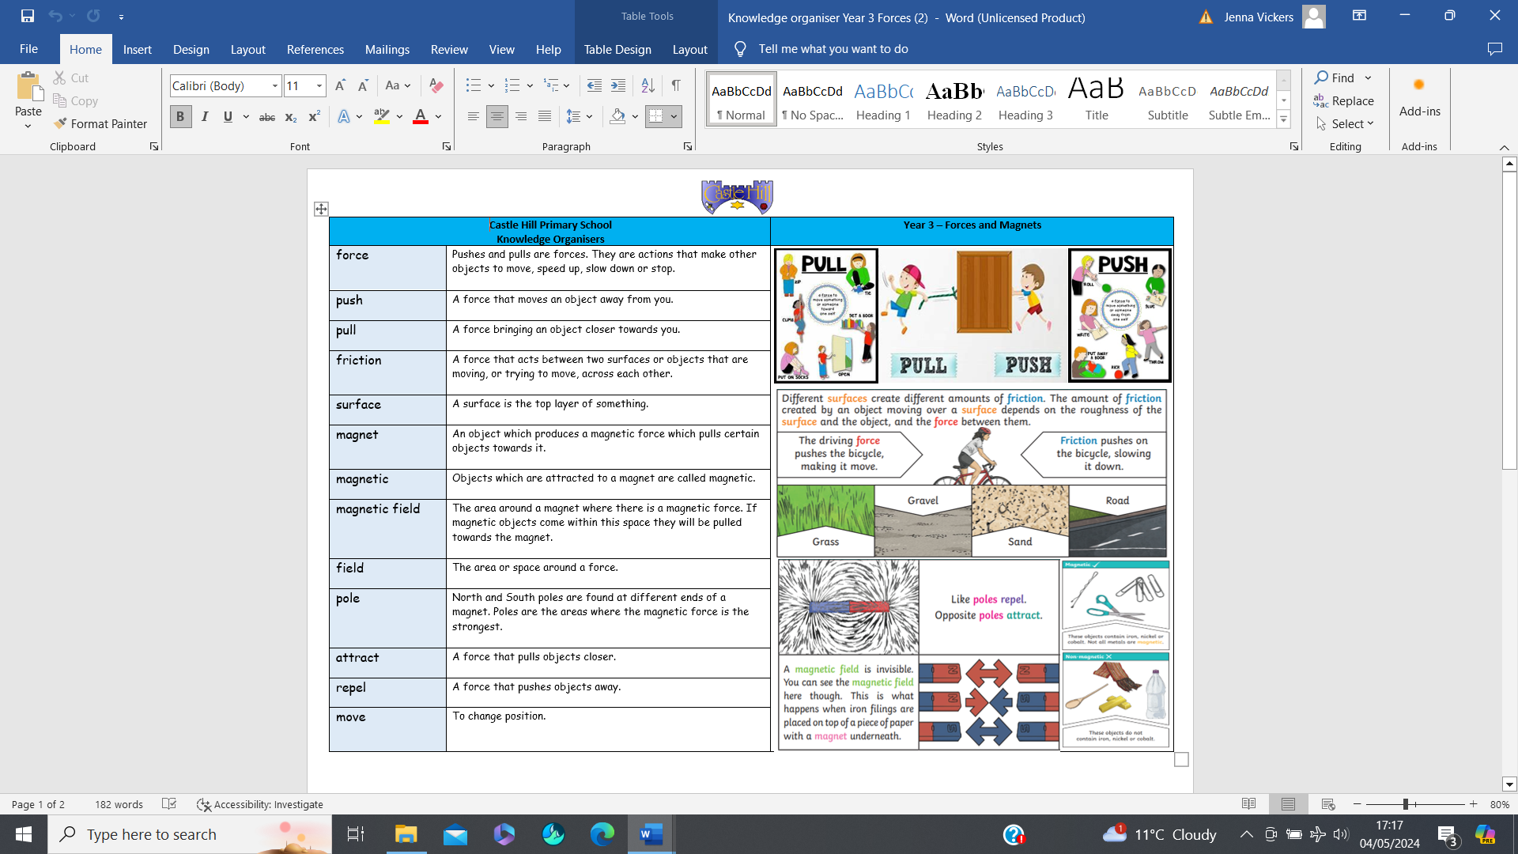  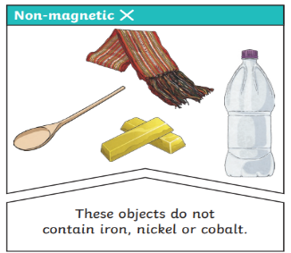  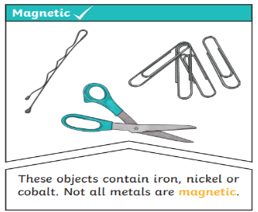
push | A force that moves an object away from you.
pull | A force that brings an object closer towards you.
magnet | An object which produces a magnetic force which pulls certain objects towards it.
magnetic | Objects which are attracted to a magnet are called ‘magnetic’.
attract | A force that pulls objects closer.
repel | A force that pushes objects away.
move | To change position.
magnetic field | The area around a magnet where there is a magnetic force. If magnetic objects come within this space, they will be pulled towards the magnet.
field | The area or space around a force.

