  Year 4  Autumn 2: Electricity! |  | 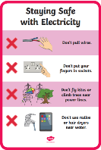   | 
Vocabulary

electricity | The flow of an electric current through a material. For example, this is often from a power source, through wires, to an appliance. | Need to know knowledge:  - To identify common appliances which run on electricity and to understand that appliances can work using mains electricity (plug sockets and wires) or batteries.  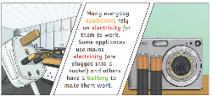  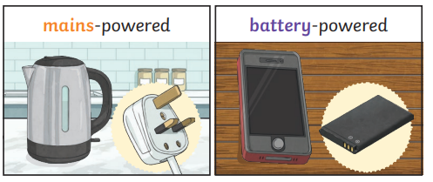  - To know that electricity is the flow of an electric current from a power source to an appliance.  - To know that a battery is a device which stores electrical energy inside it so that appliances can work without plugging it into mains sockets using wires.  - To know that an electric circuit is a pathway that electricity can flow round freely without being stopped. Allowing the electricity to go from the power source to the appliance making it work.  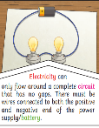  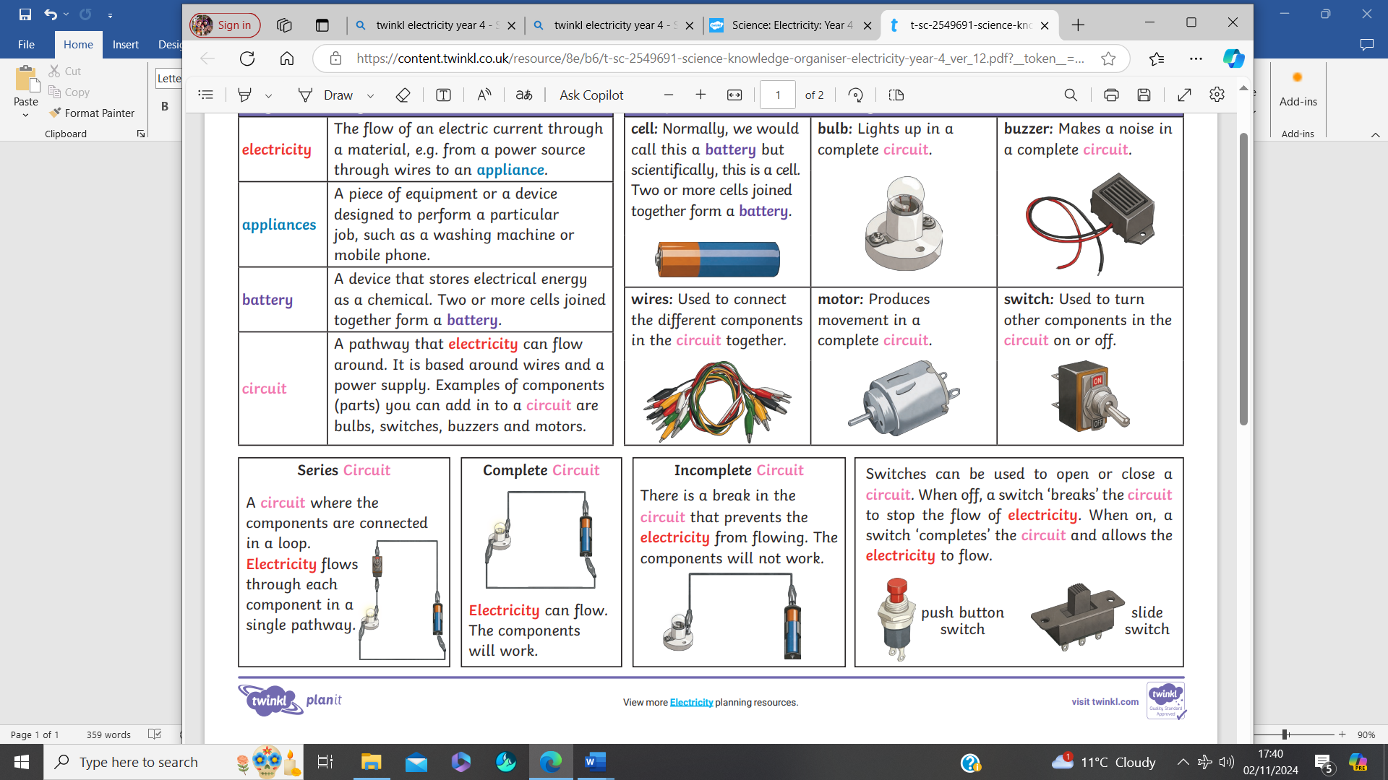  - To understand that appliances stop working if a circuit is broken. To know that a ‘switch’ can be used to make or break the connection in an electrical circuit, turning things on and off.  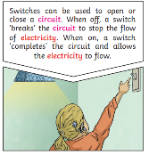 | 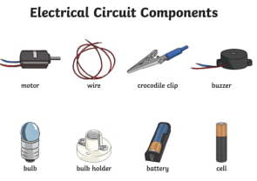  Circuit symbols  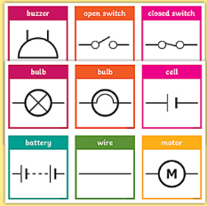  Nice to know knowledge:  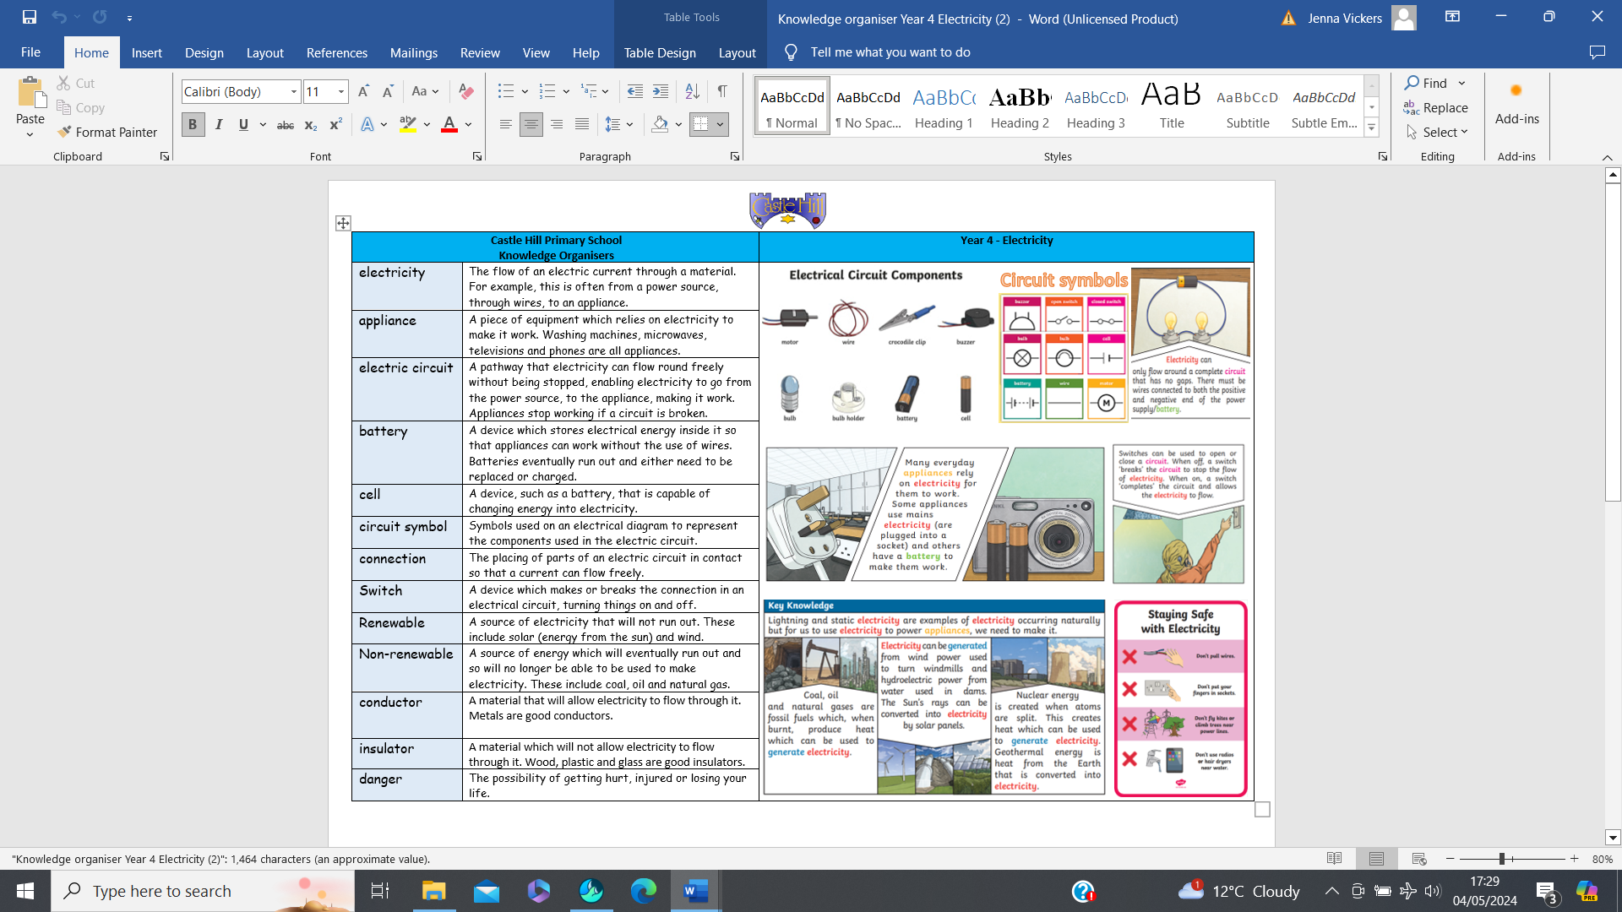  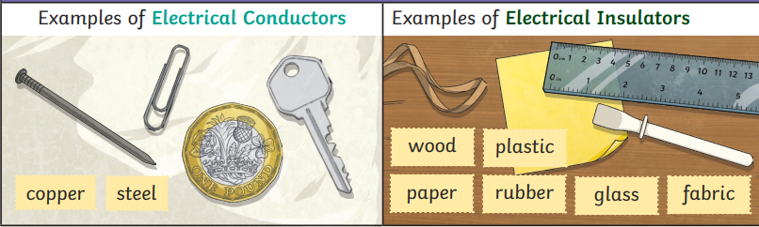  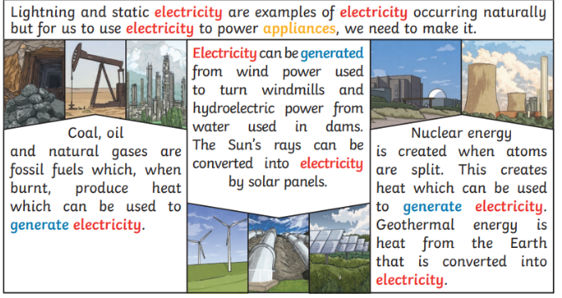
appliance | A piece of equipment which relies on electricity to make it work. Washing machines, microwaves, televisions and phones are all appliances.
mains electricity | Electricity supplied to a building through wires.
battery | A device which stores electrical energy inside it so that appliances can work without the use of wires. Batteries eventually run out and either need to be replaced or charged.
cell | A device, such as a battery, that is capable of changing energy into electricity.
electric circuit | A pathway that electricity can flow round freely without being stopped, enabling electricity to go from the power source, to the appliance, making it work. Appliances stop working if a circuit is broken.
electric current | The flow of electricity in an electronic circuit.
circuit symbol | Symbols used on an electrical diagram to represent the components used in the electric circuit.
connection | The placing of parts of an electric circuit in contact so that a current can flow freely.
switch | A device which makes or breaks the connection in an electrical circuit, turning things on and off.
danger | The possibility of getting hurt, injured or losing your life.

