  Year 4  Spring 2: Living things and their habitats! |  | 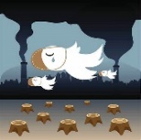   | 
Vocabulary

classification | The process of sorting plants or animals into different groups in accordance to their characteristics, by looking closely at their similarities or differences. | Need to know knowledge:  - To know that the term ‘classification’ is the process of sorting things into different groups in accordance to their characteristics.  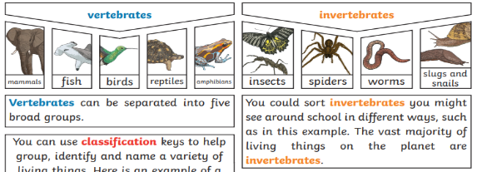  Animals can be grouped in lots of different ways by looking at how they are similar or different.  - To know that the term ‘environment’ refers to the place or conditions in which a human, animal or plant lives.  - To understand that environments can be changed by both natural causes (earthquakes/storms/ floods/ draughts/ wildfire) and by humans (deforestation/pollution/ litter).  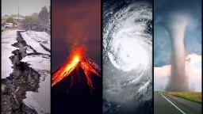  Changes to an environment can be natural or caused by humans. Examples include:  Natural: earthquakes, storms, floods. Draughts, wildfires, the seasons  Human-made: deforestation, pollution, urbanisation, the introduction of a new animal or plant species to an environment.  Plants and animals rely on their environment to give them everything they need. Therefore, when habitats change, it can be very dangerous to the plants and animals that live there:  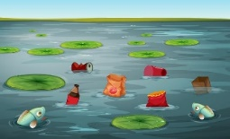  - To begin to talk in greater detail about the 7 life processes, building on our learning from year 2 (MRS GREN).  - To know that some animals have a backbone, these are called ‘vertebrates’. To know that some animals do not have a backbone and these are called ‘invertebrates’. | Nice to know knowledge:  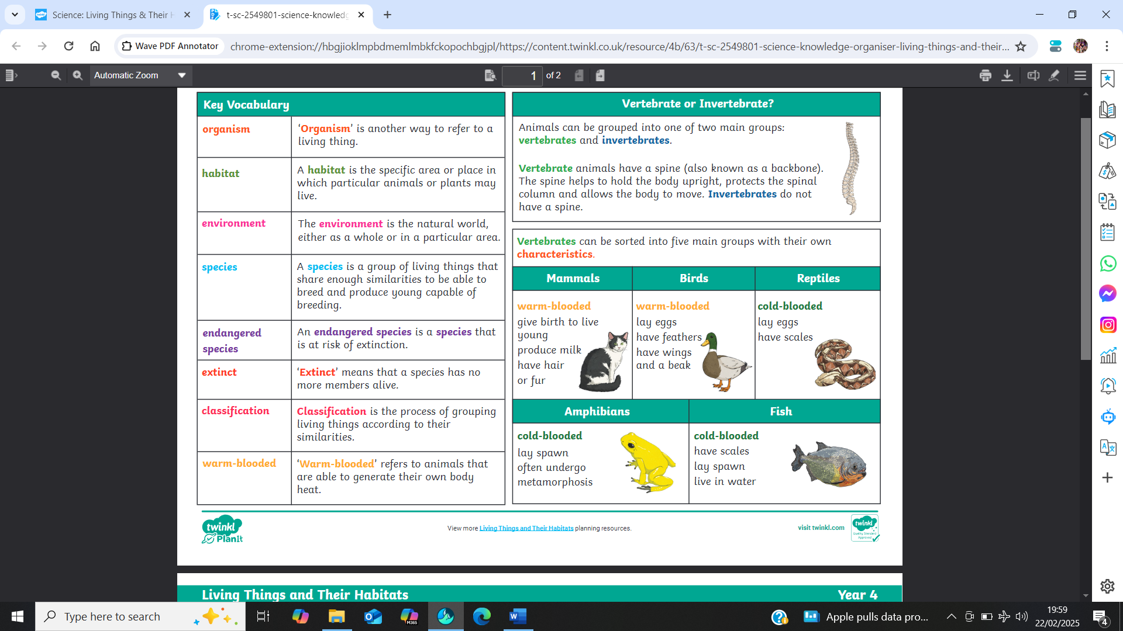  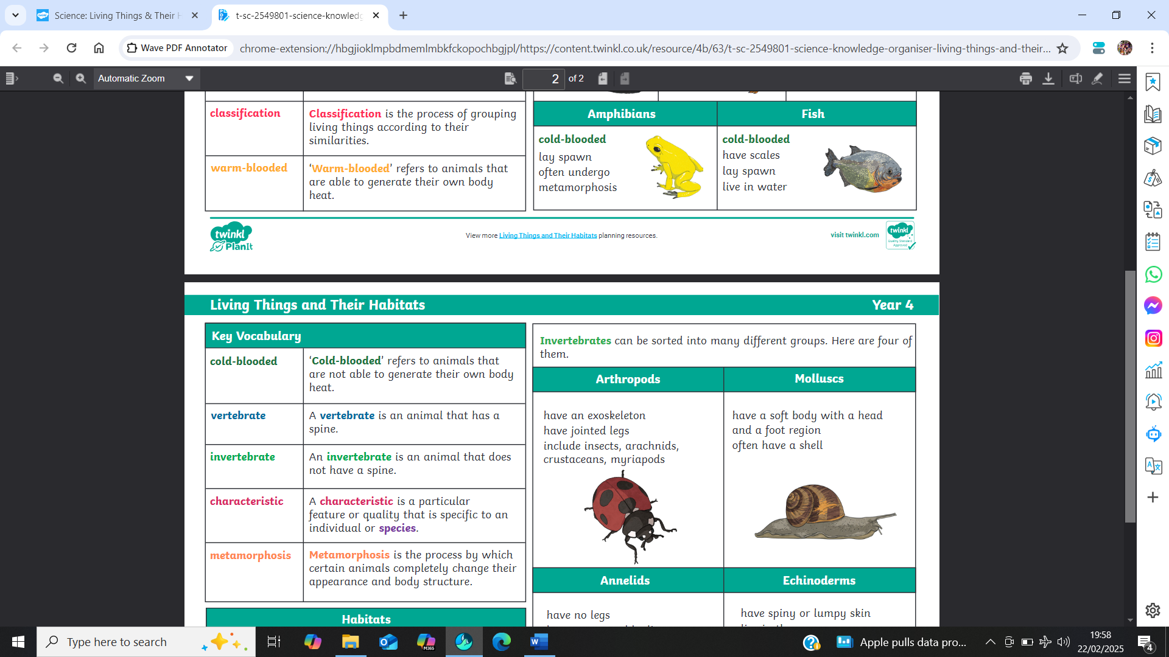  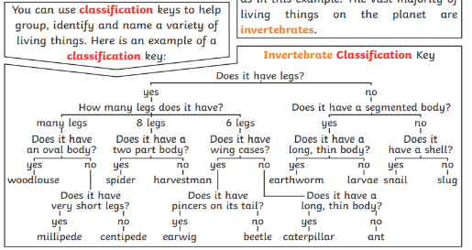  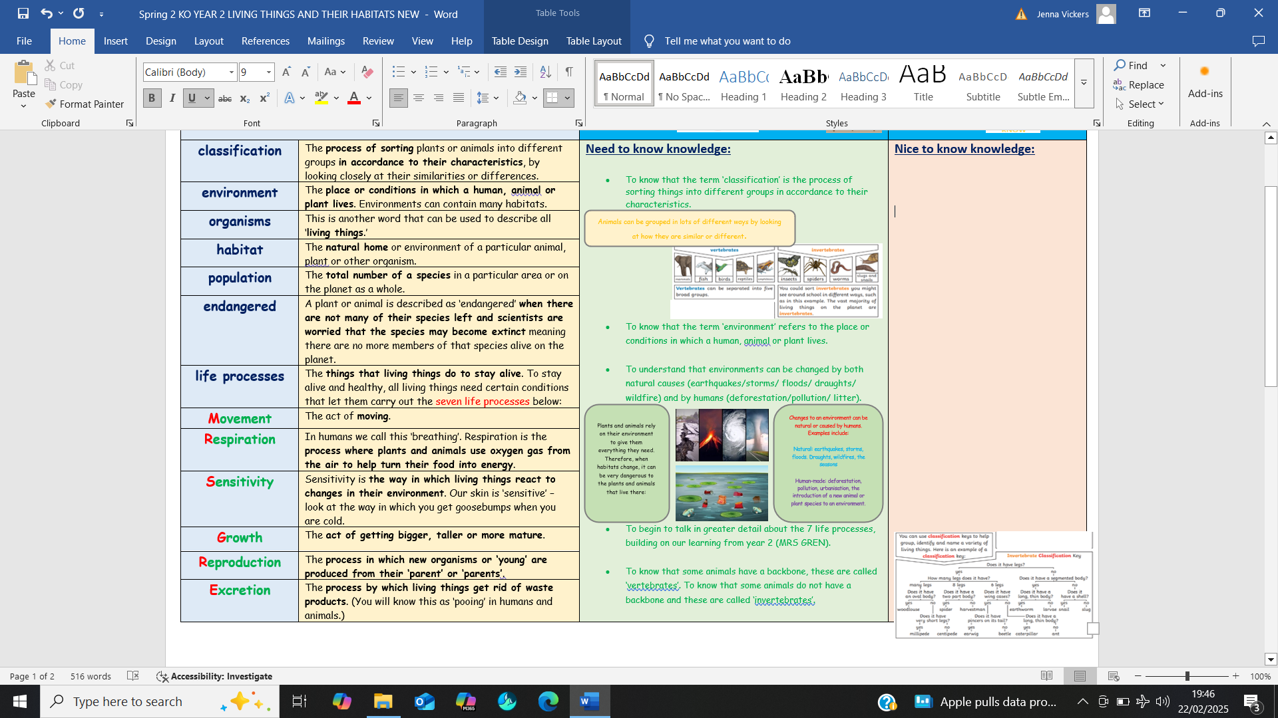  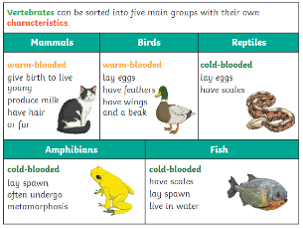  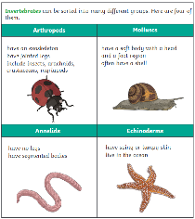
characteristics | Particular features or qualities that are specific to an individual or species.
environment | The place or conditions in which a human, animal or plant lives. Environments can contain many habitats.
habitat | The natural home or environment of a particular animal, plant or other organism.
endangered | A plant or animal is described as ‘endangered’ when there are not many of their species left and scientists are worried that the species may become extinct meaning there are no more members of that species alive on the planet.
life processes | The things that living things do to stay alive. To stay alive and healthy, all living things need certain conditions that let them carry out the seven life processes below:
Movement | The act of moving.
Respiration | In humans we call this ‘breathing’. Respiration is the process where plants and animals use oxygen gas from the air to help turn their food into energy.
Sensitivity | Sensitivity is the way in which living things react to changes in their environment. Our skin is ‘sensitive’ – look at the way in which you get goosebumps when you are cold.
Growth | The act of getting bigger, taller or more mature.
Reproduction | The process in which new organisms or ‘young’ are produced from their ‘parent’ or ‘parents’.
Excretion | The process by which living things get rid of waste products. (You will know this as ‘pooing’ in humans and animals.)
Nutrition | The process of obtaining (getting) food to provide living things with the energy to live and stay healthy.
vertibrate | An animal with a backbone (spine).
invertibrate | An animal without a backbone (spine).

