  Year 4  Summer 1: Animals including humans! |  |  | 
Vocabulary

human | Us! A group of ground dwelling mammals who walk upright, are tailless, can communicate through speech and use our hands to complete day to day tasks. | Need to know knowledge:  - To understand that teeth are bones set in sockets in the jaws of animals and they help us to eat (chewing and biting) and also to articulate speech.  - To know that there are different types of human teeth for different purposes:  - Incisors help to bite and cut food.  - Canines help to rip and tear.  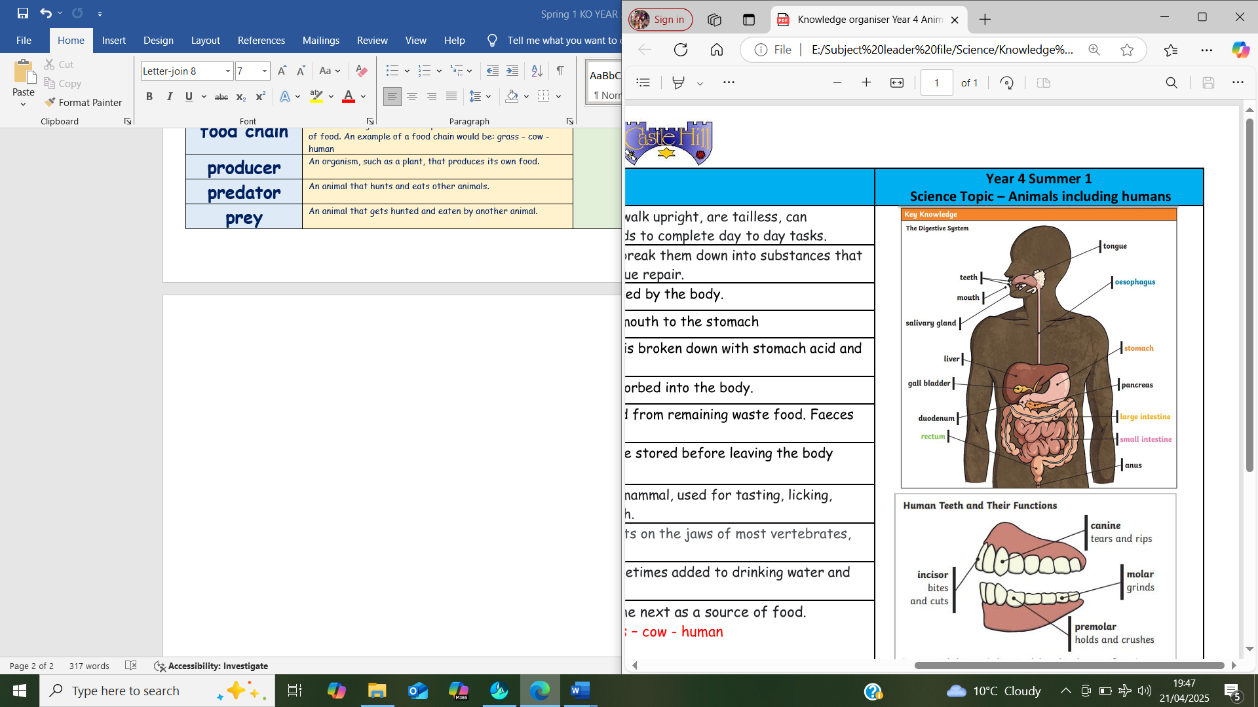  - Molars help to crush and grind food before swallowing.  - To know that within food chains we have:  - Producers (animals or plants that make their own food).  - Predators (animals that hunt for food – often carnivores)  - Prey (animals that are hunted – often herbivores, omnivores or smaller carnivores)  - To understand that digestion is the act of breaking down the food that we eat so it can be turned into energy.  - To know that the digestive system consists of organs that move and break down the food as it passes through our body. | Nice to know knowledge:  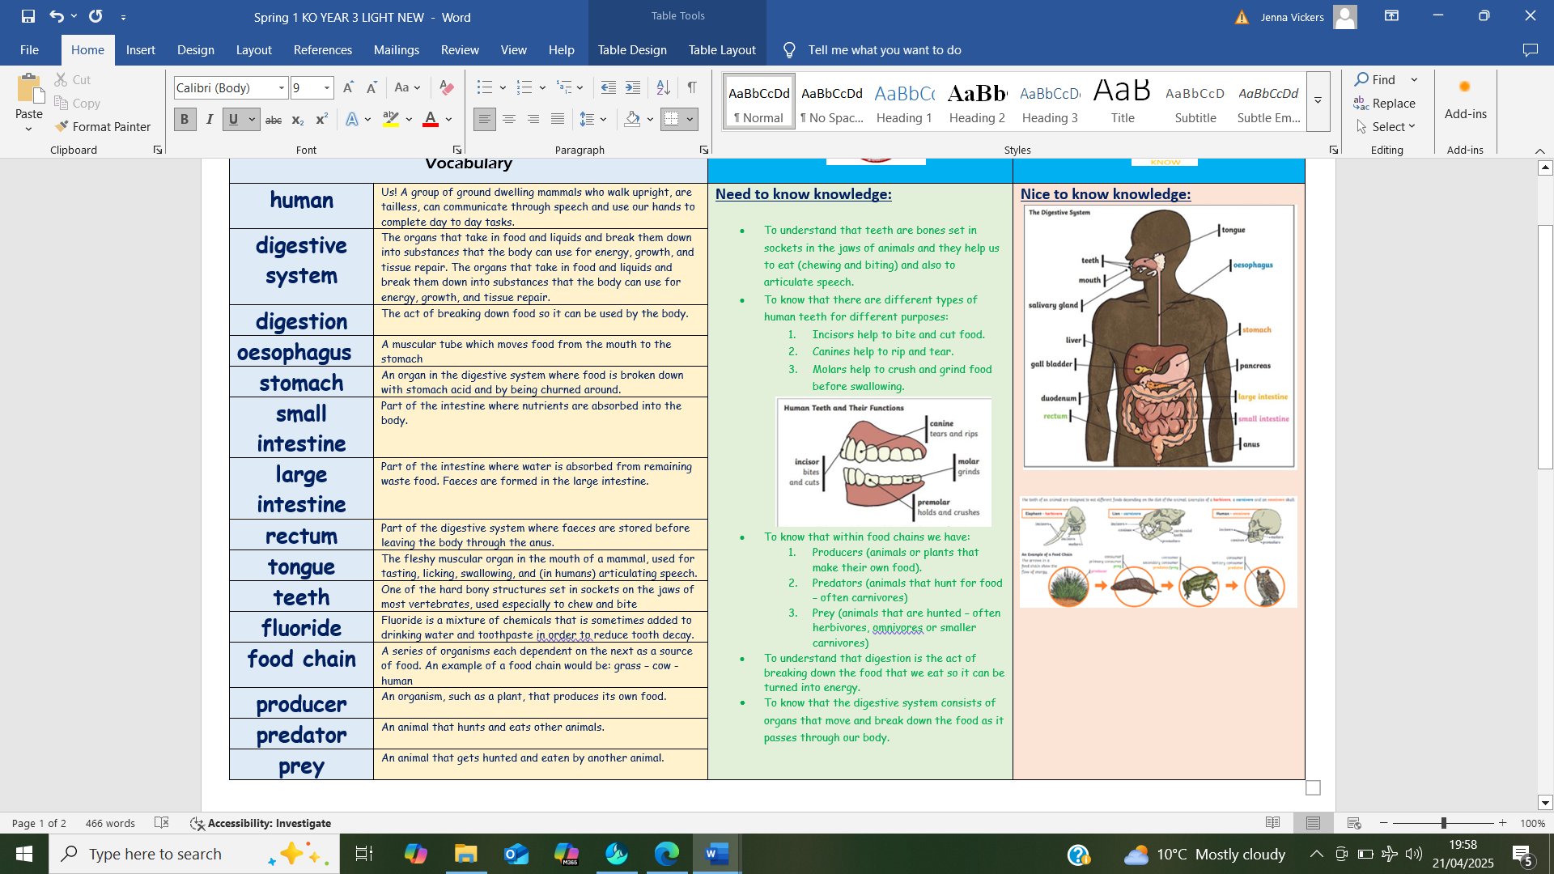  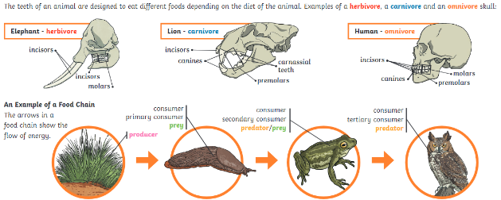
digestive system | The organs that take in food and liquids and break them down into substances that the body can use for energy, growth, and tissue repair. The organs that take in food and liquids and break them down into substances that the body can use for energy, growth, and tissue repair.
digestion | The act of breaking down food so it can be used by the body.
oesophagus | A muscular tube which moves food from the mouth to the stomach
stomach | An organ in the digestive system where food is broken down with stomach acid and by being churned around.
small intestine | Part of the intestine where nutrients are absorbed into the body.
large intestine | Part of the intestine where water is absorbed from remaining waste food. Faeces are formed in the large intestine.
rectum | Part of the digestive system where faeces are stored before leaving the body through the anus.
tongue | The fleshy muscular organ in the mouth of a mammal, used for tasting, licking, swallowing, and (in humans) articulating speech.
teeth | One of the hard bony structures set in sockets on the jaws of most vertebrates, used especially to chew and bite
food chain | A series of organisms each dependent on the next as a source of food. An example of a food chain would be: grass – cow - human
producer | An organism, such as a plant, that produces its own food.
predator | An animal that hunts and eats other animals.
prey | An animal that gets hunted and eaten by another animal.

