  Year 4  Summer 2: Changes of Matter! |  |  | 
Vocabulary

States of matter | Materials can be one of three states: solids, liquids or gases. Some materials can change from one state to another and back again. | Need to know knowledge:  - To know that:  - Solids are materials that keep their shape unless a force is applied. They can be hard or soft and the particles are close together and cannot move.  - Liquids can flow or be poured and they take the shape of their container. The particles are quite close together but can move around easily.  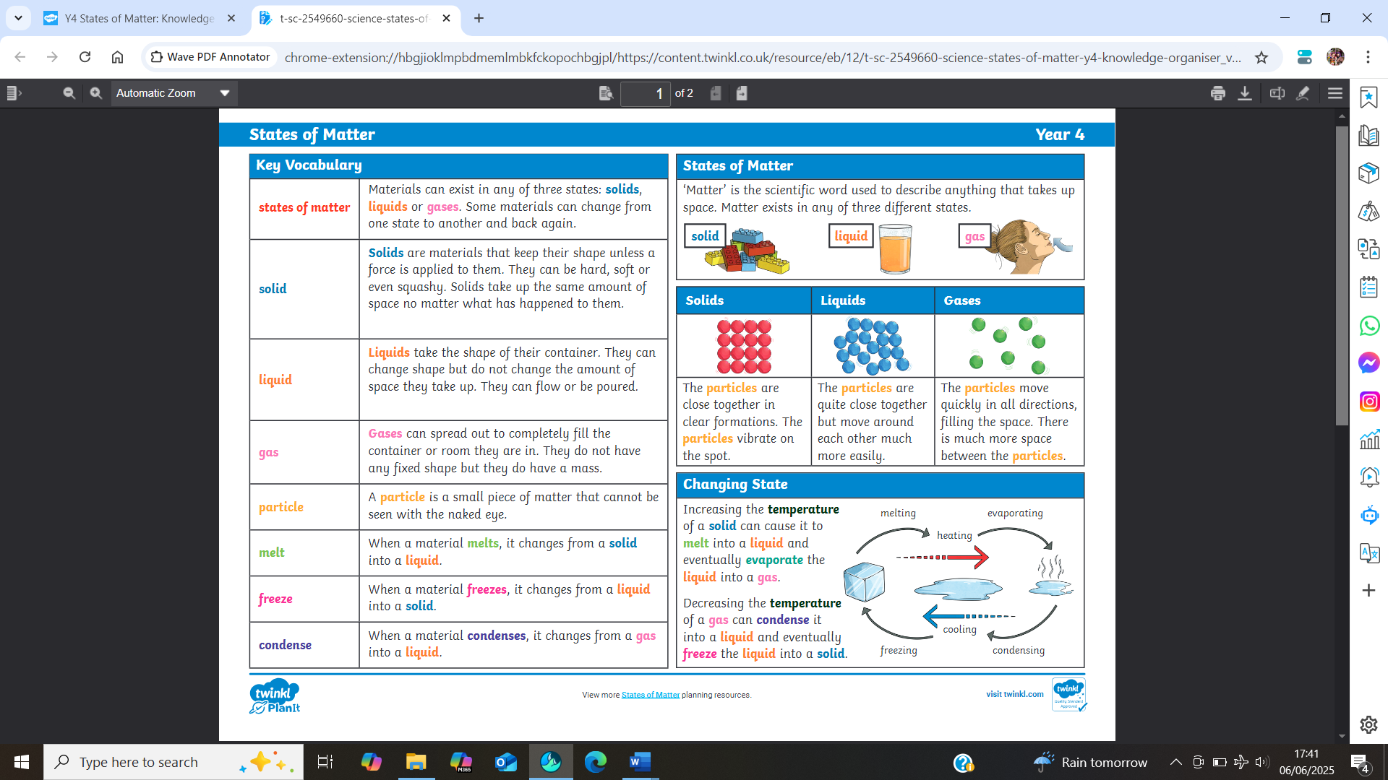  - Gases can spread out to completely fill the container they are in. They have no fixed shape as the particles are far apart and can move very quickly in all directions.  - To know that ‘temperature’ is a measurement used to define how hot or cold something is.  - To know that to increase the temperature of something we ‘heat it’ or make it ‘hotter’. To decrease the temperature, we ‘cool it’ or make it ‘colder’.  - To begin to discuss the water cycle in simple terms understanding that water from our planet is (evaporated) by our suns heat and turned into gas (water vapour). This then rises to the clouds and cools down to form water droplets (condensation). These droplets then fall from the sky as rain, hail or snow. | Nice to know knowledge:  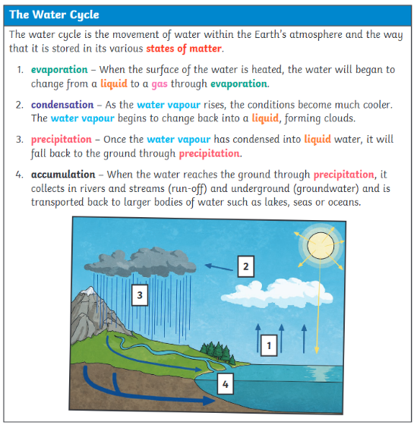  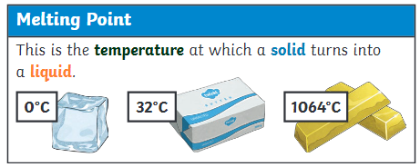  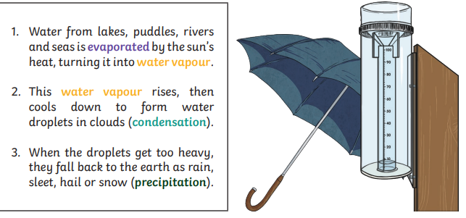
Solids | These are materials that keep their shape unless a force is applied to them. They can be hard, soft or even squashy. Solids take up the same amount of space no matter what has happened to them.
Liquids | Liquids take the shape of their container. They can change shape but do not change the amount of space they take up. They can flow or be poured.
Gases | Gases can spread out to completely fill the container or room they are in. They do not have any fixed shape but they do have a mass.
Particles | Tiny pieces of matter that make up solids, liquids and gases. They are so small we are not able to see them.
Melt | This is when a solid changes to a liquid.
Freeze | Liquid turns to a solid during the freezing process.
Temperature | The measurement used to define how hot or cold something is.
Heating | To increase the temperature of something, making it hotter.
Cooling | To reduce the temperature of something, making it colder.
Condense | When a gas turns into a liquid.
Evaporate | When a liquid turns into a gas.
Water vapour | This is water that takes the form of a gas. When water is boiled, it evaporates into a water vapour.
Precipitation | Liquid or solid particles that fall from a cloud as rain, sleet, hail or snow.

