  Year 5  Autumn 1: Forces! |  |  | 
Vocabulary

Force | 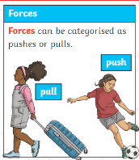  Forces are pushes or pulls which have an impact on the movement of objects. It can cause an object to start or stop moving, change direction, speed or shape. | Need to know knowledge:  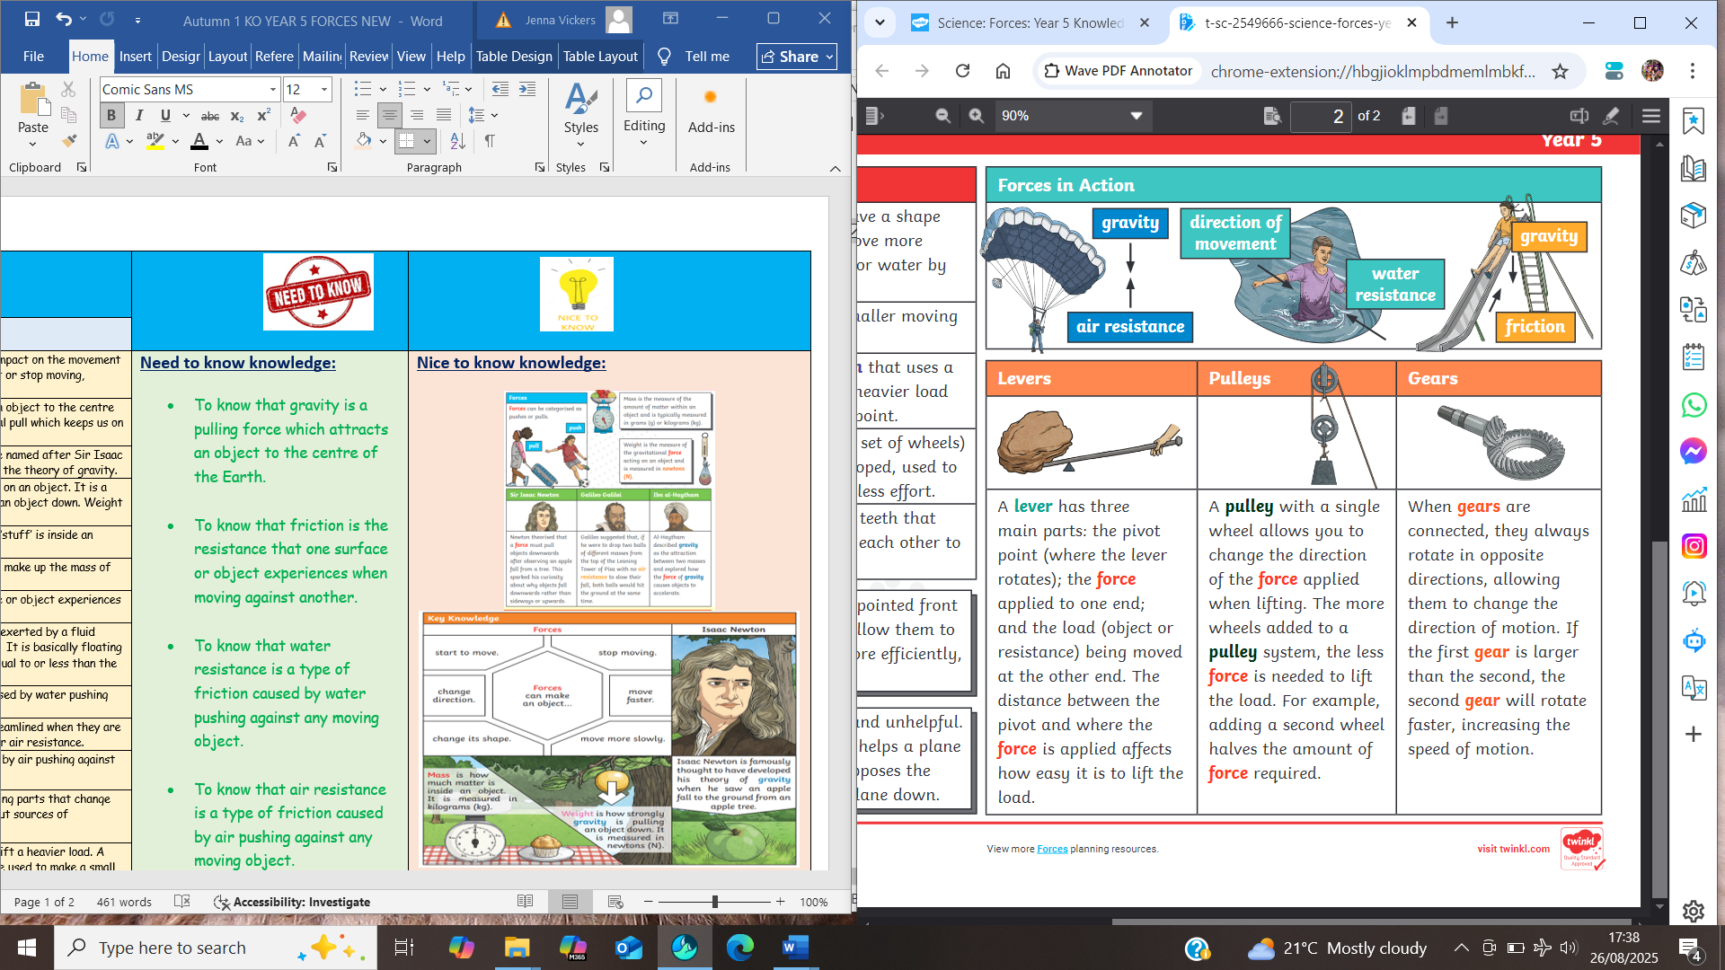  - To know that gravity is a pulling force which attracts an object to the centre of the Earth.  - To know that friction is the resistance that one surface or object experiences when moving against another.  - To know that water resistance is a type of friction caused by water pushing against any moving object.  - To know that air resistance is a type of friction caused by air pushing against any moving object.  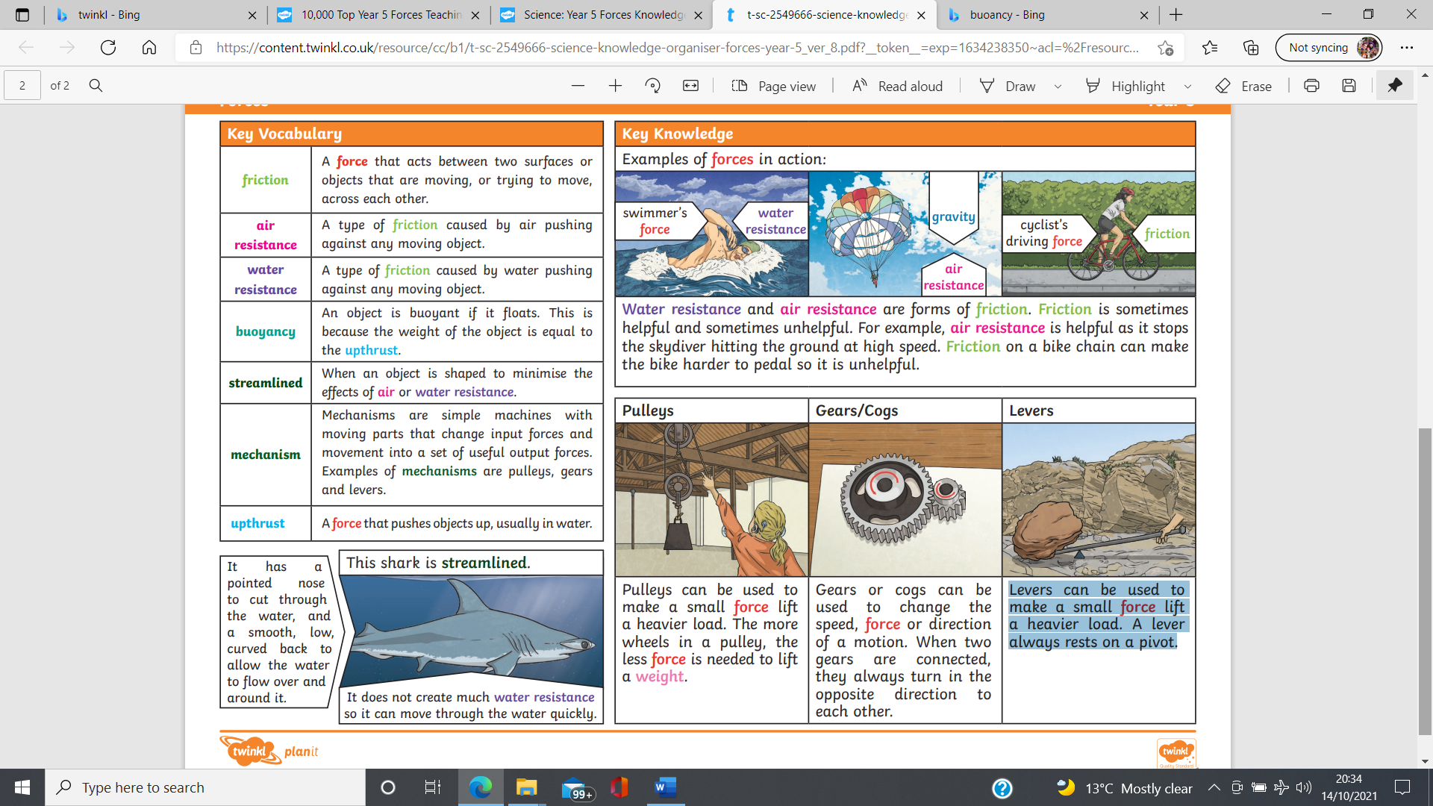 | Nice to know knowledge:  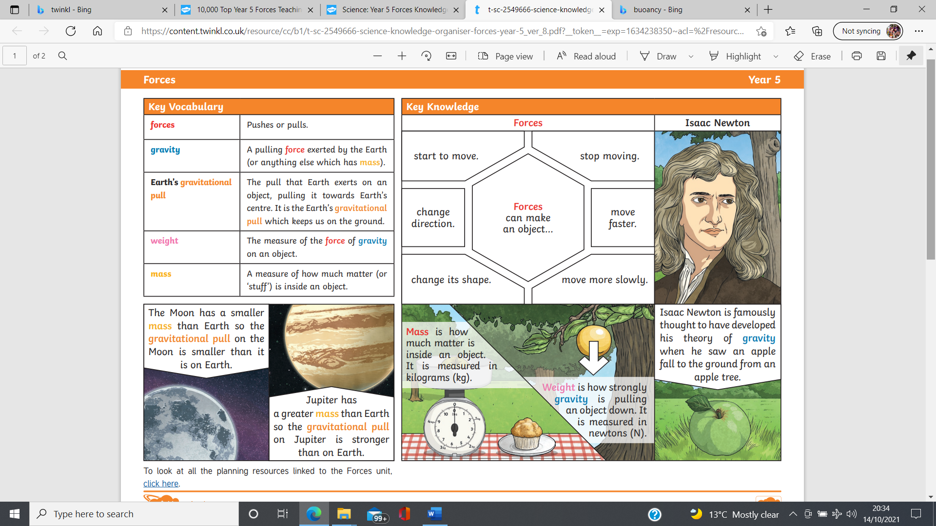  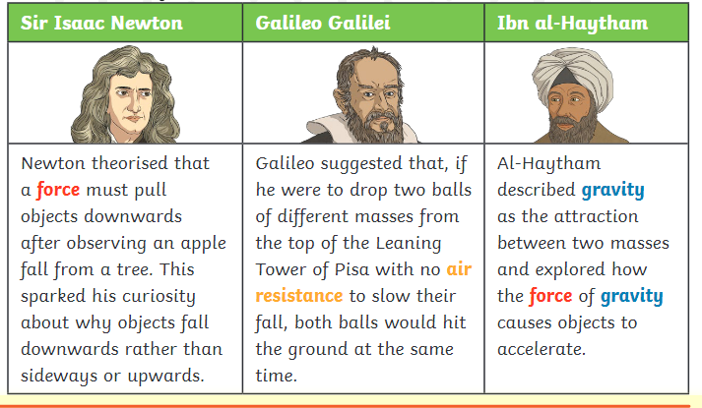
Gravity | Gravity is a pulling force which attracts an object to the centre of the Earth. It is the Earth’s gravitational pull which keeps us on the ground.
Newton | A Newton is a unit of force. Newtons were named after Sir Isaac Newton, a famous scientist who developed the theory of gravity.
Weight | Weight is the measure of force of gravity on an object. It is a measure of how strongly gravity is pulling an object down. Weight is measured in Newtons.
Mass | Mass is a measure of how much matter or ‘stuff’ is inside an object.
Matter | Matter is the collection of particles which make up the mass of an object.
Friction | Friction is the resistance that one surface or object experiences when moving against another.
Buoyancy | Buoyancy, or upthrust, is an upward force exerted by a fluid against the weight of an immersed object. It is basically floating or sinking! If the weight of an object is equal to or less than the upthrust it floats!
Water resistance | Water resistance is a type of friction caused by water pushing against any moving object.
Steamline | Like sharks and aeroplanes, things are streamlined when they are shaped to minimise the effects of water or air resistance.
Air resistance | Air resistance is a type of friction caused by air pushing against any moving object.
Mechanism | Mechanisms are simple machines with moving parts that change input forces of movement into useful output sources of movement.
Levers | Levers can be used to make a small force lift a heavier load. A lever always rests on a pivot. Levers can be used to make a small force lift a heavier load. A lever always rests on a pivot.
Pulleys | Pulleys can be used to make a small force lift a heavier load. The more wheels in a pulley, the less force is needed to lift a weight.
Cogs | Gears or cogs can be used to change the speed, force or direction of a motion. When two gears are connected, they always turn in the opposite direction to each other.
Gears

