  Year 5  Autumn 2: Properties and changes of materials! |  |  | 
Vocabulary

material | The matter from which an object is made. For example, wood, plastic or metal. | Need to know knowledge:  - To know that particles are tiny pieces of matter that make up solids, liquids and gases.  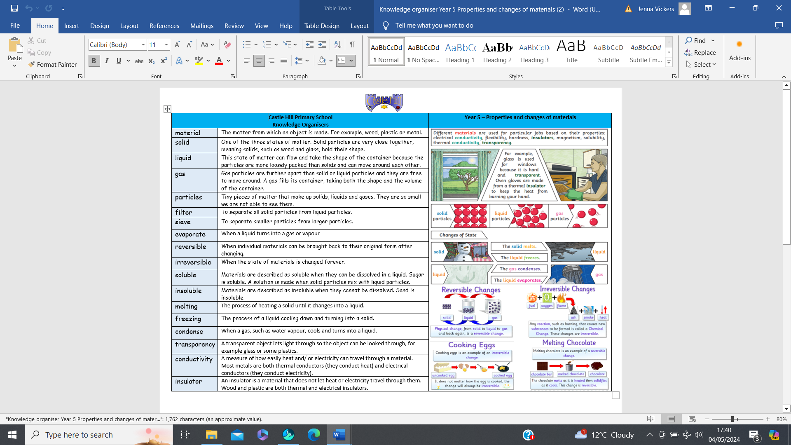  - To know that:  - To filter is to separate all solid particles from liquid particles.  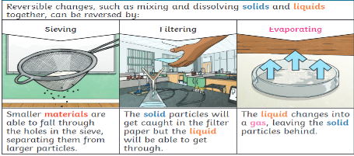  - To sieve is to separate smaller particles from larger particles.  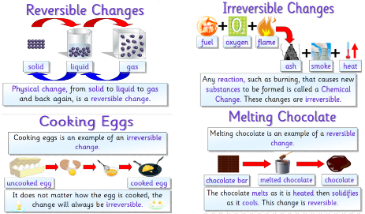  - To know that some changes are reversible (meaning that individual materials can be brought back to their original state after changing) and some changes are irreversible (meaning that the state of materials has been changed forever).  - To know that:  - ‘Soluble’ materials can be dissolved in a liquid creating a ‘solution’ E.g. sugar.  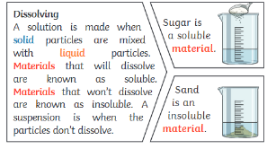  - ‘Insoluble’ materials do not dissolve in water. E.g. sand. | Nice to know knowledge:
solid | One of the three states of matter. Solid particles are very close together, meaning solids, such as wood and glass, hold their shape.
liquid | This state of matter can flow and take the shape of the container because the particles are more loosely packed than solids and can move around each other.
gas | Gas particles are further apart than solid or liquid particles and they are free to move around. A gas fills its container, taking both the shape and the volume of the container.
particles | Tiny pieces of matter that make up solids, liquids and gases. They are so small we are not able to see them.
filter | To separate all solid particles from liquid particles.
sieve | To separate smaller particles from larger particles.
evaporate | When a liquid turns into a gas or vapour.
reversible | When individual materials can be brought back to their original form after changing.
irreversible | When the state of materials is changed forever.
soluble | Materials are described as soluble when they can be dissolved in a liquid. Sugar is soluble. A solution is made when solid particles mix with liquid particles.
insoluble | Materials are described as insoluble when they cannot be dissolved. Sand is insoluble.

