  Year 5  Spring 1 and 2:  Living things and their habitats. |  |  | 
Vocabulary

life cycle | The journey of changes that take place throughout the life of a living thing including birth, growing up, reproduction and death. | Need to know knowledge:  - To understand that:  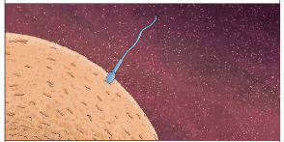  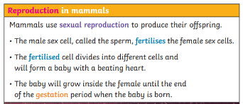  - ‘Sexual reproduction’ is when two parents are needed to make offspring which are similar but not identical to either parent.  - ‘Asexual reproduction’ is when one parent is needed to create an offspring, which is an exact copy of the parent.  - To know that:  - Humans and other mammals develop inside their mothers and use sexual reproduction to produce their offspring.  - Amphibians and insects are laid in eggs and once hatched, many experience changes or metamorphosis before reaching adulthood.  - Birds, fish, and reptiles are also hatched from eggs.  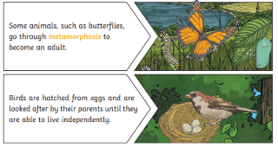  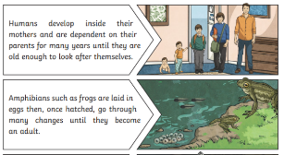  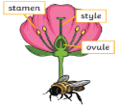  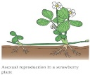  - To know that most plants contain both the male sex cell (pollen) and the female sex cell (ovules) but most plants can’t fertilise themselves. This is where pollination comes in! Wind, animals and insects help to transfer pollen from the stamen of one plant to the stigma of another to allow fertilisation. | Nice to know knowledge:  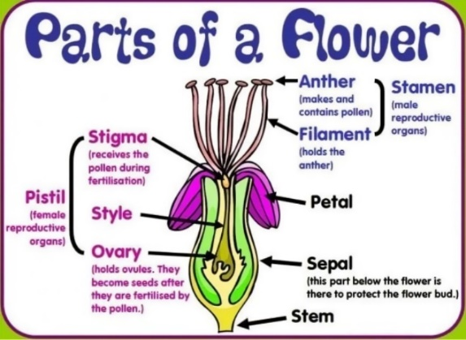  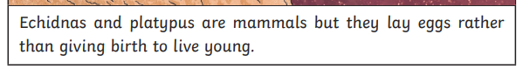  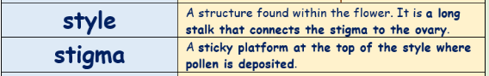  Some plants, such as strawberry plants, potatoes, spider plants and daffodils use asexual reproduction to create a new plant.  Once pollen has been moved from the stamen of one plant to the stigma of another, the pollen then travels down a tube called a style and fuses with the ovule.
sexual reproduction | Two parents are needed to make offspring which are similar, but not identical to, either parent.
asexual reproduction | One parent is needed to create an offspring, which is an exact copy of the parent.
reproduction | The process of new living things being made.
fertilisation | The action of fusing the male and female sex cells in order to develop an egg, creating new life.
pollination | The transfer of pollen to a stigma to allow fertilisation.
pollen | A fine, powdery substance, typically yellow, made up of tiny grains discharged from the male part of the flower.
stamen | The male reproductive part of the plant. Typically, this consists of a filament and an anther which makes and holds the pollen.
ovule | Ovules are egg cells located inside a plant’s ovary – the part of the plant that develops into a seed when fertilised.
mammal | A warm-blooded animal with fur or hair on its skin and a skeleton inside its body. Mammal mothers have live births and produce milk to feed their babies. Most mammals have four legs or two arms and two legs. Dogs, elephants, mice, whales, and humans are all mammals.
gestation | The length of a pregnancy from fertilisation through to birth.
metamorphosis | An abrupt and obvious change in the structure of an animal’s body and their behaviour. An example of metamorphosis is a caterpillar becoming a butterfly or a tadpole becoming a frog.
amphibian | A cold-blooded vertebrate animal of a class that includes frogs, toads, newts and salamanders. They are distinguished by having an aquatic gill-breathing larval stage followed (typically) by a terrestrial lung-breathing adult stage, spending part of its life cycle in water and part on land.
reptile | A cold-blooded vertebrate animal of a class that includes snakes, lizards, crocodiles, turtles, and tortoises. They are distinguished by having a dry scaly skin or skin containing hard plates and typically laying soft-shelled eggs on land.

