  Year 5  Summer 1: Earth and Space |  |  | 
Vocabulary
Solar System | The 8 planets and dwarf planet (along with their moons) which orbit the sun. | Need to know knowledge:  - Know that the Solar System is a collection of 8 planets and their moon which orbit the Sun.  - Know the name and order of the planets:  - Mercury  - Venus  - Earth  - Mars  - Jupiter  - Saturn  - Uranus  - Neptune  (Mnemonic: My very easy method just speeds up naming planets)  - Know that Mercury, Venus, Earth and Mars are rocky planets, mostly made up of metal and rock.  - Know that Jupiter, Saturn, Uranus and Neptune are gas giants (made of gases).  - Know that it takes 365 days for the Earth to orbit the Sun. The Earth spins on its axis while it orbits. It takes the Earth 24 hours to do one complete spin on its axis.  - Know that daytime occurs when one side of the Earth is facing towards the Sun’s light. Night time occurs when one side of the Earth is facing away from the Sun’s light (it’s in shadow). | Nice to know knowledge:  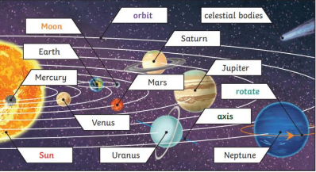  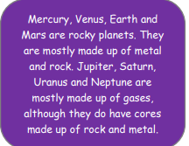  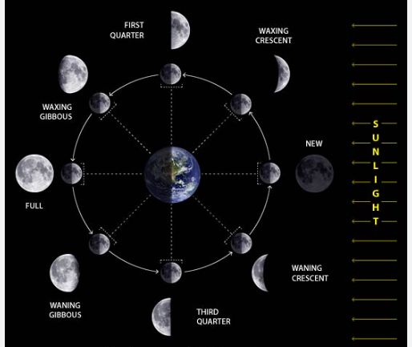
Planet | A spherical (round) shape which orbits a star.
Star | A giant ball of gas held together by its own gravity. The Sun is a star.
Sun | A huge star that Earth and the other planets in our solar system orbit around.
Axis | An imaginary line which the planet rotates on.
Rotate | To spin. E.g. Earth rotates
Orbit | To move in a curved path around another object.
Moon | A natural satellite which orbits a planet.
Satellite | Any object or body in space that orbits something else. For example, the Moon is a satellite for Earth.
Celestial Body | Any astronomical object such as a planet, star or Sun.
Spherical | A 3D (three dimensional) round, ball shape.
Geocentric | An incorrect belief that the Earth was at the centre of the Solar System. People used to believe that the Sun and other planets orbited around the Earth.
Heliocentric | The fact that the Sun is at the centre of our solar system and the planets orbit it.
Astronomer | Some who studied space (astronomy).

