  Year 5  Summer 2: Animals Including Humans! |  |  | 
Vocabulary

Life Cycle | The changes living things go through, including reproduction. | Need to know knowledge:  - To identify and order the stages of human life. (fertilisation, prenatal, infancy, childhood, adolescence, early, middle and late adulthood.)  - To identify and describe the changes as humans develop in adolescence and know that boys and girls changes may differ:  - Girls: skin becomes oilier, hair grows under armpits, on arms, legs and in the pubic region, breasts grow, start to menstruate.  - Boys: skin becomes oilier, hair grows under armpits, on arms, legs and in the pubic region as well as on the face and chest, larynx grows producing an ‘Adam’s apple’, scrotum, testes and penis develops.  - To understand that the above changes are known as ‘puberty’.  - To know that ‘menstruation’ is known as a ‘period’ and girls experience this as the lining of the uterus is discharged from the body in absence of fertilisation | Nice to know knowledge:  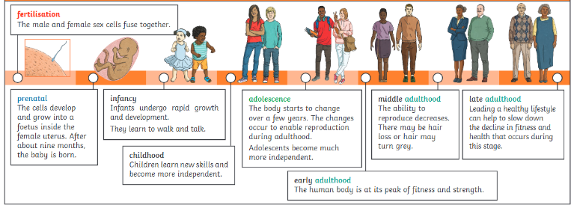  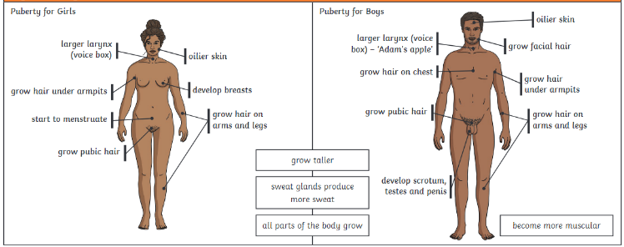  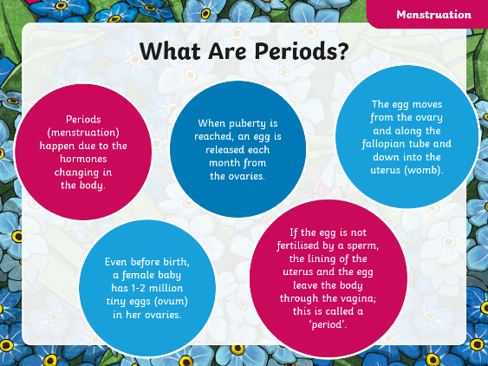  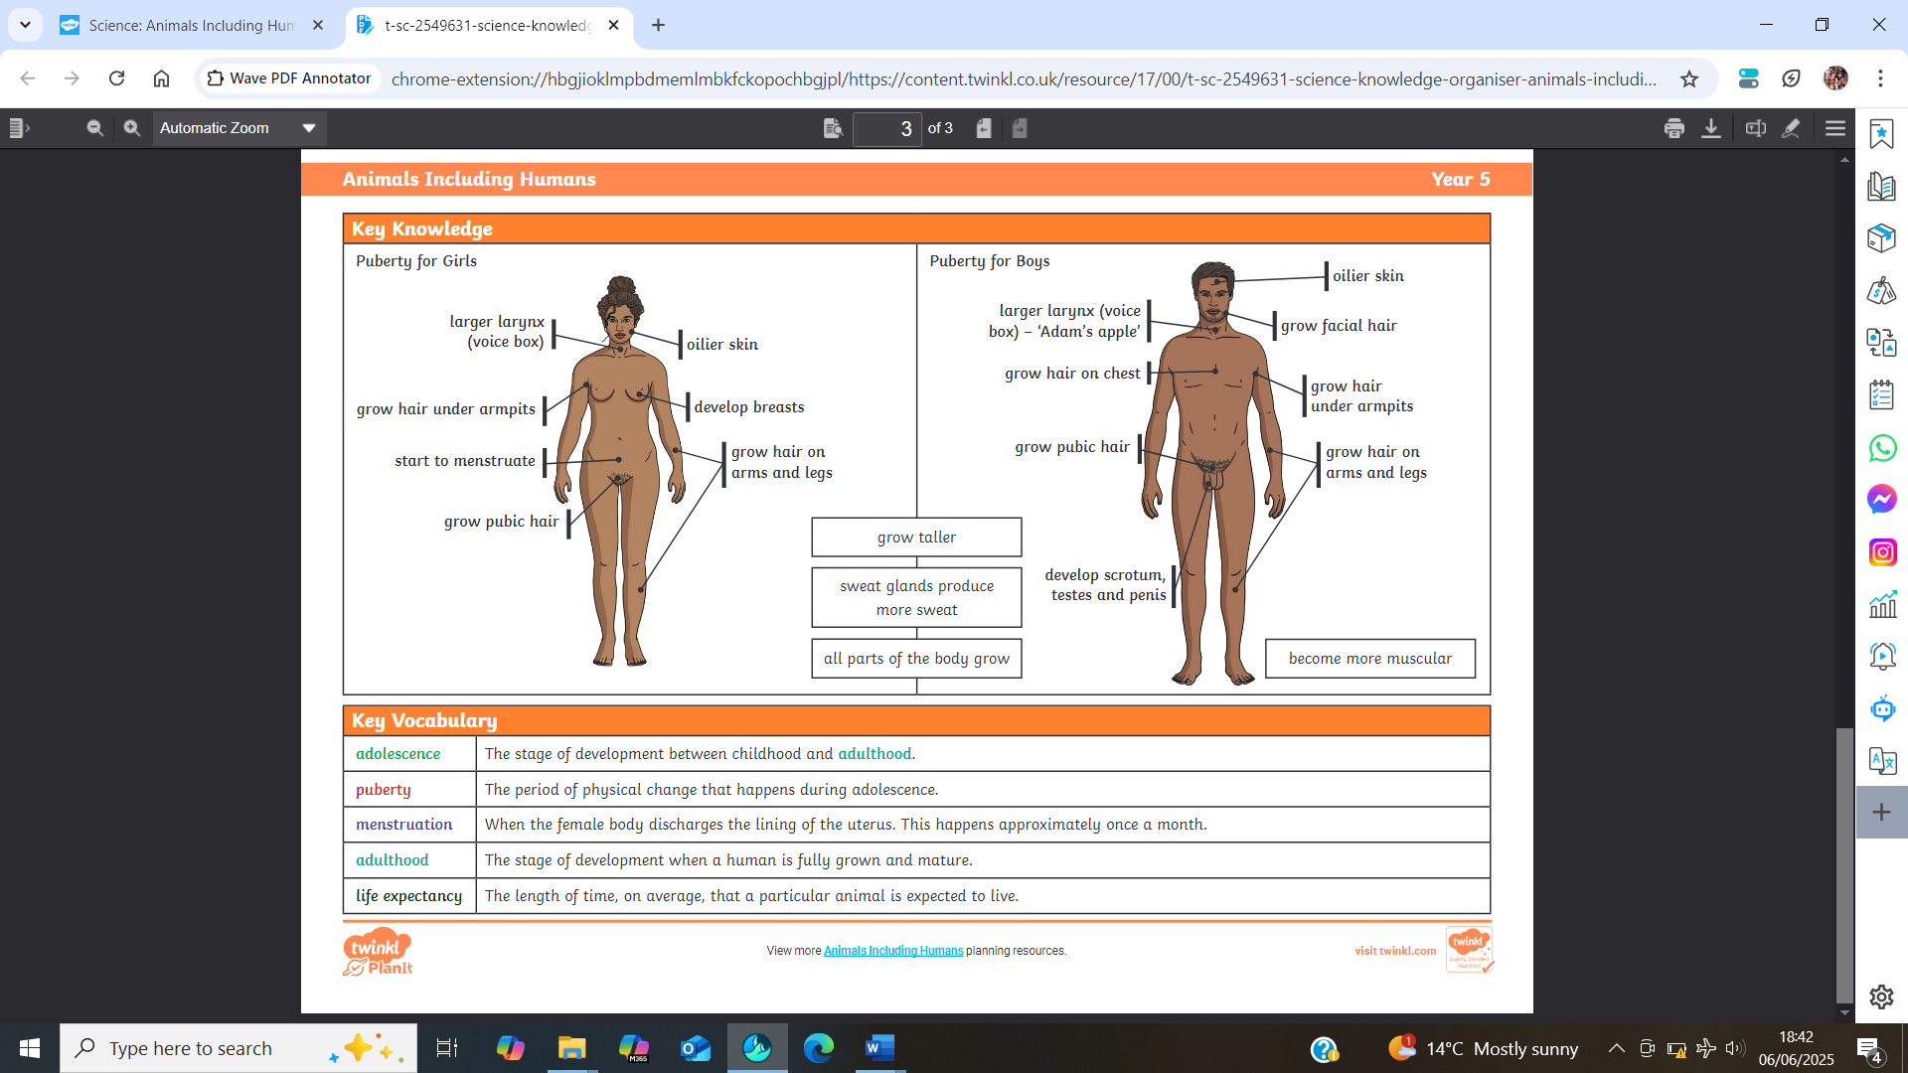
Reproduction | To produce new animals or plants.
Fertilisation | The process of the male and female sex cells fusing together.
Sexual Reproduction | A process where two parents – one male and one female – are required to produce new life.
Asexual Reproduction | A process where one parent alone produces new life.
Gestation | The process or time when prenatal development takes place before birth.
Prenatal | The stage of development from the time of fertilisation to the time of birth.
Infancy | The early stage of development when a young human is still heavily reliant on their parents or the adults around them.
Childhood | The stage of development pre puberty when a human is yet to become fully grown and mature.
Adolescence | The social and emotional stage of development between childhood and adulthood.
Puberty | The physical stage of development between childhood and adulthood.
Adulthood | The stage of development when a human is fully grown and mature.
Growth | To grow in size and get bigger.
Development | To grow bigger and become stronger.
Menstruation  (period) | When the female body discharges the lining of the uterus. This happens approximately once a month and stops when a fertilised egg buries into the lining.

