  Year 6  Autumn 1: Evolution and Inheritance! |  |  | 
Vocabulary

Evolution | How the characteristics in a species have changed or ‘adapted’ over a long period of time, often several generations. | Need to know knowledge:  - To recognise that living things produce offspring of the same kind but that offspring are not always identical to their parents.  - To know that ‘adaptation’ is the process of change by which a human, animal or plant becomes gradually better suited to its environment over a long period of time.  - To know that ‘Natural Selection’ is a process in which organisms which are better adapted to their environments, thrive and continue to produce more offspring.  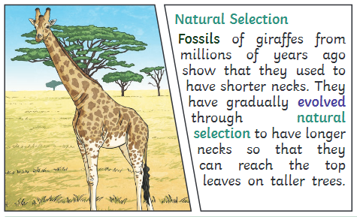  - To understand that the theory of evolution describes how inherited traits within a population change over generations, leading to a new process called natural selection.  - To know that ‘inheritance’ is the process of passing on characteristics or traits from parents to their offspring.  - To know that fossils provide information about living things that inhabited the Earth millions of years ago. | Nice to know knowledge:  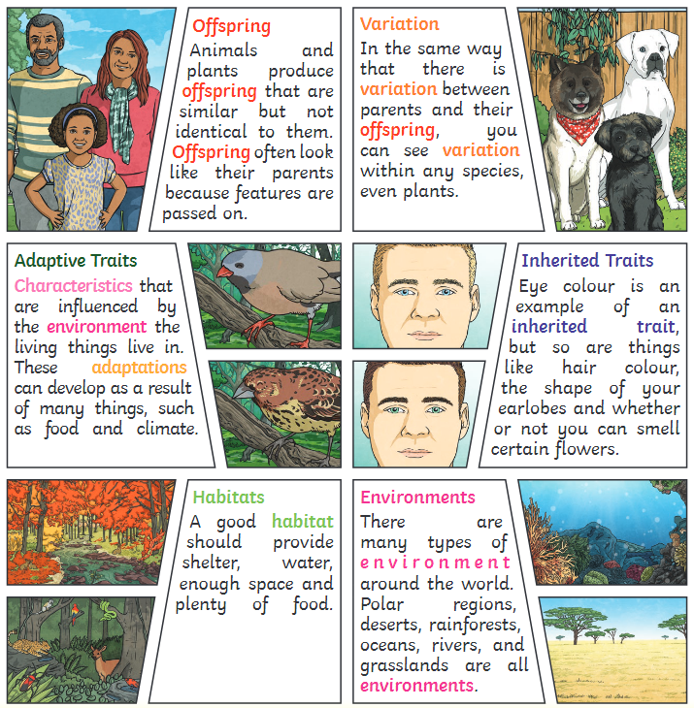  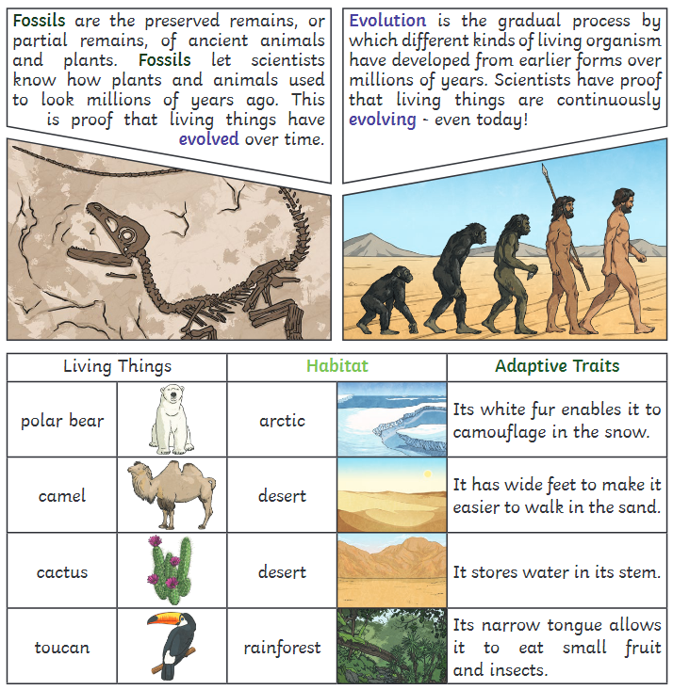
Environment | The place or conditions in which a human, animal or plant lives. Environments can contain many habitats.
Characteristics | Features or qualities that help us to identify a person, place or object. Different species have specific characteristics which unify them.
Reproduction | The biological process in which new organisms or ‘offspring’ are produced from their ‘parent’ or ‘parents’.
Genetics | The study of genes looking at how characteristics have been passed through generations from parents to their offspring.
Adaptation | The process of change by which a human, animal or plant becomes gradually better suited to its environment over a long period of time, enabling it to better survive and reproduce.
Habitat | The natural home or environment of a human, animal, plant or other organism.
Variation | Something that is slightly different from the usual form or arrangements. Variation can occur between cells, individual organisms, or groups of organisms or species.
Inheritance | The process of passing on characteristics or traits from parents to their offspring through the coping of genetic information.
Traits | A distinguishing quality or characteristic that can be genetically determined through inheritance or a product of adaptation. Families may share similar traits such as curly hair.
Natural selection | A process explored by Charles Darwin in which organisms which are better adapted to their environments, thrive and continue to produce more offspring.
DNA | A self-replicating material which carries genetic information. DNA is present in nearly all living things.
offspring | A product of reproduction, offspring are the young creation of living organisms.
fossils | The preserved remains of a once living thing, embedded in rock.

