  Year 6  Autumn 2: Living things ad their habitats! |  |  | 
Vocabulary

taxonomist | A scientist who classifies different living things into categories. Starting with the domain or Kingdom, they group similar things together and then split the groups again and again based on their differences until they are left with the species. All living things on Earth are descended from a single common ancestor. Species branched off at different points in evolutionary history, and then again split off many times more, until there were millions of species – and most are still undiscovered by humans to this day. | Need to know knowledge:  - To understand that ‘classification’ is the process of sorting things into different groups in accordance to their characteristics.  - To use this knowledge to ‘classify’ or ‘group’ living things using their features or qualities to help identify them. (Nice to know: To begin to use a key to demonstrate this.)  - To begin to understand and use the terms ‘Kingdom’, ‘domain’ and ‘species’, knowing that ‘species’ is a group of animals that can reproduce to produce fertile offspring.  - To know that microorganisms are viruses, bacteria, moulds and yeast. | 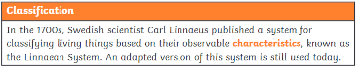  Nice to know knowledge:  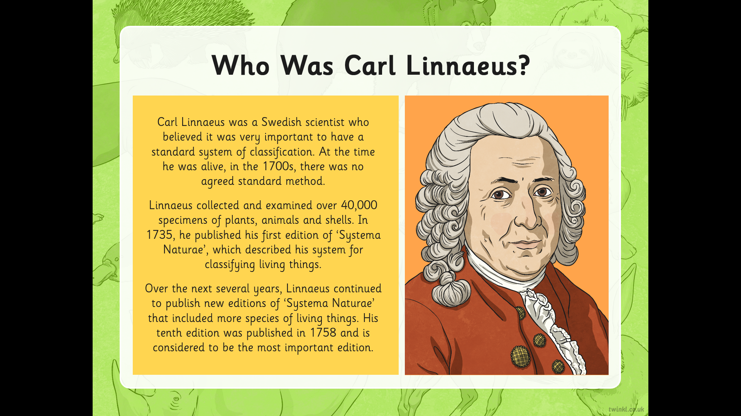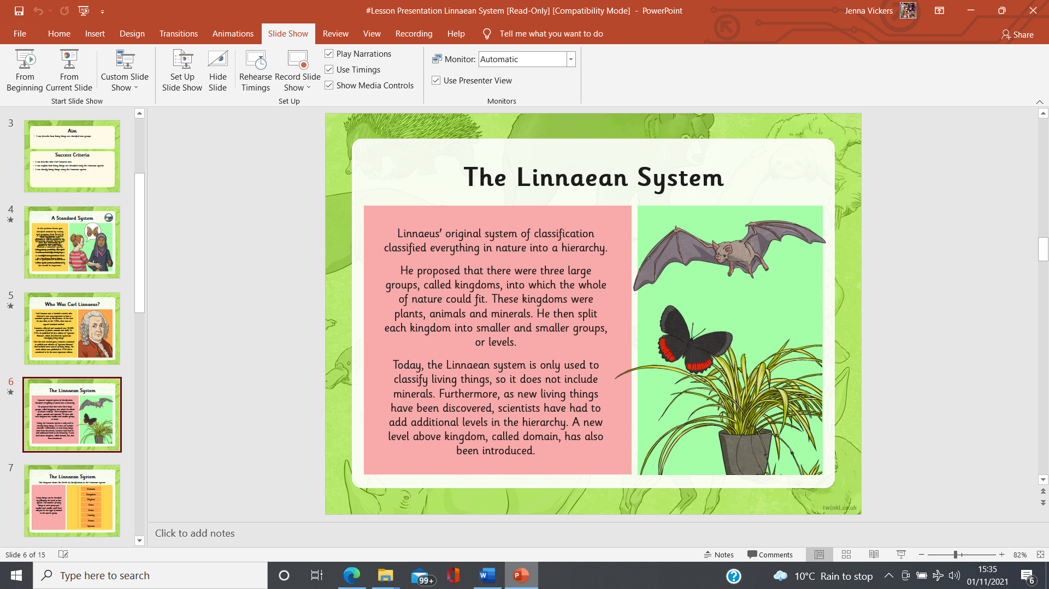  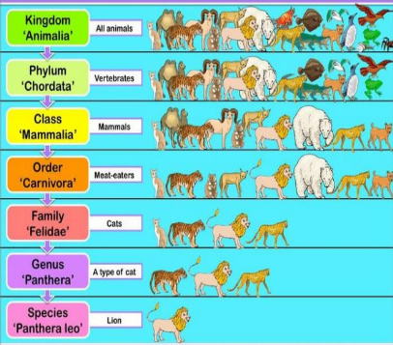  Here is an example of a key which helps us with our classification.  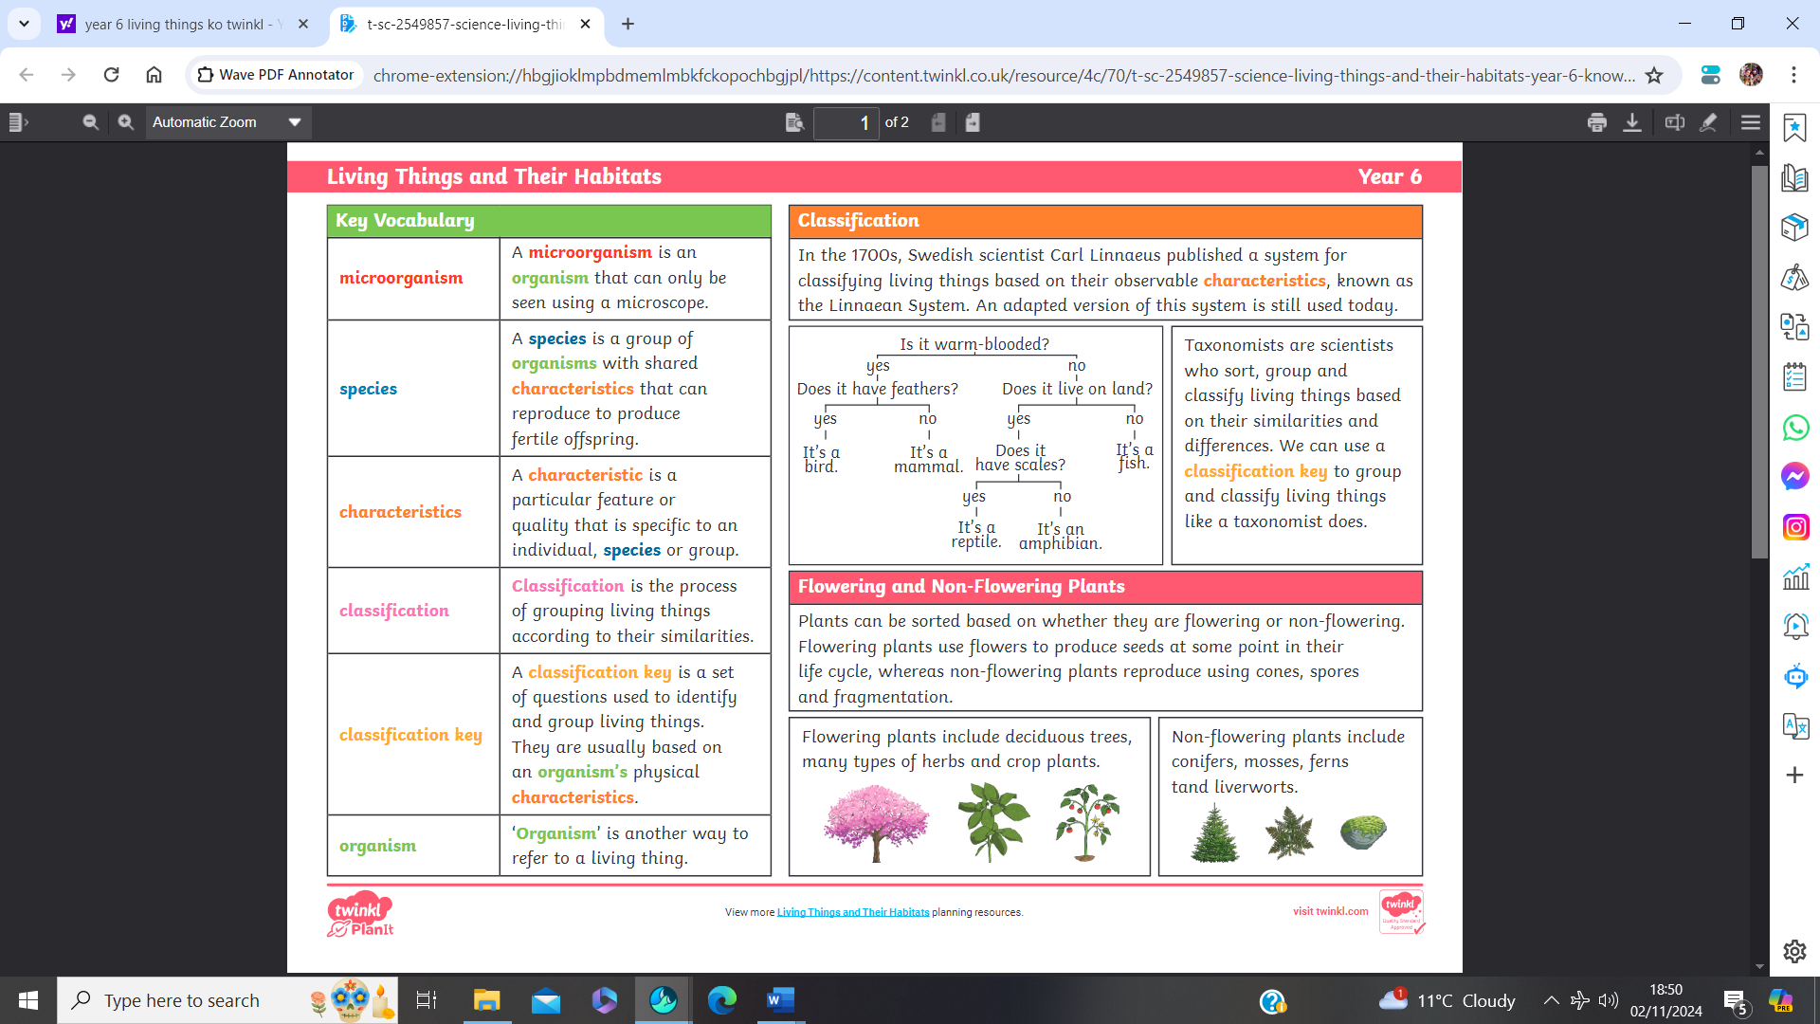  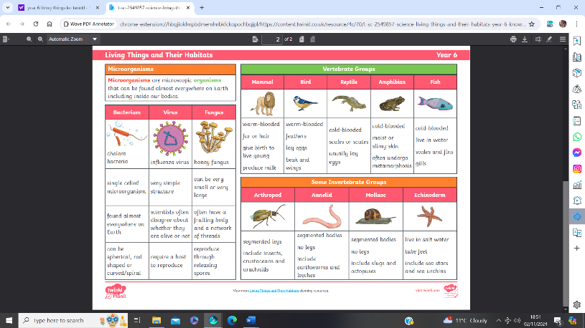  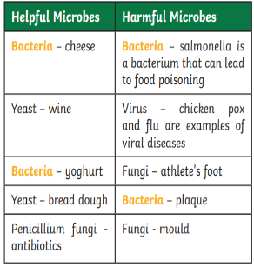  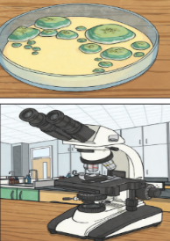
characteristics | Features or qualities that help us to identify an individual or group of things. Different animals, groups of animals or species have specific characteristics which either unify them or make them different to others.
classification | The process of sorting things into different groups in accordance to their characteristics.
key | A series of questions about the characteristics of living things. A key is used to identify a living thing or decide which group it belongs to by answering 'yes' or 'no' questions.
species | A group of animals or other organisms that can reproduce to produce fertile offspring.
Kingdom | A kingdom is the second highest taxonomic rank, just below domain. Many Scientists believe that there are six kingdoms (Animalia, Plantae, Fungi, Protista, Archaea/Archaebacteria, and Bacteria/Eubacteria)
domain | In biology, a domain refers to the largest of all groups in the classification of life. There are currently 3 agreed groups at this level, the Archaea domain, Bacteria domain, and Eukaryadomain.
organism | ‘Organism’ is another way to refer to a living thing.
Micro-organisms | Microorganisms are very tiny living things that can only be seen using a microscope. They are found in and on our bodies, in the air, in water and on objects around us. They can be viruses, bacteria, moulds and yeast. Some animals (dust mites) and plants (phytoplankton) are also microorganisms.
Bacteria | A single-celled microorganism. We can have good bacteria which helps to make us healthy and bad bacteria which makes us sick.

