  Year 6  Spring 1 and 2: Electricity |  |  |  | 
Vocabulary

electrons | Very small particles that travel around an electrical circuit. | Need to know knowledge:  - To recognise components of a Circuit (bulb, wire, cell, battery, switch, motor, buzzer).  - To recognise the representations of components of a Circuit (as Circuit symbols).  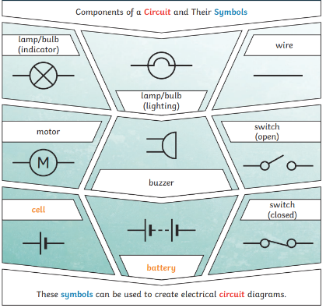  - To understand that more batteries or a higher voltage create more power to flow through the circuit.  - To understand that the brightness of a bulb or the volume of a buzzer is linked to the number and voltage of cells used within a circuit.  - To know that:  - Conductors allow electricity to flow through them. (Metals)  - Insulators will not allow electricity to flow through them (wood/ rubber) |  | Nice to know knowledge:  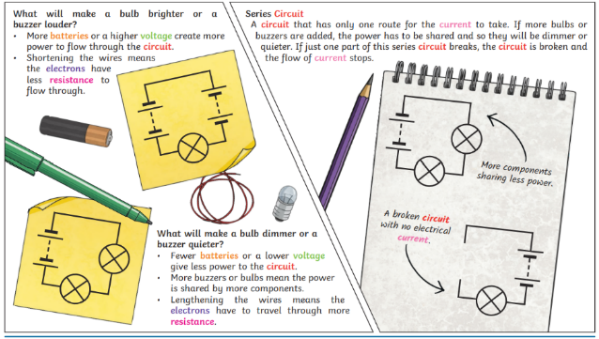  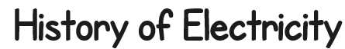  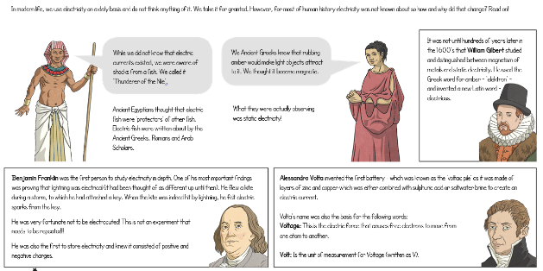  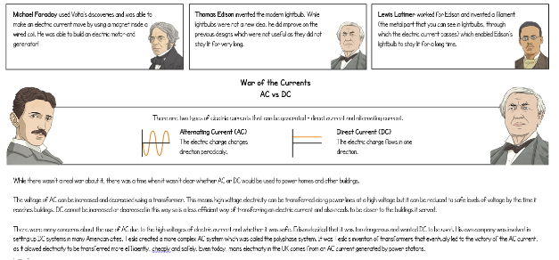
electric current | The flow of electrons, measured in Amps.
Amps | How electric current is measured.
electric circuit | A pathway that the electric current can flow round freely without being stopped, enabling electricity to go from the power source, to the appliance, making it work. Appliances stop working if a circuit is broken.
circuit diagram | A drawing of an electric circuit using symbols.
circuit symbol | Symbols used on an electrical diagram to represent the components used in the electric circuit.
cell | A cell is a single unit. A battery is a collection of cells.
battery | A device which stores electrical (chemical) energy inside until it is needed so that appliances can work without the use of wires. Batteries eventually run out and either need to be replaced or charged.
wire | A wire is a single usually cylindrical, flexible strand or rod of metal, usually used to carry electricity from one place to another.
bulb | A bulb contains a filament which gives off light when heated by an electric current.
switch | A device which makes or breaks the connection in an electrical circuit, turning things on and off.
buzzer | A device that creates an audible tone triggered by an electric current. This output may either be in the form of a buzzing or a beeping sound.
motor | An electric motor is a device for converting electrical energy into mechanical energy in the form of rotation.
conductor | A material that will allow electricity to flow through it. Metals are good conductors.
insulator | A material which will not allow electricity to flow through it. Wood, plastic and glass are good insulators
Voltage | The force that makes the electric current move through the wires. The greater the voltage, the more current will flow.
resistance | The difficulty that the electric current has when flowing around a circuit.

