  Year 6  Summer 1: Light! |  |  | 
Vocabulary

light | A form of energy that travels in a wave from a source. | Need to know knowledge:  - To know that light waves travel out from sources of light in straight lines. These lines are often called rays or beams of light.  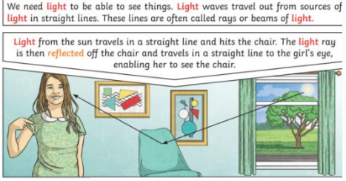  - To understand that we can see objects because they reflect light into our eyes.  - To understand that a shadow is an area of darkness where light has been blocked.  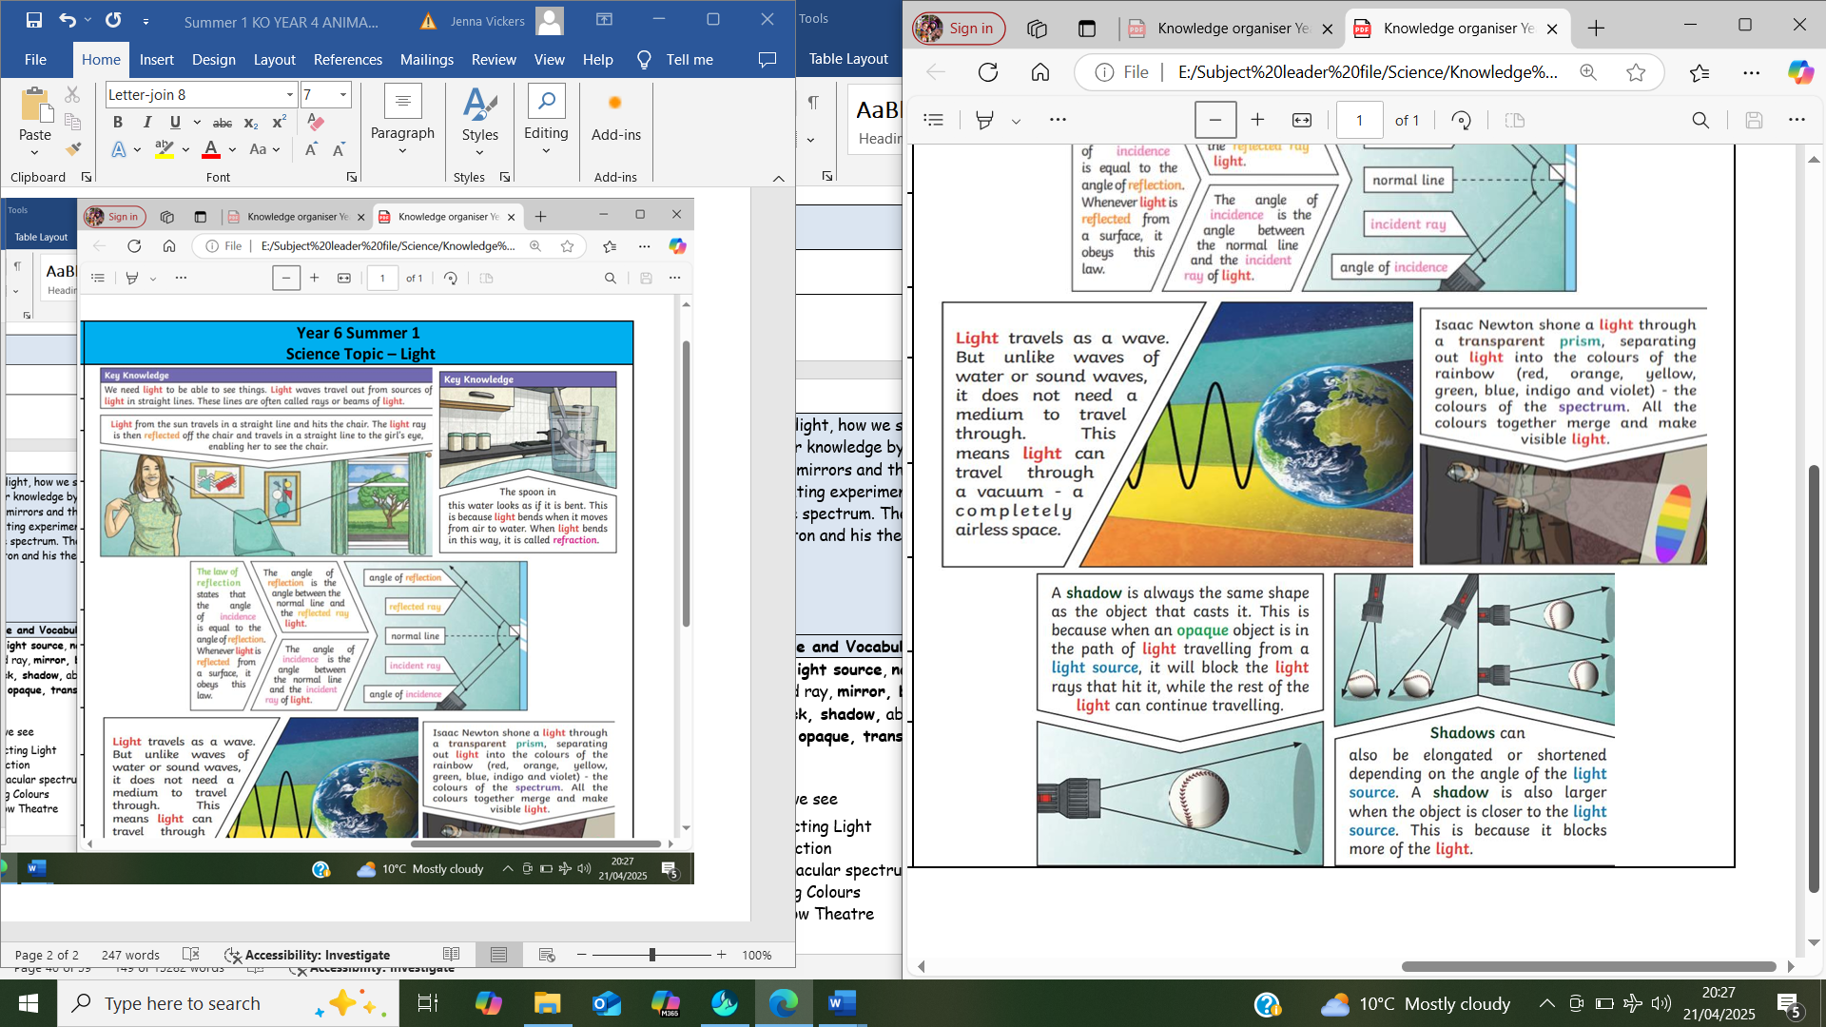  - To know that a shadow is always the same shape as the object that cast it as it shows where the light has been blocked. | Nice to know knowledge:  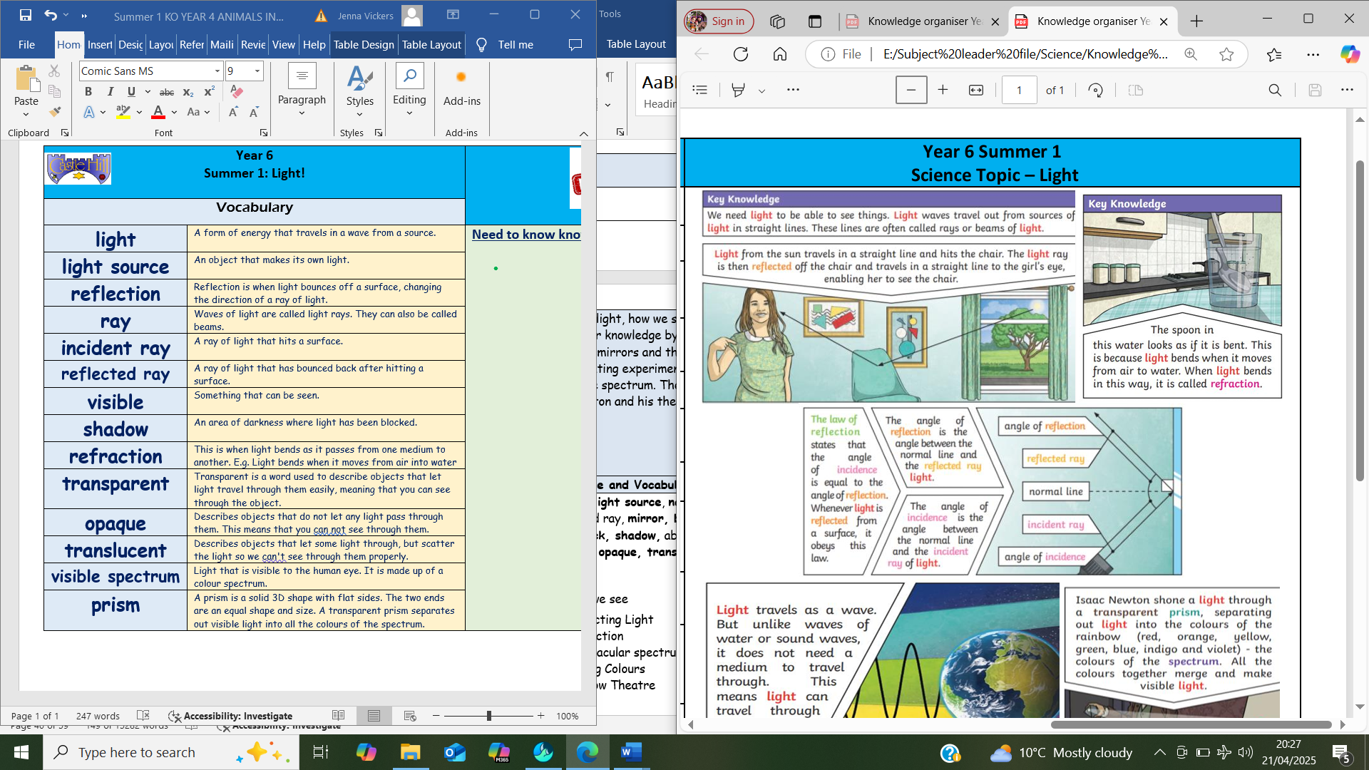
light source | An object that makes its own light.
reflection | Reflection is when light bounces off a surface, changing the direction of a ray of light.
ray | Waves of light are called light rays. They can also be called beams.
incident ray | A ray of light that hits a surface.
reflected ray | A ray of light that has bounced back after hitting a surface.
visible | Something that can be seen.
shadow | An area of darkness where light has been blocked.
refraction | This is when light bends as it passes from one medium to another. E.g. Light bends when it moves from air into water
transparent | Transparent is a word used to describe objects that let light travel through them easily, meaning that you can see through the object.
opaque | Describes objects that do not let any light pass through them. This means that you can not see through them.
translucent | Describes objects that let some light through, but scatter the light so we can't see through them properly.
visible spectrum | Light that is visible to the human eye. It is made up of a colour spectrum.
prism | A prism is a solid 3D shape with flat sides. The two ends are an equal shape and size. A transparent prism separates out visible light into all the colours of the spectrum.

