  Year 6  Summer 2: Animals Including Humans! |  |  | 
Vocabulary

Circulatory system | A system which includes the heart, veins, arteries and blood transporting substances around the body. | Need to know knowledge:  - To know that the heart pumps blood to the lungs to get oxygen. It then pumps this oxygenated blood around the body.  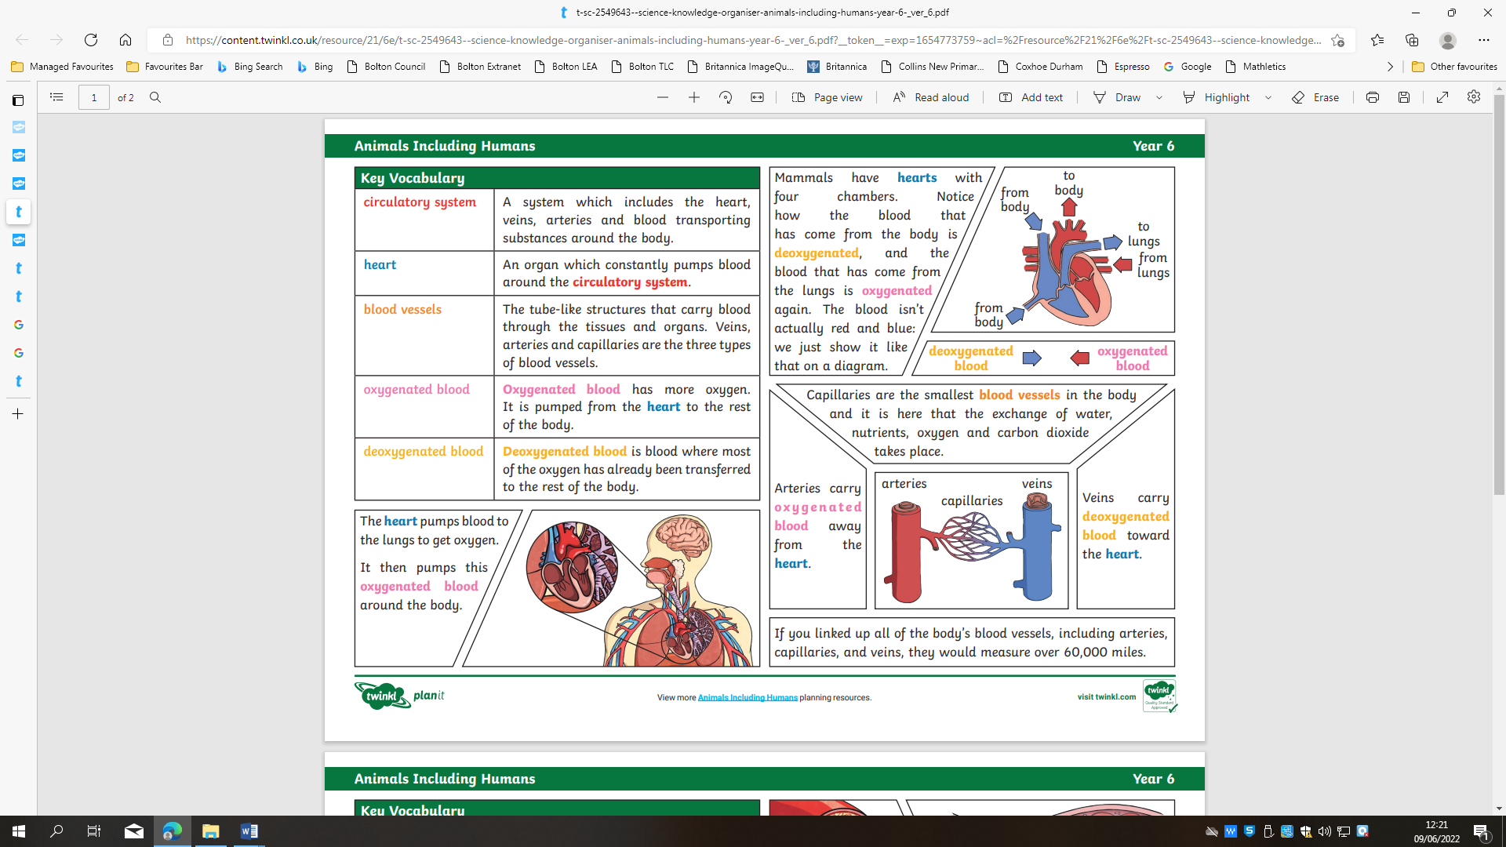  - To know that blood transports:  - Gases (mostly oxygen and carbon dioxide) and  - Nutrients (including water)  - To know that:  - Veins carry deoxygenated blood towards the heart and  - Arteries carry oxygenated blood away from the heart.  - To understand that a healthy diet involves eating the right types of nutrients in the right amounts.  - To know that exercise enhances or maintains physical fitness and overall health and wellness.  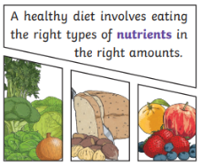  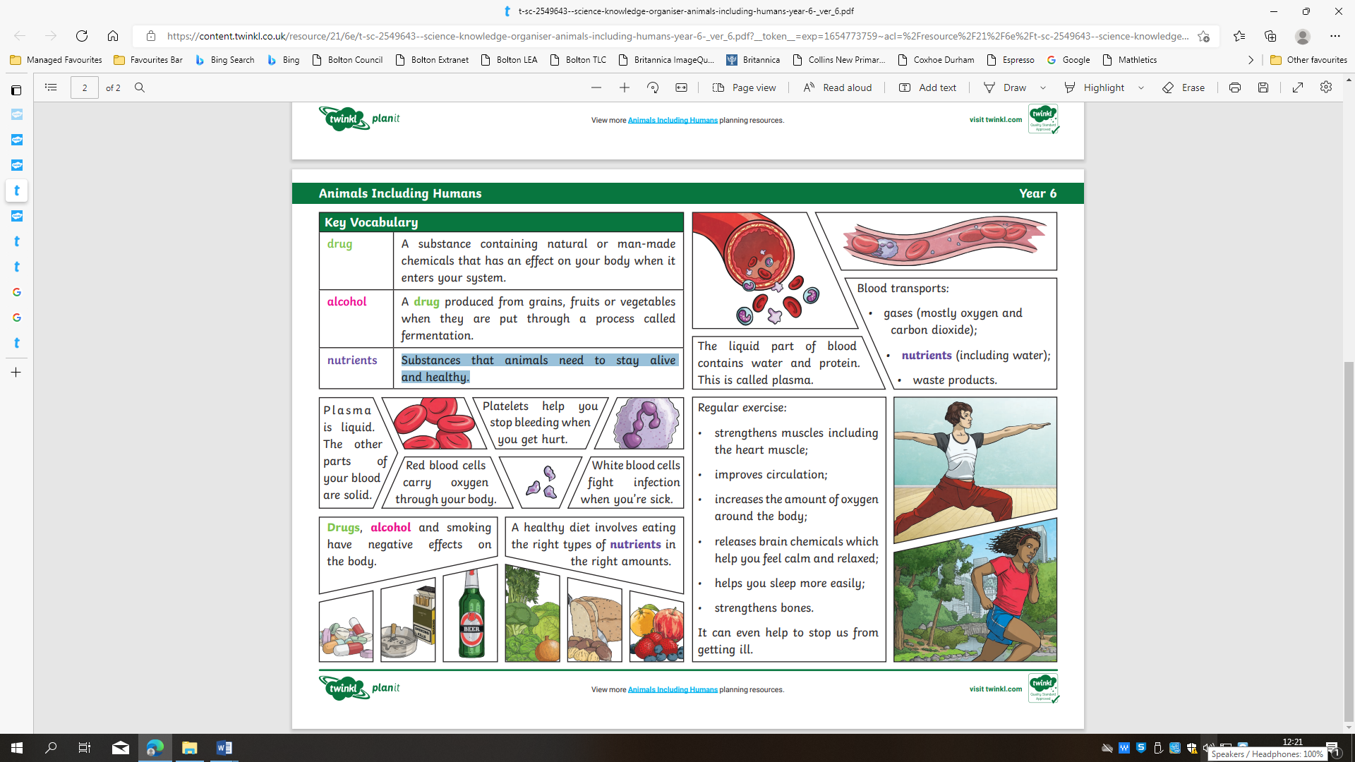  - To understand that drugs, alcohol, and smoking have negative effects on the body. | Nice to know knowledge:      Suggested reading!
Heart | An organ which constantly pumps blood around the circulatory system.
Lungs | A pair of organs in the chest that supplies the body with oxygen, and removes carbon dioxide from the body.
Blood vessels | The tube-like structures that carry blood through the tissues and organs. Veins, arteries and capillaries are the three types of blood vessels.
Artery | Arteries carry oxygenated blood away from the heart.
Vein | Veins carry deoxygenated blood toward the heart.
Oxygenated | Oxygenated blood has more oxygen. It is pumped from the heart to the rest of the body.
Deoxygenated | Deoxygenated blood is blood where most of the oxygen has already been transferred to the rest of the body.
Exercise | Exercise is any bodily activity that enhances or maintains physical fitness and overall health and wellness.
Respiration | The act of breathing.
Nutrition/ nutrients | Substances that animals need to stay alive and healthy.
Alcohol | A drug produced from grains, fruits or vegetables when they are put through a process called fermentation.
Drugs | Substances containing natural or man-made chemicals that have an effect on your body when they enter your system.

