
Castle Hill Primary School Year 1/Year 2 Summer 1
Knowledge Organisers Physical Education Athletics
Athletics | A variety of sports that test speed and strength.  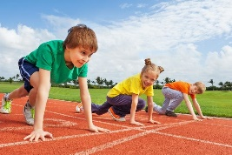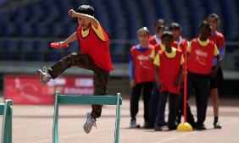 | Levels | The movement of the body between High, Medium and Low height levels during a performance.  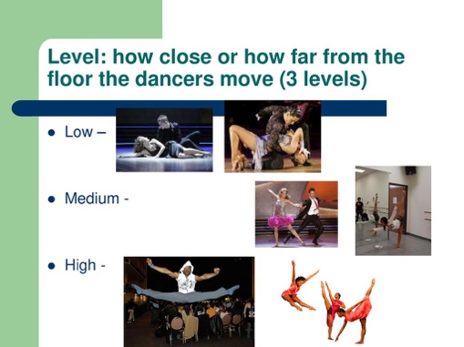
Run | To make yourself move by moving your legs quickly.  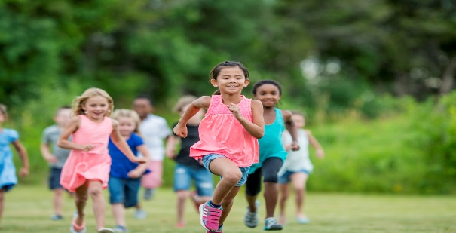 | Levels
Speed | How fast the movements are. This is usually linked to the needs of the event. | Throw | To use the hand, wrist and arm to send something through the air with force.
Direction | Movements such as up/down, forwards/backwards, left/right, clockwise/anti-clockwise and compass directions (North, South, East, West). | Distance | How far one thing is from another. E.g. How far a race is or that you can throw something.
Movement | Changing place or position. Involves moving body parts, especially arms or legs. | Coordination | The movement of more than one body part to get the best results. E.g. This game needs good hand-eye coordination.
Rhythm | A regular repeated pattern of movements. | Jump | To move in the air and leave the ground, either to go up or across (also known as leap).
Sequence | One movement following another. | Height | The distance from the bottom to the top. Jumping events need some height.

