
Castle Hill Primary School Year 3/Year 4 Summer 1
Knowledge Organisers Physical Education Athletics
Athletics | A variety of sports that test speed and strength.  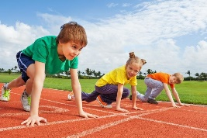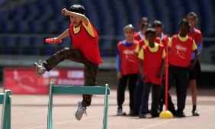 | Levels | The movement of the body between High, Medium and Low height levels during a performance.  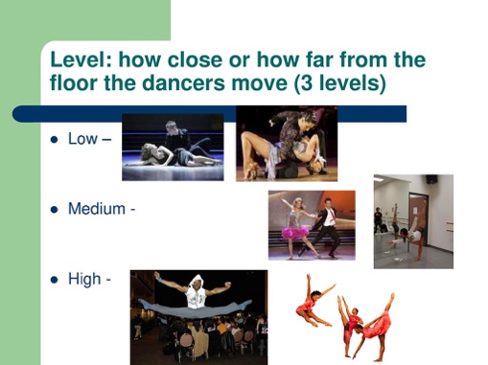
Run | To make yourself move by moving your legs quickly.  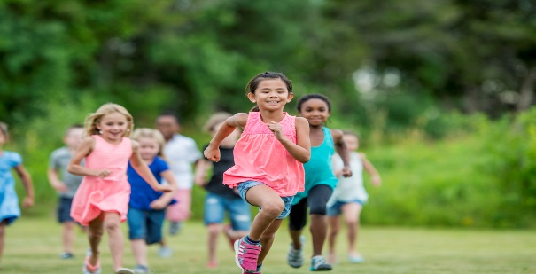 | Levels
Speed | How fast the movements are. This is usually linked to the needs of the event. | Throw | To use the hand, wrist and arm to send something through the air with force.
Direction | Movements such as up/down, forwards/backwards, left/right, clockwise/anti-clockwise and compass directions (North, South, East, West). | Distance | How far one thing is from another. E.g. How far a race is or that you can throw something.
Direction |  | Under-arm | To swing the arm down or back.
Direction |  | Over-arm | Thrown or bowled with arm raised above the shoulder.
Movement | Changing place or position. Involves moving body parts, especially arms or legs. | Coordination | The movement of more than one body part to get the best results. E.g. This game needs good hand-eye coordination.
Rhythm | A regular repeated pattern of movements. | Jump | To move in the air and leave the ground, either to go up or across (also known as leap).
Sequence | One movement following another. | Height | The distance from the bottom to the top. Jumping events need some height.
Hurdle | A barrier to jump over. | Trailing leg | The back leg or last leg that goes over a hurdle.
Obstacle  Bicep | Equipment to either jump over, move around, walk on, climb on or under.  A muscle on the front of the arm above the elbow. It has two parts, a long and a short part. Helps move the forearm.  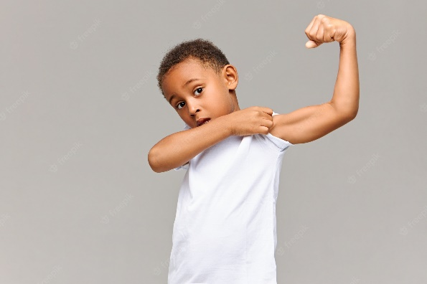 | Hitch Kick | To push the front foot out in front then bring the back foot forward whilst in the air. Effective in long jumping.
Obstacle  Bicep |  | Stride Jump  Tricep | Start with feet together, then on jumping up spread arms and legs in a ‘V’ shape. Land with arms and legs together by the side.  A muscle on the back of the arm. It has three parts and it straightens the arm.  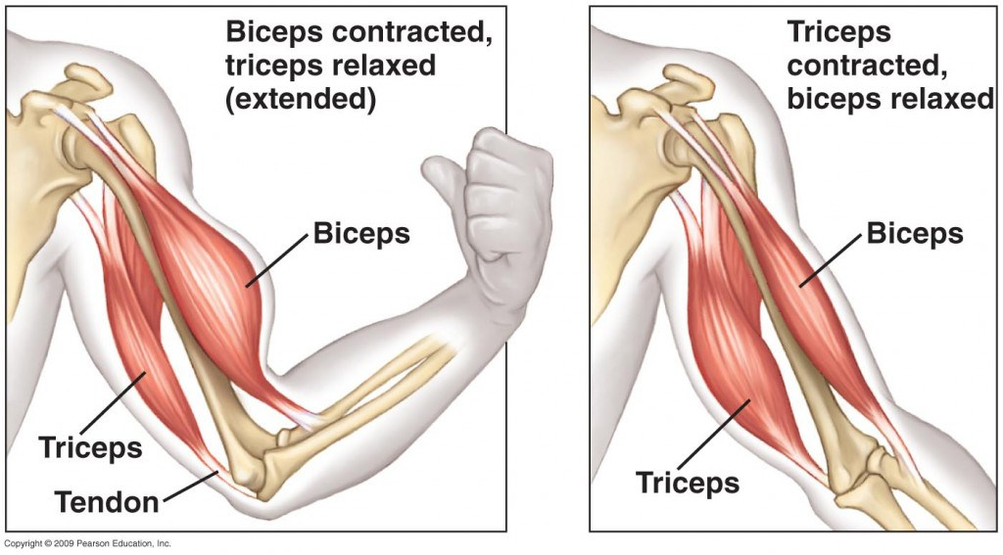
Calf | The muscle at the back of the leg below the knee.  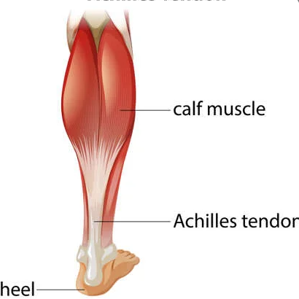 | Quads | Quadriceps – The muscles on the front of your thighs (above the knee). There are four main muscles.  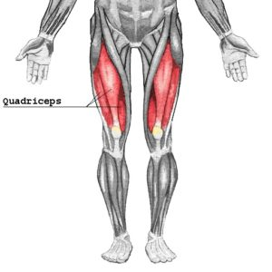
Hamstring | The three muscles down the back of your leg from your thigh to your knee.  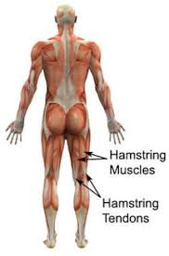 | Abdominals | The muscles in front of your abdomen (the area below your chest and above your belly button)  

