
Castle Hill Primary School Year 5/Year 6 Summer 1
Knowledge Organisers Physical Education Athletics
Athletics | A variety of sports that test speed and strength.  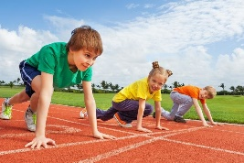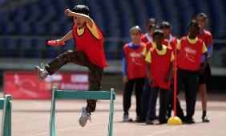 | Circuit Training | A combination of six or more physical exercises that are performed for a set time and one after the other.  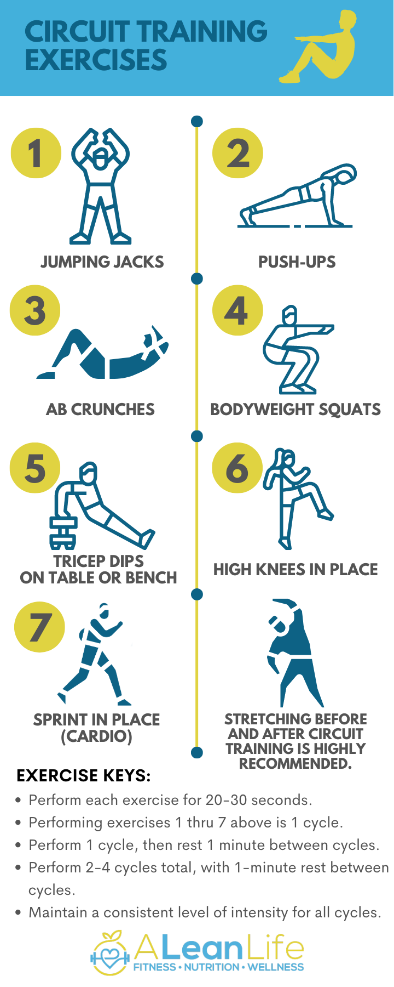
Pace | How fast you are running. You may change pace at different times during a race.  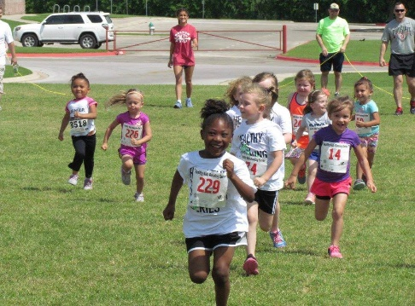 | Circuit Training
Levels | The movement of the body between High, Medium and Low height levels during a performance. | Duration | How long an event or race lasts for.
React | The time it takes for someone between when something happens and the body’s response to it. E.g. How quickly the hands and eyes coordinate to hit a ball after it has been thrown. | Distance | How far one thing is from another. E.g. How far a race is or that you can throw something.
React |  | Under-arm | To swing the arm down or back.
React |  | Over-arm | Thrown or bowled with arm raised above the shoulder.
Movement | Changing place or position. Involves moving body parts, especially arms or legs. | Coordination | The movement of more than one body part to get the best results. E.g. This game needs good hand-eye coordination.
Rhythm | A regular repeated pattern of movements. | Relay | A team in which people do different parts of a race. They may pass a baton.
Sequence | One movement following another. | Height | The distance from the bottom to the top. Jumping events need some height.
Javelin | A thin rod thrown over a distance using the arm. | Long Jump | To try and jump as far as you can. Can be standing or from a run up.
Shot Put  Bicep | A heavy ball or sphere that is held in the hand and tucked under the chin. It is then pushed out from under the chin by straightening the arm for distance.  A muscle on the front of the arm above the elbow. It has two parts, a long and a short part. Helps move the forearm.  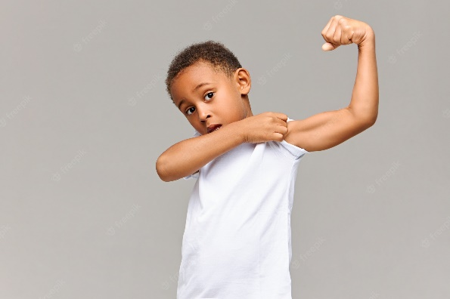 | Triple Jump | A series of three movements in sequence of a hop, step and then finishing with a jump to travel as far as you can. Usually from a run up.
Shot Put  Bicep |  | Tricep | A muscle on the back of the arm. It has three parts and it straightens the arm.  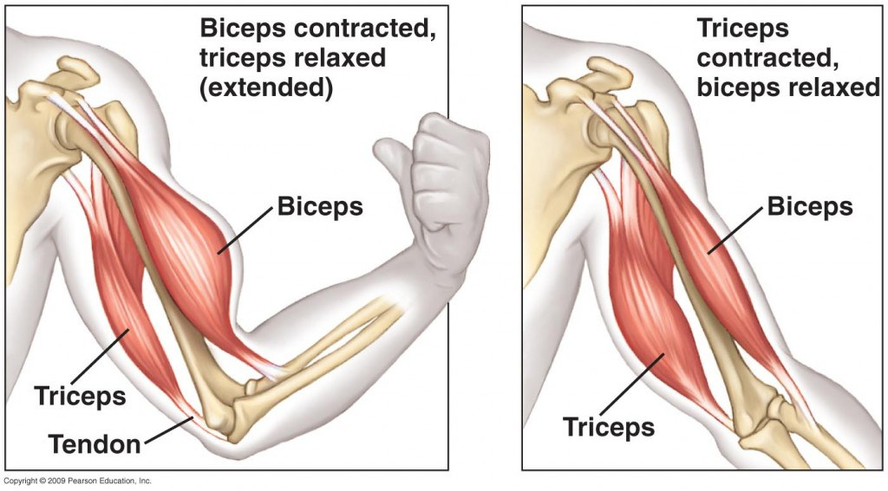
Calf | The muscle at the back of the leg below the knee.  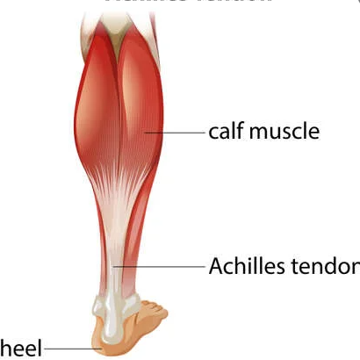 | Quads | Quadriceps – The muscles on the front of your thighs (above the knee). There are four main muscles.  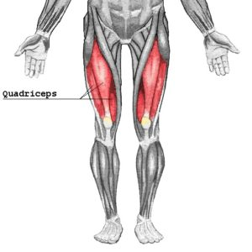
Hamstring | The three muscles down the back of your leg from your thigh to your knee.  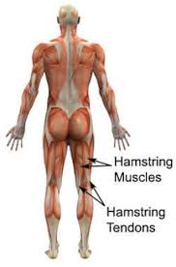 | Abdominals | The muscles in front of your abdomen (the area below your chest and above your belly button)  

