 |  | Year 1 Autumn 1  Christianity  What does it mean to belong to a faith community?
 |  | Vocabulary
Need to know:  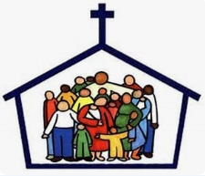  - People that share many of the same religious beliefs are a faith community. | Nice to know:  - People belong to groups; we might call them communities.  - Groups of people with something in common are a community.  - Faith communities share symbols and actions that unite them.  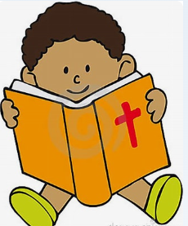 | Christianity | Christianity is the belief that Jesus is the Christ, or chosen one, whom God sent to the world to save the humans.
 |  | faith | A set of religious beliefs or a belief that something is certain even if no evidence exists.
 |  | symbols | Articles/items that represent an aspect of the faith in question.  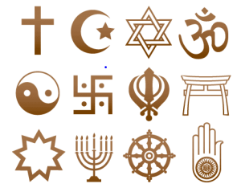
 |  | parable | A story that teaches a lesson.
 |  | bible | A compilation of books and letters containing the sacred writings of a religion.

