 |  | Year 2 Autumn 1  Islam  Who is Muslim and how do they live? (part 1)
 |  | Vocabulary
Need to know:  - Allah is the Muslim word for God. | Nice to know:  - Muslims believe in one God.  - Muslims repeat the Shahadah often.  - The Shahada is a declaration of faith.  - Muslims pray 5 times a day.  - There are 99 names (descriptions) for Allah. | Qur’an | 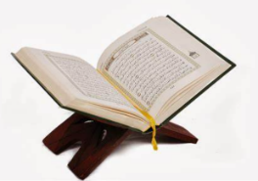  The Qur’an is the holy book of Islam.
Need to know:  - Allah is the Muslim word for God. |  | Islam | A religion based on belief in Allah (PBUH) as the only God and in Muhammad the prophet of God.
Need to know:  - Allah is the Muslim word for God. |  | The five pillars | The five pillars of Islam are the five duties that every Muslim in order to live a good and responsible life according to Islam.
Need to know:  - Allah is the Muslim word for God. |  | Shahadah | 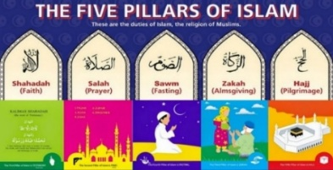  The first pillar of Islam: the belief that there is no God but Allah (PBUH)
Need to know:  - Allah is the Muslim word for God. |  | Muslim | A Muslim is a person who follows or practices Islam.

