 |  |   Year 3 Autumn 2  Christianity-People of God  What is it like for someone to follow God?
 |  | Vocabulary
Need to know:  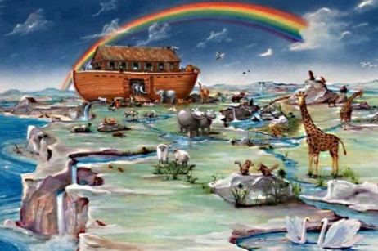  - People of God-The Old Testament tells the story of a particular group of people, the children of Israel (people of God) and their relationship with God. | Nice to know:  - A covenant is a promise. God promised Noah that he would never flood the earth again and sent a rainbow as a symbol of his promise.  - Promises make relationships stronger.  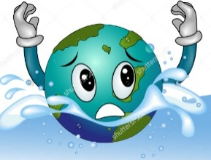  - Breaking promises can damage a relationship | Genesis | The making of everything; the universe, the world, animals, plants , people.
 |  | Noah | Noah was an obedient servant of God in the Old Testament who found favour with God amidst a sinful world.
 |  | Promise | People make special promises that show what matters to them: becoming a church member, getting married, joining scouts. Its when someone gives their word and says they will do something.
 |  | Old Testament | The first part of the Bible that was completed before Jesus Christ was born.
 |  | Flood | A large amount of water often caused by heavy rain.

