 |  |   Year 4 Autumn 1  Christianity-Incarnation  What is the ‘trinity’ and why is it so important to Christians?
 |  | Vocabulary
Need to know:  - God is the Trinity: The Father; Son and Holy Spirit.  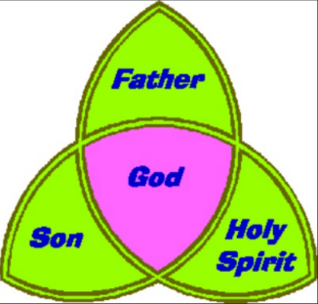 | Nice to know:  - The bible has two main parts: The Old Testament and the New Testament.  - In the New Testament there are four Gospels. Matthew, Mark, Luke and John.  - Gospels tell stories about the life of Jesus.  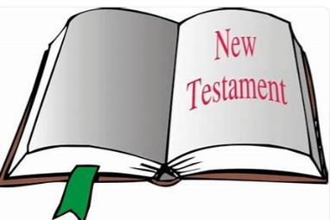 | Gospel | The Gospels are historical documents that make the first four books of the Bibles’s New Testament. They describe the life; death and resurrection of Jesus and were written by four of his followers.
 |  | Trinity | God is Trinity: three in one; The Father, The Son and Holy Spirit.
 |  | Incarnation | God took human form coming to earth in the body of Jesus to rescue humanity.
 |  | Baptism | A naming ceremony that is very important Hindu ritual after the birth of a child.
 |  | Holy Spirit | God the Holy Spirit-often symbolised by the dove
 |  | Father | God the father-God
 |  | Son | God the Son- Jesus

