 |  |   Year 6 Autumn 1  General  What matters most to Humanists and Christians?
 |  | Vocabulary
Need to know:  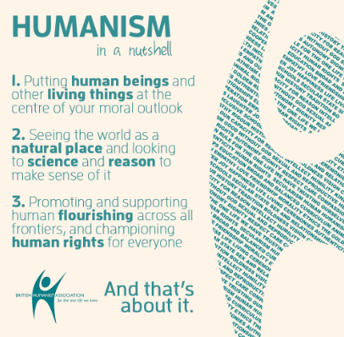  - Humanists do not believe in God. | Nice to know:  - Both Humanists and Christians want the world to be a better place.  - Humanists and Christians have some common values but the beliefs behind these values differ. | Humanist | 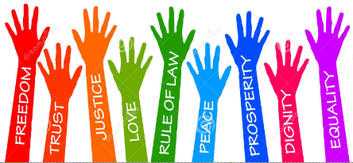  A rationalist outlook or system of thought attaching prime importance to human rather than supernatural matters.
 |  | Faith | Strong belief in a religion based on spiritual conviction rather than proof.
 |  | Values | Are basic and fundamental beliefs that guide or motivate attitudes or actions.
 |  | Fairness | Treating all parties involved in any activity with equal amounts of action or inaction.
.

