 |  | Year 1 Autumn 2  Christianity-God  What do Christians believe God is like?
 |  | Vocabulary
Need to know:  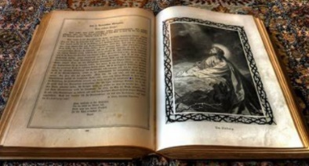  - The Bible is a holy book. | Nice to know:  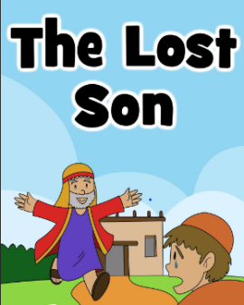  - God- Fundamental to Christian belief is the existence of God, Father, Son and Holy Spirit.  - The parable of ‘The lost son’ teaches about love and forgiveness. | God | Is believed to be the eternal supreme being who created and preserves all things.
 |  | Christian | A person who believes that Jesus Christ is the son of God and follows his teachings.
 |  | Christianity | Is a belief that Jesus is the Christ, or chosen one, whom God sent to the world to save humans.
 |  | Forgiveness | Starting afresh when you have realised your mistake
 |  | Parable | A story that teaches a lesson.
 |  | Holy Bible | A compilation of books and letters containing the sacred writings of a religion.

