 |  | Year 2 Autumn 2  Christianity- Incarnation  Why does Christmas matter to Christians?
 |  | Vocabulary
Need to know:  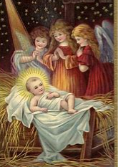  - Incarnation- Christians believe God came to Earth in human form as Jesus. | Nice to know:  - The Bible stories teach us that Jesus was extraordinary (worshiped as a king) and that he came to bring good news.  - Jesus is important to Christians because he is the symbol of hope (the light of the world)  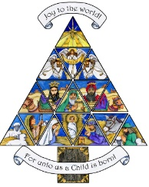  - Christians celebrate Jesus’ birth; advent is a time for getting ready for Jesus’ coming. | Incarnation | Jesus is God in flesh and that in Jesus God came to live among humans.
 |  | Christmas | The Christian holiday to celebrate the birth of Jesus Christ.
 |  | Advent | An important timer of the Christian calendar. It means ‘coming’ and it the period before Christmas which celebrates the birth of Jesus.
 |  | Gospel | Historical documents that make up the first four books of the Bible’s New Testament. They describe the life, death and resurrection of Jesus and were written by his four followers.
 |  | Nativity | The story about the birth of Jesus.

