 |  |   Year 3 Autumn 1  General  What do Christians learn from the creation story?
 |  | Vocabulary
Need to know:  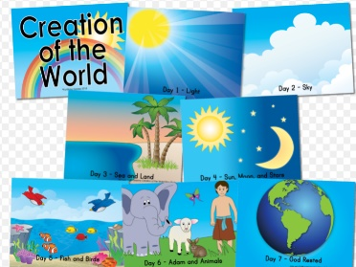  - Creation is the first story in the Bible. | Nice to know:  - Christians and Jews believe that God created the world.  - Christians thank God for creation by: praying, singing and supporting environmental charities. | Creation | The making of everything; the universe, the world, animals, plants , people.
 |  | The Bible | 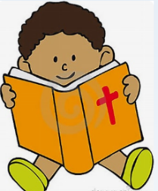  The compilation of books and letters containing the sacred writings of a religion.
 |  | Fall | People disobeying God
 |  | Sin | 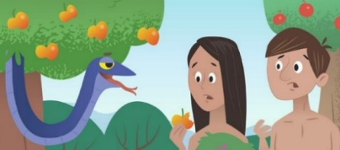  An action that breaks a religious law.

