 |  |   Year 4 Autumn 2  Hinduism  What do Hindus believe God is like?
 |  | Vocabulary
Need to know:  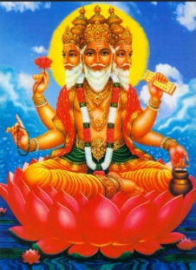  - Hindus believe in one God, Brahman. | Nice to know:  - Hinduism is a set of cultural and religious beliefs and practices that originated in India.  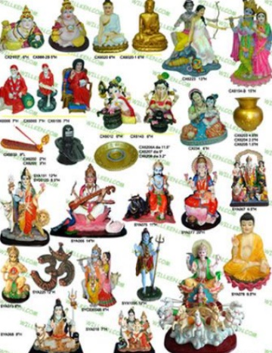  - Hindus have many deities which represent different aspects of Brahman, and these are often represented as small figures called Murtis. | Mandir | A spiritual building for Hindus.
 |  | Diwali | Diwali means ‘rows of lighted lamps’ and is known as the festival of lights.
 |  | Brahma | Hindu God.
 |  | Atman | The spark of God in everything.
 |  | Dieties | A god or goddess.
 |  | Murtis | Small figures that represent different deities.
 |  | Vishnu | The preserver and protector of the universe.
 |  | Lakshmi | The goddess of money, wisdom and good luck.

