 |  |   Year 5 Autumn 2  Christianity-Incarnation  Why do Christians believe Jesus was the Messiah ?
 |  | Vocabulary
Need to know:  - For Christians Jesus is the answer, the Messiah and saviour. | Nice to know:  - Incarnation- Christians believe God came to Earth in human form as Jesus and lived among the humans.  - He will repair the effects of sin  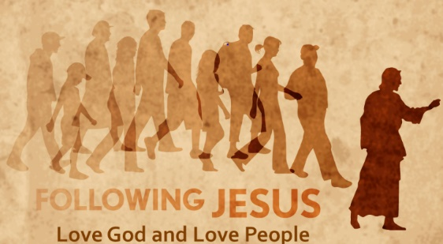  - He will bring humans back to God again. | Incarnation | A Christian church that is the home church of a bishop.
 |  | Messiah | The person whom God sent to save his people and to rule them.
 |  | Saviour | A person who saves someone or something from danger or difficulty.
 |  | Prophecy | A message claimed by a person to have been communicated to them by a deity or God.
 |  | Sin | Anything that is contrary to the law or God.
 |  | New Testament | The second part of the bible which contains 27 books. It begins with the four gospels which focus on the life, death and resurrection of Jesus Christ.
 |  | Old Testament | The first part of the bible completed before the birth of Jesus. It contains 24 books about God and includes ‘The Big Story’

