 |  |   Year 6 Autumn 2  General  Why do some people believe in God and some people do not?
 |  | Vocabulary
Need to know:  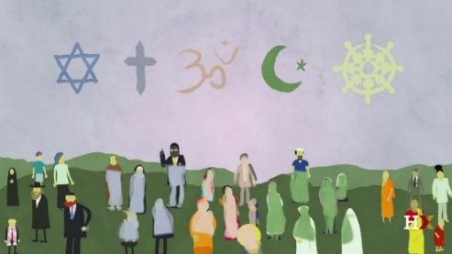  - Identify and explain what religious and non-religious people believe about God. | Nice to know:  - Give reasons why some people do not believe in God  - Believing in God is valuable to some people.  - Where do people get their ideas about God from? | Christian | A person who believes that Jesus Christ is the Son of God and follow his teachings.
 |  | Atheist | A person who does not believe in a god or gods.
 |  | Faith | Strong belief in a religion based on spiritual conviction rather than proof.
 |  | Agnostic | Agnostics neither affirm nor deny the existence of God, but acknowledge that there is not enough to approve or disprove it.
 |  | Theists | Believe in one or more Gods.
.

