 |  | Year 1 Spring 1  Judaism  Who is Jewish and how do they live?
 |  | Vocabulary
Need to know:  - The Torah is the compilation of the first five books of the Hebrew Bible.  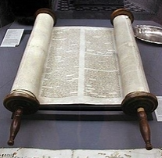 | Nice to know:  - Jews believe in one God.  - Jews believe that they are God’s favoured people  - Jews often write God as God as a sign of respect for God.  - Jews use objects at home to keep God in their thoughts.  - Jews celebrate special times to help them remember and think about their relationship with God. | Mezuzah | A small case affixed to the doorpost of Jewish homes, synagogues, and business establishments
 |  | Hanukkah or Chanukah | A festival celebrating the Jews winning a battle over 2000 years ago.
 |  | Shabbat | Shabbat is the name of the day of rest in Judaism. Shabbat happens on the seventh day (Saturday) of every week.
 |  | Shema | The Shema is one of the most important Jewish prayers. It is one of the first prayers that Jewish children learn.
 |  | Sukkot | The festival of Sukkot is a time to remember how thousands of years ago the Jewish people wandered the desert, trying to find a place to live.
 |  | 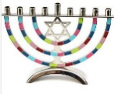  Menorah | A menorah is a nine-branched candelabrum lit during the eight-day holiday of Hanukkah.

