 |  | Year 2 Spring 1  Islam  Who is Jewish and how do they live?
 |  | Vocabulary
Need to know:  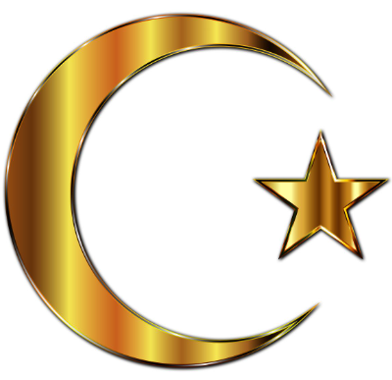  - Allah is the Muslim word for God. | Nice to know:  - Muslims believe in one God.  - Muslims repeat the Shahadah often.  - The Shahada is a declaration of faith.  - Muslims pray 5 times a day.  - There are 99 names (descriptions) for Allah. | Prophet | A person who speaks on behalf of a god or who is divinely inspired to reveal the will of a god.
 |  | Muhammad | The first and most important Islamic prophet.
 |  | Fast | To go without eating or drinking.
 |  | Prayer mat | A small carpet used by Muslims for kneeling on when praying.
 |  | Prayer beads | Prayer beads are a form of beadwork used to count the repetitions of prayers or chants.
 |  | Ramadan | The ninth month of the Muslim year, during which strict fasting is observed from dawn to sunset.

