 |  |   Year 3 Spring 1  Islam  How do festivals and worship show what matters to a Muslim?
 |  | Vocabulary
Need to know:  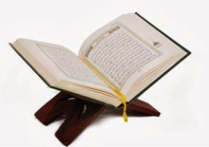  - The Qur’an is the Muslim holy book.  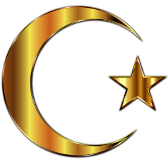 | Nice to know:  - Muslim means one who willingly submits to God’s will.  - Ibadah means worship and belief in action  - Muslims worship in a mosque.  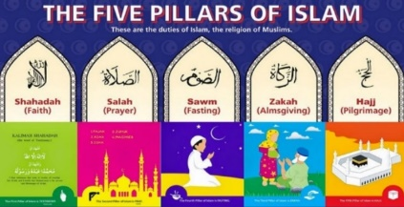  - One of the five pillars of faith is fasting, ‘Sawn’ | Surah | Is a chapter in the Qur’an
 |  | Laylat al Qadr | The night of power.
 |  | Ibadah | The following of Islamic beliefs and practices.
 |  | Sawm | Fasting, the act of giving up something of great value to show loyalty or deep affection.
 |  | Eid-al-Fitr | The Muslim festival marking Sawm the end of the fast of Ramadan.
 |  | Mosque | A place of worship for Muslims.

