 |  |   Year 4 Spring 1  Hinduism  What does it mean to be Hindu in Britain today?
 |  | Vocabulary
Need to know:  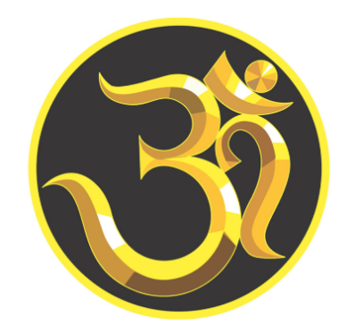  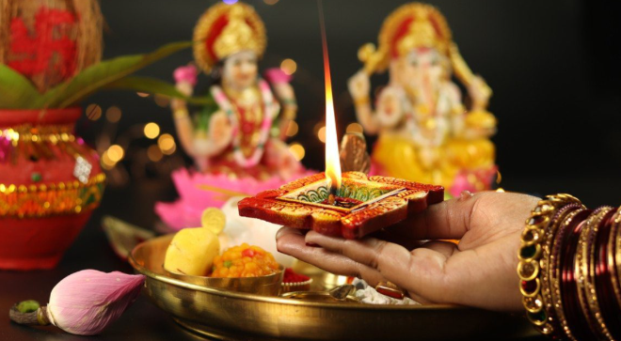  - Puja is ceremonial worship in Hinduism. | Nice to know:  - Hindus worship as a community.  - Diwali is a Hindu festival.  - Dharma is the eternal and inherent nature of reality underlying right behaviour and social order.  - Sanataan the duties or religiously ordained practices all Hindus have to follow. | Diwali | Diwali means 'rows of lighted lamps'. Diwali is known as the 'festival of lights'
 |  | Holi | Hindu festival that welcomes the Spring and celebrates the new life and energy of the season
 |  | Eternal | Lasting forever
 |  | Ritual | A ritual is a religious service or other ceremony which involves a series of actions performed in a fixed order.
 |  | Puja | A ritual in honour of the gods, performed either at home or in the mandir
 |  | Faith | A belief that something is true. Believing in God
 |  | Sacred | Something that is sacred is believed to be holy and to have a special connection with God

