 |  |  |  |  |  |   Year 5 Spring 1  Islam  What does it mean to be Muslim in Britain today?
 |  |  |  |  |  | Vocabulary
Need to know:  - Hajj is a pilgrimage. | Nice to know:  - There are 28 mosques are in Bolton.  - Not all mosques are the same.  - The design and purpose of a mosque reflect Muslim beliefs.  - The festival of Eid-ul-Ahda celebrates Ibrahim’s faith being tested when he was asked to sacrifice Ismail. |  |  |  |  | Pilgrimage | A holy journey.
Need to know:  - Hajj is a pilgrimage. |  |  |  |  |  | Allah | Is the Arabic word for God
Need to know:  - Hajj is a pilgrimage. |  |  |  |  |  | Mosque | Islamic place of worship.
Need to know:  - Hajj is a pilgrimage. |  |  |  |  |  | Sacrifice | is a loss or something you give up, usually for the sake of a better cause.
Need to know:  - Hajj is a pilgrimage. |  |  |  |  |  | Festival | celebration, often of a spiritual nature.
The five Pillars |  | Shahadah | Salah | Sawm | Zakah |  | Hajj
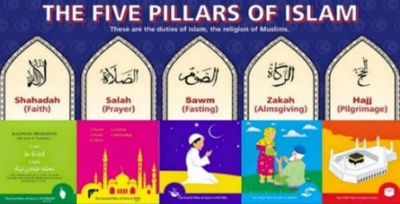 |  | Sincerely reciting the Muslim profession of faith. | Performing ritual prayers in the proper way, five times each day. | Fasting during the month of Ramadan. | Paying an alms (or charity) tax to benefit the poor and the needy. |  | The pilgrimage, or religious journey, every adult Muslim must make to the holy city of Mecca.

