 |  |   Year 6 Spring 1  Hinduism  Why do Hindus want to be good?
 |  | Vocabulary
Need to know:  - The ultimate aim of Hinduism is to leave the cycle of rebirth and become one with Brahma. This is called Moksha  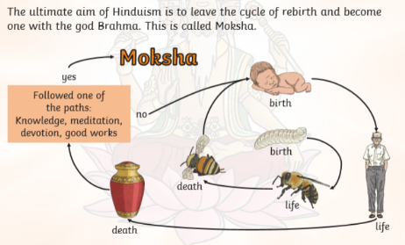 | Nice to know:  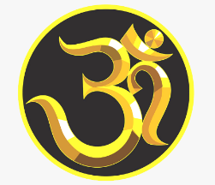  - Through Samsara and good learning in life eventually, Hindus believe you can leave Samsara and become one with the god Brahma. | Dharma | Dharma means social and moral duty
 |  | Karma | Prayer: a person of faith speaking to God.
 |  | Samsara | Samsara describes the cycle of birth, death and rebirth.
 |  | Moksha | Moksha describes the ultimate goal of all Hindus to escape the cycle of Samsara and to be finally reunited with Brahman.
 |  | Values | Beliefs about what is right and wrong and what is important in life.
 |  | Morals | Standards of good behaviour
 |  | Reincarnation | The name of the idea that people are born again in another body after they die and this cycle continues over many lifetimes.
.

