 |  | Year 1 Spring 2  Judaism  Who is Jewish and how do they live?
 |  | Vocabulary
Need to know:  A Synagogue is a place where Jewish people meet to worship and pray to God  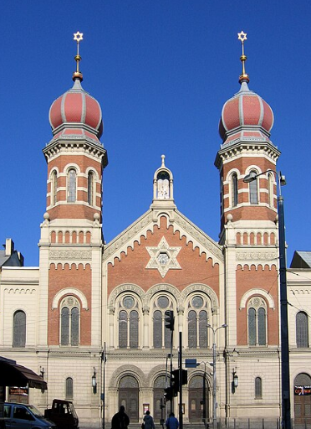 | Nice to know:  - Jews believe in one God.  - Jews believe that they are God’s favoured people  - Jews often write God as G-d as a sign of respect for God.  - Jews use objects at home to keep God in their thoughts.  - Jews celebrate special times to help them remember and think about their relationship with God. | 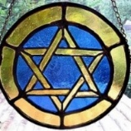  Star of David | The Star of David is the symbol of the Jewish community.
 |  | Passover | A Jewish holiday that honours the freedom and exodus of the Israelites (Jewish slaves) from Egypt.
 |  | Ark | A cabinet where the Torah Scrolls are kept.
 |  | Rabbi | A spiritual leader or religious teacher in Judaism.
 |  | Tallit | A prayer shawl worn by Jewish men from the age of eighteen.
 |  | 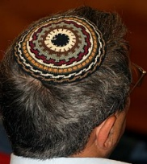  Kippah | The Jewish head covering worn by men at prayer or in the synagogue.

