 |  | Year 2 Spring 2  Christianity-Salvation  Why does Easter matter to Christians?
 |  | Vocabulary
Need to know:  Easter is the most important festival in the Christian calendar.  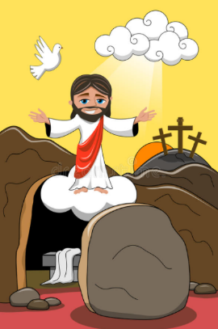  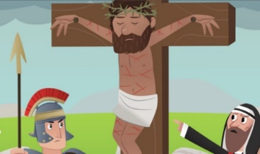 | Nice to know:  - Recognise that Salvation is part of the ‘Big Story’ of the Bible.  - Understand that Holy Week leads up to Good Friday.  - Palm crosses represent Jesus’ entry into Jerusalem on Palm Sunday.  - Know that Good Friday is the day that Jesus was Crucified.  - Recognise that Christians believe that Jesus came back to life on Easter Sunday.  - Hot cross buns have a cross to represent the crucifixion. Easter eggs symbolise new life. | Salvation | Salvation means being saved from sin, and to have eternal life with God in heaven after death.
 |  | Holy week | The last week of the 40 days of Lent. It is the week right before Easter Sunday. It starts with Palm Sunday and ends with Holy Saturday.
 |  | Palm Sunday | Is the last Sunday of Lent and first day of the Holy week in Christian churches. It falls on the Sunday before Easter.
 |  | Good Friday | Good Friday marks the day when Jesus Christ was crucified on the cross.
 |  | Easter Sunday | A The celebration of Jesus Christ’s rising from the dead (His resurrection) after his crucifixion.

