 |  |   Year 4 Spring 2  Christianity  Why do Christians call the day Jesus died good Friday?
 |  | Vocabulary
Need to know:  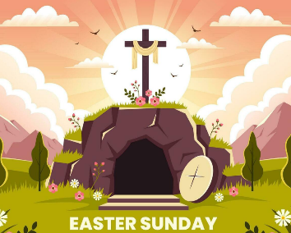  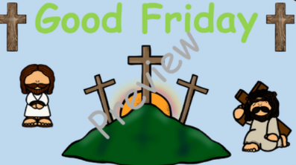  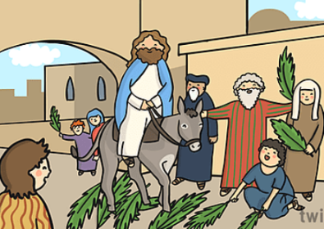    - Know the events of Holy Week. | Nice to know:  - Know that Christians see the Holy Week as the culmination of Jesus’ earthy life, leading to his death and resurrection.  - Know that the various events of Holy Week, such as the last supper were important in showing the disciples what Jesus came to earth to do.  - Recognise that Christians today trust that Jesus really did rise from the dead and so is still alive today.  - Recognise that Christians remember and celebrate Jesus’ last week, death and resurrection. | Salvation | Salvation means being saved from sin and to have eternal life with God in heaven after death
 |  | Holy week | Is the last week of the 40 days of Lent. It is the week right before Easter Sunday. It starts with Palm Sunday and ends with Holy Saturday
 |  | Palm Sunday | Is the last Sunday of Lent and the first day of Holy Week in Christian churches. It falls on the Sunday before Easter
 |  | Maundy Thursday | Is the Christian feast, or holy day, falling on the Thursday before Easter. It commemorates the Maundy and last supper of Jesus Christ.
 |  | Good Friday | Marks the day when Jesus Christ was crucified on the cross.
 |  | Crucifiction | The act of killing someone by nailing his or her feet and hands to a cross.
 |  | Easter Sunday | The celebration of Jesus Christ’s rising from dead after his crucifixion.
 |  | Resurrection | Christians believe that Jesus Christ returned to life (rose from the dead) after his crucifixion.

